
Specs : Tools : Electrical : Fuel System : Engine : Bodywork : Links : News

Electrical Troubleshooting

Keeping the electrical system in working order is an annoying task on most scooters. The electrical equipment is hard to get to, and the wires and connectors are fragile. Everything on this page will need patience. Since there are various schematics for P200's please make identify YOUR particular bike before tracing wiring diagrams and modifying your harness. The following is a list of all of the electrical problems I have successfully fixed. Please note that while these methods worked for me, they may not work for all situations. If there is anything you are stuck on or find ambiguous, drop me a line or ask a question on the International Scooterist BBS in the links section of this site. Good Luck!
How does the CDI work? - added: 02/14/03
How does the Turn Signal system work? - added: 02/14/03
How does the Voltage Regulator work? - added: 02/14/03
Making a Spark Plug Wire - added: 11/21/02
Degree Wheel for setting timing advance - added: 11/08/01 updated:11/09/01
Get a Diagram! - added: 10/26/01
Changing and Reading Your Spark Plug - added: 10/18/01
Cleaning Up and Filling Up: Your Battery - added:10/16/01

How Does the CDI Work?

As part of my series explaining how the various electrical black boxes work on the P200, I thought I would have a look at the inner workings of the Capacitive Discharge Igntion ("CDI") system fitted to most every bike. The animation below shows how the system works in motion, but it probably isn't glaringly obvious to most what is happening. Using the animation as a reference, I will describe the behaviour of the ignition system. This tutorial assumes a little electrical knowledge on behalf of the reader.

Okay so if you're stuck on how it works, let's look at the parts of the ignition system in order. We'll start with the stator.

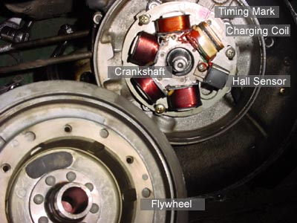

The flywheel is a large permanent magnet that spins on the crankshaft. It is magnetized at the factory and has a defined north and south pole. Think of it as a horseshoe magnet rolled into a circle.
The Stator is the plate holding all of the electrical coils of wire, which powers the bike's lights, ignition and battery charging circuits.
The charging coil is one coil on the stator that produces the 6 volts needed by the condensor, C1, inside the CDI box. The charging coil supplies a single pulse of power based on the flywheel's movement around the field. The CDI box has to absorb the electrical pulse as completely as possible to ensure a good spark at the spark plug.
The Hall Sensor measures the hall effect, the instantaneous point where the flywheel's magnet changes from a north to a south pole. When the pole change occurs, the device sends a single, tiny pulse to the CDI box which triggers it to dump the energy from the charging capacitor into the high voltage transformer. there's more info from honeywell's Sensing product line.
The timing mark is an arbitrary alignment point shared by the engine case and stator plate. It indicates the point at which the top of the piston's travel is equivalent with the trigger point on the flywheel and stator. By rotating the stator plate left and right, you effectively change the trigger point of the CDI, thus advancing or retarding your timing, respectively.
As the flywheel turns past the charge coil, the charge coil produces an alternating current from +6V to -6V. The CDI box has a collection of semiconductors that regulate the flow of electricity. The Rectifier connected to G1 on the box allows only the positive pulse enter the condensor, C1. So when the wave enters the CDI, the Rectifier allows only the postive part of the wave through to the capacitor and blocks the negative part. The trigger circuit is a switch, presumably using a transistor, thyristor or SCR. These components are basically gates that are triggered by the pulse from the Hall Sensor on the stator. They do not allow current to pass through to the other side of the circuit until they are triggered. Once a charge is induced into C1, it has no where to go, so it stays full for a few seconds until it leaks off.
Once C1 is fully charged, the circuit can be triggered. This is why there is timing involved with the motor. If the condensor and stator coil were perfect, they would charge instantaneously and you could trigger them as fast as you wished. however, they require a fraction of a second to come to full charge. If the circuit triggers too fast, the spark from the spark plug will be extremely weak. Indeed, with higher revving motors, you risk the chance of triggering faster than the condensor can fill, which will affect performance (with misfires).
The trigger pulse from the hall sensor feeds into the gate's latch and allows all the stored charge to rush through the primary side of the high voltage transformer. The transformer shares a common ground between the primary and secondary windings. In this configuration, we have an "auto-step up" transformer. Therefore, if you multiply the windings on the secondary side, you will multiply the voltage. Since a spark plug needs a good 30,000 volts to spark, there must be many thousands of wraps of wire around the high voltage or secondary side. When the gate opens and dumps all the current into the primary side, it saturates the low voltage side of the transformer and sets up a short but immense magnetic field. As the field collapses, the large current in the primary windings forces the secondary windings to hold the charge by producing an extremely high voltage. However, the voltage is now so high that it can arc through air, so rather than being absorbed or retained by the transformer, the charge travels up the plug wire and jumps the plug gap.
When you go to kill the motor, you use a switch on the headset: either the key or the kill switch. The switches ground out the charging circuit so the entire charging pulse is sent to ground. Since the CDI can no longer charge, it will cease to provide spark and the engine will slow to a stop.
How Do the Turn Signals Work?

The turn signals on the P200 are fairly basic in design. There are two types of signals: AC and DC. The DC based style is shown in the picture, but the AC signals contain the following parts and a small DC converter.
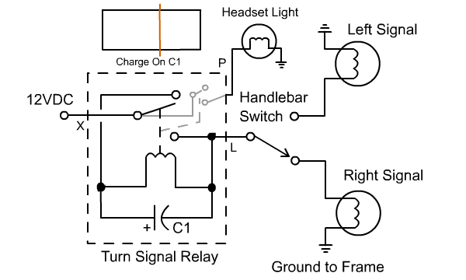
The cycle goes as follows:
When the handlebar switch is operated, a path to ground opens up for the capacitor, C1, indside the flasher relay. The DC voltage enters C1 and the capacitor begins to take in a charge. As soon as it charges to a certain voltage, it energizes the relay coil and the switch moves to the second position. in this second position, the battery is connected directly to the turn signal and the light turns on. However, C1's charging circuit has been disrupted, so it will begin to discharge. When it falls to a specific voltage, it will no longer hold the relay coil and the switch will click back to the starting position.
The relay coil also controls a second switch which mimics the movements of the main switch. it's common lead is also connected to the power supply, so when the relay switches, regardless of the selection on the handlebar, it will flash. This circuit controls the turn signal indicator on the headset.
How Does the Voltage Regulator Work?

The Voltage Regulator / Rectifier on the P200 is a black box that performs two distinct funtions withing the same box. The first function is battery charging. The battery on a Vespa requires constant charging in order to run many of the indicators and safety features of the bike (and starter motors is your bike is so equipped). The second function of the regulator is to regulate the AC power for the headlight and spedometer light. The regulator/charger box is probably the most advanced collection of circuits on the bike, but it is the least prone to failure.
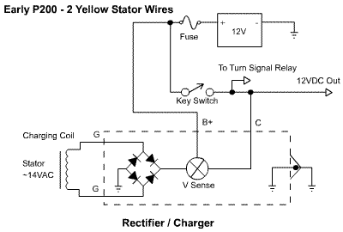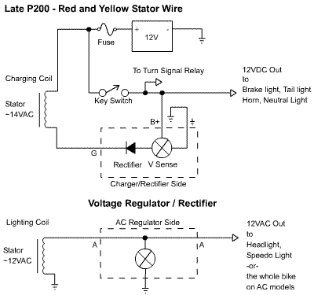

These circuits contain the layout of the battery charger / rectifier circuit. A battery is a pretty finnicky device as far as power input is concerned. The Voltage regulator has to satisfy two goals: 1. provide a DC input source and 2. Provide a voltage of roughly 14 Volts. The regulator employs a rectifier in order to change the power from AC to DC, but it is not used as we are used to seeing it in North America. It attaches on the ground side of the battery as is common in conventional current circuit layouts. Next to the rectifier is the Voltage Sense Deivce, which I can only assume it is driven by a handful of semiconductors. The sensor accomplishes two tasks, it limits the upper charging voltage to 14.4V and charges the battery with more or less current depending on the battery's condition. The battery's positive terminal feeds back into the circuit to help the regulator decide how hard to drive the charger. Under normal conditions, the charger works very little, simply trickle charging the full battery. But as the battery gets weaker, the charger senses less voltage and boosts the charge current. When the battery dies, or the fuse blows, the voltage sensing assumes a completely dead battery and drives as hard as it can. This circuit is current limited so it will not just explode, but it would be a good idea to fix any problems with the battery circuit so that the battery doesn't go completely dead.
The bottom circuit (in the late P200 diagram) is a layout of the AC regulator. The soul purpose of this device is to limit the overvoltages from a high revving engine. As the engine spins faster, the overall voltage goes up past the operating voltage of the headlight. That kind of overvoltage can take out an expensive headlight, so as a safeguard, the power from the stator is routed into the voltage regulator. All power that surpasses a threshold of about 14 volts is shorted to ground. It doesn't matter which way you wire up the circuit for the two "A" inputs, since the circuit is not polarized. This circuit is not current limited, so running with no load (ie dead headlight) will make the regulator overheat. If your headlight goes out and there is no immediate replacement, disconnect the wire from the "A" wire that goes to the stator.
Rolling Your Own Spark Plug Wire

If your bike ever becomes really hard to start or a pain to keep running, it may be caused by a weak spark. Other than replacing the sparkplug, there are a few other measures that may help your bike start and run better. One of them is replacing the sparkplug wire. This high voltage wire rots over time and causes a resistance to build up between the CDI and the Spark plug. Usually the symptoms will be misfiring (popping from the exhaust), hard starting and sudden motor die outs. Replacing these parts is good yearly maintenance. Do this job only after you replace the plug and check the carb over. You will need to go to a motorcycle shop and get about 20" of stranded spark plug wire as well as a plug head (you may as well replace it too). The job costs about ten dollars and takes less than 5 minutes.
Tools & Parts Needed
20 inches of Stranded 18AWG Sparkplug Wire
A good set of wire cutters
A plug cap kit (includes a cap and two pices of rubber)
A pair of pliers
Sparkplug Wrench
Procedure

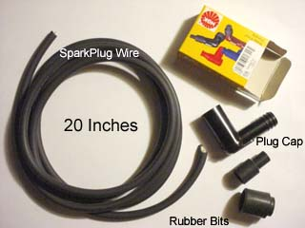 |  | Step 1  A picture of the goodies you need. Costs about ten dollars.

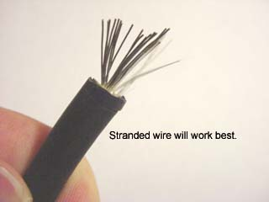 |  | Step 2  This is what I mean by stranded wire. It has a number of strands of wire inside the rubber jacket. This works the best because the connector (a screw) holds onto it tightly.

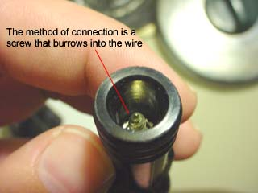 |  | Step 3  See the little screw? that screw jams into the center of the wire and positively connects with the little wire strands inside. The CDI box has the same kind of connector. Keep in mind this is ONLY for P-series bikes, I can't guarantee it is this way for anything else.

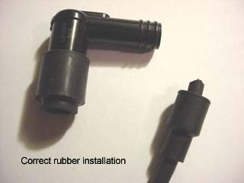 |  | Step 4  Prepare the connectors with the rubber bits. put the larger bit on the end of the cap. This will seal out all the road dirt. Put the smaller one on the wire. Pull it back a bit so you can prep the spark plug wire. Make a straight cut across the wire end so that the wire will seat properly.

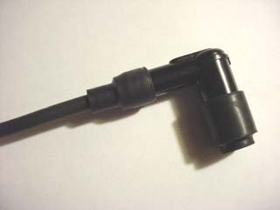 |  | Step 5  Now twist the prepared wire onto the screw until it feels tight. Give it a tug to make sure it wont pull off and slide the small boot down over the wire and onto the plug cap.

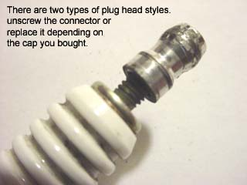 |  | Step 6  When you go to buy a plug cap, they may ask you what kind. You need a 90 degree NGK style cap. Typically the cap will plug onto the little threads under the connector. It's up to you what kind to buy, both work just as well, so get whatever's in stock. You may need a pair of pliers to get the silly connector off of the plug.

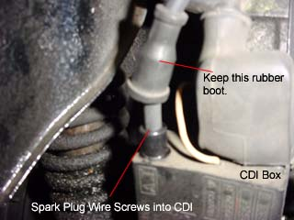 |  | Step 7  The final step is to get the old wire off your CDI box, a black box right near the rear shock. Pull the old one off the plug and unhook it from the shrouding. Next, pull back the boot and unscrew the wire. After preparing the new wire, slip the boot over the new wire and screw it into the CDI box. Hook the new wire back into the shroud and slip the cap onto the plug.

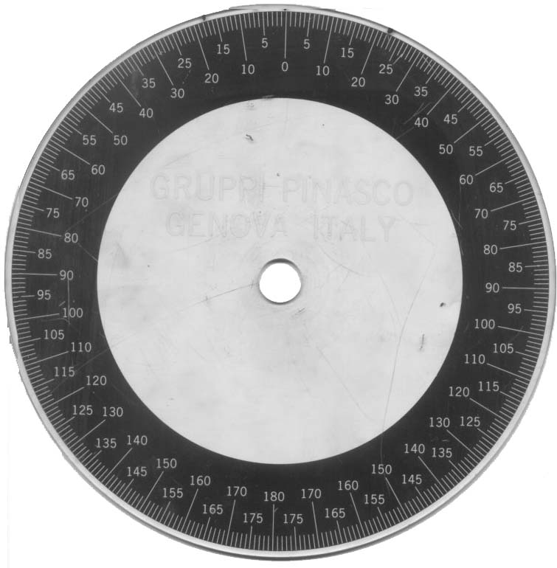
Wiring Diagrams

The wiring structure on the P200 is dependant on the presence of a battery. The best way to identify the diagram that works for you is to have a look at the voltage regulator (under the spare tire side cowl). The difference between these regulators is that one has an AC regulator in it and the other has an AC regulator AND a diode protected output(labelled B+). If there are only 3 terminals, use diagram 1; if there are 5, use diagram 2. There are rogue wiring looms out there that won't look like these diagrams. If you have one like this, document everything you do to the wiring and make notes of problematic areas. If you are buying a new scoot, ask the owner if they have changed the wiring harness. If they have, ask them for a diagram. If you have any other diagrams please email me and send me a scan, I will put it up ASAP! If you want to trace out wires quickly on the second diagram, check out the interactive wiring diagram below (you will need the flash 5 plugin)
Printer-Friendly Wiring Harness Schematics

3 Terminal Voltage Regulator (Batteryless)
5 terminal Voltage Regulator (Battery)
Interactive Diagram - 5 Pole Regulator

To get a close look at the the connections, click the right mouse button and click "zoom in". This diagram is a trace from the second diagram (5 pole voltage regulator).
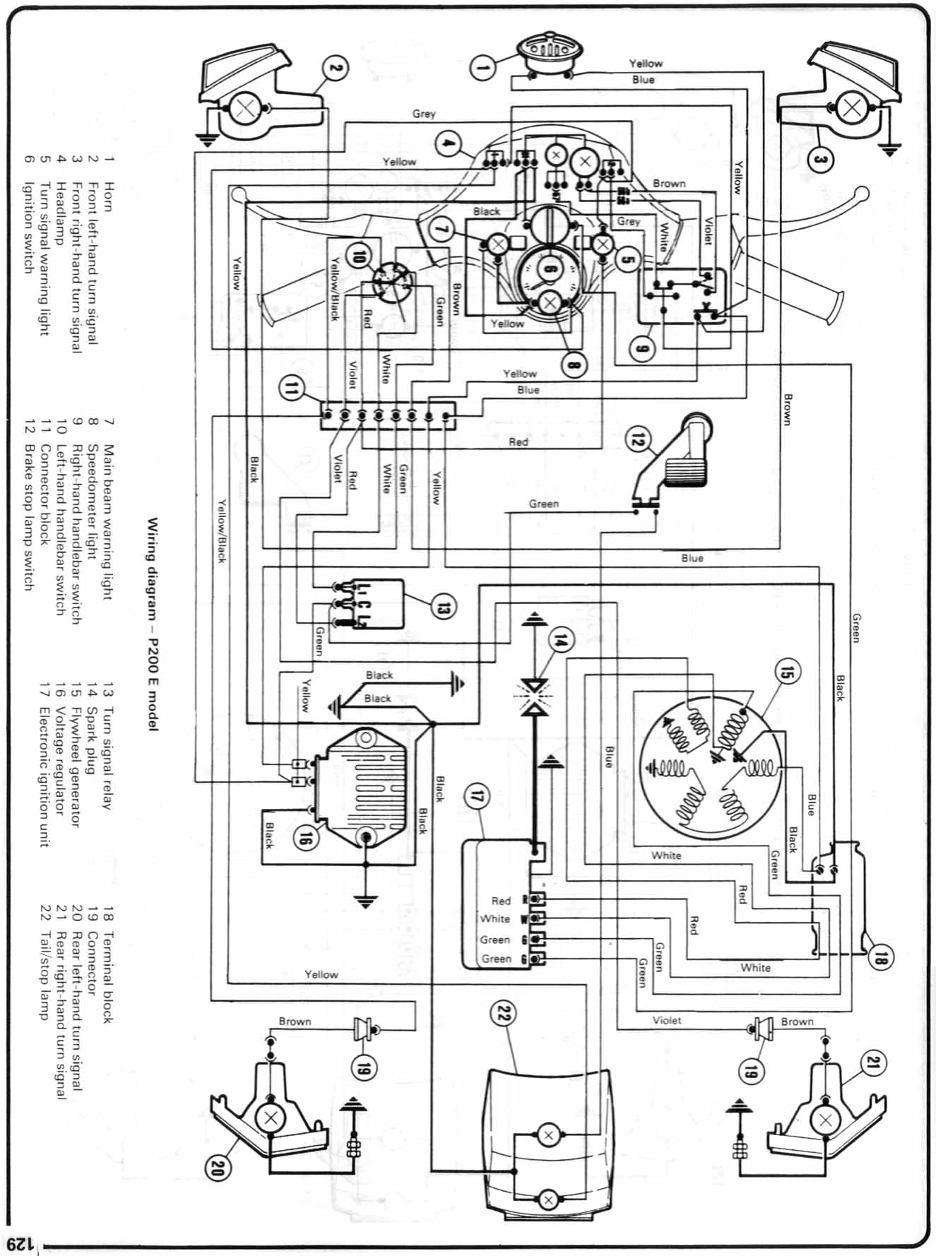
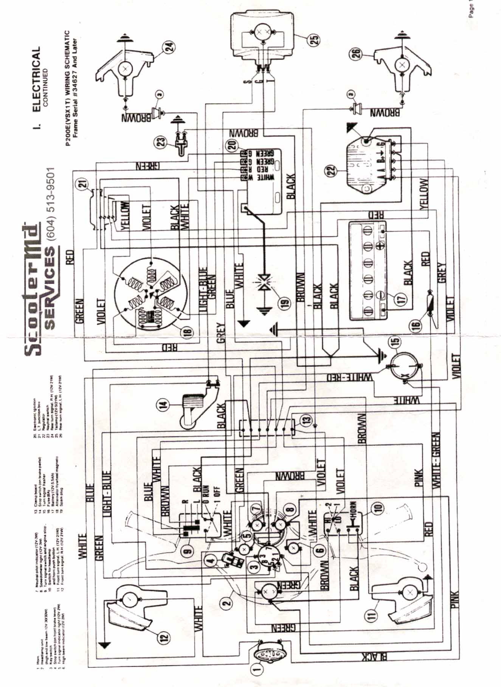
Spark Plugs

The spark plug is a very important component in your engine. The spark plug ignites the fuel mixture inside the cylinder by passing a huge voltage, approximately 40,000-100,000V (40kV-100kV), over an air gap. This air gap exists between the electrode (anode) and the ground (a piece of metal directly below the anode). An 'air gap' is like an open switch. The only time any current may cross the gap is when the potential on the anode gets high enough to jump to the ground. When this occurs, a visible spark can be seen as the resistance of the air is broken down and a split-second short circuit occurs. If this spark cannot occur, your gas will not be able to ignite and your engine will falter. The spark plug's job is not only to ignite the gas, but also to serve as a meter for your engine's overall health. Too black, you may be running rich, which will affect the ability for your engine to fully burn gas; too white, there is a chance that your engine is overheating. The plug should be a nice "chocolate brown" colour, and there should be a sharp, blue-white spark centered in the air gap. What follows is a guide to selecting, cleaning and monitoring spark plugs.
Plug Wear Patterns

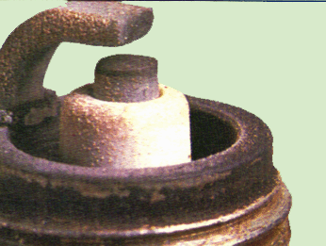 |  | This is what a good plug looks like. The anode should be square and the ceramic surrounding it should be light to chocolate brown. If your plug looks like this, your engine is probably pretty healthy and the timing is probably spot on.

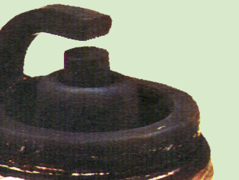 |  | This is an example of a fouled plug. Usually this condition is caused by a bad ignition system (misfiring), Too much fuel (a rich condition), or a plug that is too cold. Eventually this condition will prohibit the sparkplug conducting spark and the engine will get dirty from left over deposits. If you are having troubles with black, foul plugs, you probably need less fuel and more air being introduced into the engine. You may need to reduce the size of the main jet to allow less gas into the carburettor's air stream. Typically you would only change to a leaner jet for altitude changes. For a stock motor, you shouldn't have to mess with plug temperature values. a B8ES plug will take the most abuse of any of them.

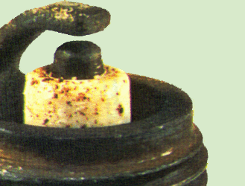 |  | Here is a plug that has severely overheated. Blistering of the ceramic insulator and the rounding of the conductor surface indicates severe wear and high temperature melting. This is a very bad condition. If your plug looks like this, there is a good chance your engine is going to melt down. Adjust your carb to let more fuel mixture into the chamber, run a colder plug and check any performance components are matched to your engine configuration. Often performance exhausts and cylinder kits will vestly change the gas requirements of your engine. You will have to re-jet your carburettor to allow more gas and oil into the engine.
Resistor Plugs versus Normal Plugs

There has been a great debate over the use of resistor plugs in Vespa scoots. Generally, they are not a good idea since the NGK spark plug cap fitted in most p200s is already resistive, and the ignition on Vespas is pretty underpowered when compared to modern motorcycles. Let's have a look at the theory behind a resistor spark plug.
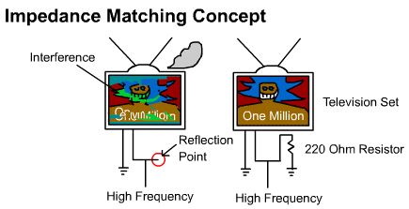

The reason to use a resistor spark plug is mainly to reduce radio interference into the environment and to protect the High Voltage electronics from the damaging side effects of reflections of a high frequency, high-power situation. The most common place we observe the effects of line reflections is in every day cable TV splitters. If we have a television set connected to one side, and an unused split connection on the other (open-circuit), under worst case circumstances, the television set will display a garbled picture. The reason for this is analagous to throwing rock in a perfectly still pond. When the rock hits the water, waves ripple in a spherical pattern; throw another rock in the pond and you will get overlapping waves. In an electronics sense, you have ruined the information being sent and risk sending a more powerful wave back to the transmitter and other receivers in the chain. This phenomenon is called an impedance mismatch. If a resistance, 220 ohms in the case of televisions, is inserted in parallel to all the other circuits, it will channel all the unused energy at a split into useful work instead of wasting power in the environment. Thus, the resistor will prevent the picture from degrading.
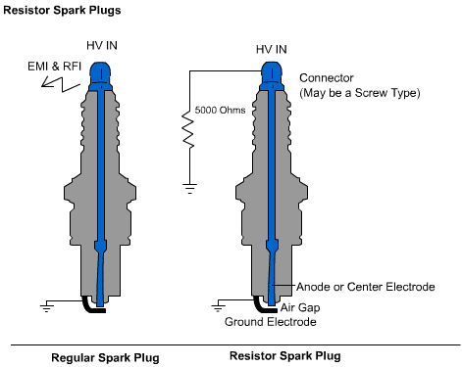

In our previous example, we were shown the effect of reflections on a television, now we look at the spark plug. Using a normal spark plug without a parallel resistance, we render all personal communications equipment useless. The reflections from the spark plug produce unwanted harmonics that interfere with any radio equipment you may have. Okay so what do we do? The magic number is 5000 ohms (or 5k) as 5k ohms is roughly matched to the characteristic impedance of the ignition transformer. If we put a 5kohms resistor inside the spark plug or the plug cap, the resistance will balance the transmission circuit and provide maximum energy to the spark plug's anode. Since there will be much less unused energy, the circuit will release much less electromagnetic and radio radiation. The end result is that we get a more efficient spark and less radio interference. The problem with the integration of a resistor is that it is designed for newer ignition transformers. The P200's ignition system's characteristic impedance may not be as high as 5kohms so the resistor may not balance the circuit like it should, which makes the system less efficient. Some find that their bike will just die once enough carbon collects on the center electrode. NGK even warns people on their site about the complications associated with older ignition systems, but so far I haven't experienced any igniton problems due to failure of a resistive plug.
Selecting a Spark Plug

Whew, an easy topic. Buy a B8ES. Done. No? Wait. So you're in a pinch and you need a spark plug. There's a B8HS and a B8ES R and a B8EGV and etc. Maybe one of these will do? Careful now, lets not do anything rash. What's the difference here? Okay, I see a problem developing here and it comes up again and again. Here's a table for what to buy. This table is for stock bikes.
B9HS, B8HS, B7HS, B6HS - These are short ended spark plugs and will not work with a P200, so ignore them.
B9EGV, B8EGV, B7EGV, B9EGV - These plugs have a tiny center conductor in them and may not always be made of copper. I have had no experience with these plugs, but from NGK's site, they appear to be for high end motorcyles, not Vespas.
B9ES - This plug may cause erratic running at city speeds, and will foul easily because it runs so cold. if you are running 'lean' because of your carb, this plug may be a temporary fix.
B8ES - Utopia. this plug is perfect for slow city riding and runs fairly cold for highway rides.
B7ES - A bit hotter than the B8ES. This plug is reccomended for quick city rides because it will not foul easily. If you're going on the highway go a little colder.
B6ES - This plug runs 'hot' this plug should only be used for special circumstances where the engine may not be getting to full temperature or the carhb is running rich (too much oil/gas mix).
'R' - R means resistor plug, there is a 5K resitor in parallel with the spark plug electrically to provide less EMI (Electromagnetic Interference) and RFI (Radio Frequency Interference). See my lengthy discussion of the pro's and cons of this plug above. These plugs aren't a bad idea because they generally make the system work better.
Battery Service

The battery on a P200 is used for various safety features including the horn, the brake and tail lights and the turn signals. Therefore, it is important to keep the battery in good condition. Your maintenance schedule should include battery service every few months.
Tools & Parts Needed
Thin Pipe Cleaner
Wire Brush
A Drinking Straw (Unused and clean)
Distilled Drinking Water
Needlenose Pliers
Screwdriver or nut driver set
WD-40, Carb Cleaner, Compressed Air
Rubber Gloves and Glasses
Procedure

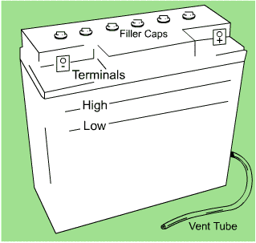 |  | To effect repairs on the battery, it is prudent to remove the battery from the bike. To get the battery off the bike, remove the spare tire and undo the GROUND (Negative Sign) terminal on the battery. By removing the ground first, you have disconnected your bike's frame so there shouldn't be any sparks. Remove the positive lead (Postitive Sign) and undo the rubber belt to free the battery. Pull the battery out SLOWLY, so the vent tube does not catch on the battery platform.
Now you have the battery in your hand take it to a clean space (the kitchen) and put the battery on top of a scrap of newspaper. If the terminals are corroded, take a wire brush and brush the heck out of them. Blow away all the filings and debris before continuing. Spray a generous amount of WD-40 onto a lint free cloth and wipe the terminals. This will seal the metal and won't affect the conductance. Now don the rubber gloves and goggles. Pull off the vent tube if possible. If you cant get the pipe off the battery, dont bother with cleaning it. To clean a removeable tube, spray carb cleaner through the hose for 1 second, then get the pipe cleaner and scrape all the crud from the inside of the tube. Spray carb cleaner on the outside of the pipe and towel it off. Re-attach the vent tube and get out the water and straw. Note the fill level in each cell of the battery; they should all be just below the "High" fill line. If they appear lower than this level on a flat surface, you should fill them up. To fill the cells, pull off the filler cap for that cell with a pair of pliers. Most filler caps pull straight out; however, some are threaded, so twist them in the direction marked first. To fill the tiny holes, use the drinking straw and your index finger to regulate the flow.
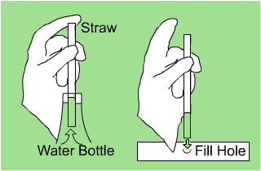
If your battery was severely discharged for some reason (signals not working, horn quiet or tail light not coming on when the key is turned), charge it up with a motorcycle battery charger and check the fuse in the bike while the spare tire is off. The fuse is held in a clip-on holder on the left hand side of the battery platform. If the fuse is blown, replace it before installing the battery. Do NOT let your stator attempt to recharge your battery! When batteries start to charge they draw a huge amount of current, this is not so hot for the fuse or the stator. Re-install the battery in the reverse order or removal making sure that the vent tube goes back in its home (lower right or left corner hole on the battery platform. If the rubber strap is rotting, order a new one. If the wires to the battery are corroded, clean them with that wire brush and WD40 method we talked about earlier, just do it GENTLY. If you need to replace a battery connector, get a similar one from an auto parts place. There ya go!

