KLR650 Kawasaki KLR500
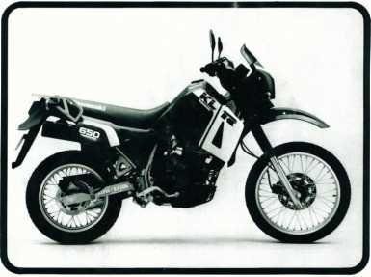
Motorcycle Service Manual Supplement

Quick Reference Guide
This quick reference guide will assist you in locating a desired topic or procedure.
- Bend the pages back to match the black tab of the desired chapter number with the black tab on the edge at each table of contents page.
- Refer to the sectional table of contents for the exact pages to locate the specific topic required.
General Information | 1
Fuel System
Engine Top End | 3|
Engine Right Side/Left Side | 1
Cooling System | = 1
Engine Removal/Installation | °l
Engine Bottom End/Transmission | 1
Wheels/Tires | »1
Final Drive | *1
Brakes | 10 I
Suspension/Steering | 111
Controls/Instruments | 121
Frame | 13|
Electrical System | 14 |
Appendix | 15|
Supplement - 2000 - 2001 Models | 16 |
Supplement - 2002 Model | ¹⁷l

-.-X
>, rt.-.- :^v?-: . .: -■ - ? .-• -v
V%.f
?<«
EMISSION CONTROL INFORMATION
au.uf
To protect the environment in which we all live, Kawasaki has incorporated crankcase
emission (1) and exhaust emission (2) control systems in compliance with applicable reg-
ulations of the United States Environmental Protection Agency and California Air Re-
sources Board. Additionally, Kawasaki has incorporated an evaporative emission control
system (3) in compliance with applicable regulations of the California Air Resources Board
on vehicles sold in California only.
- Crankcase Emission Control System
This system eliminates the release of crankcase vapors into the atmosphere. Instead,
the vapors are routed through an oil separator to the intake side of the engine. While
the engine is operating, the vapors are drawn into combustion chamber, where they are
burned along with the fuel and air supplied by the carburetion system.
- Exhaust Emission Control System
This system reduces the amount of pollutants discharged into the atmosphere by the exhaust of this motorcycle. The fuel and ignition systems of this motorcycle have been carefully designed and constructed to ensure an efficient engine with low exhaust pollutant levels.
- Evaporative Emission Control System
Vapors caused by fuel evaporation in the fuel system are not vented into the atmosphere. Instead, fuel vapors are routed into the running engine to be burned, or stored in a canister when the engine is stopped. Liquid fuel is caught by a vapor separator and returned to the fuel tank.
The Clean Air Act, which is the Federal law covering motor vehicle pollution, contains what is commonly referred to as the Act's "tampering provisions."
"Sec. 203(a) The following acts and the causing thereof are prohibited...
(3) (A) for any person to remove or render inoperative any device or element of design installed on or in a motor vehicle or motor vehicle engine in compliance with regulations under this title prior to its sale and delivery to the ultimate purchaser, or for any manufacturer or dealer knowingly to remove or render inoperative any such device or element of design after such sale and delivery to the ultimate purchaser.
(3)(B) for any person engaged in the business of repairing, servicing, selling, leasing, or trading motor vehicles or motor vehicle engines, or who operates a fleet of motor vehicles knowingly to remove or render inoperative any device or element of design installed on or in a motor vehicle or motor vehicle engine in compliance with regulations under this title following its sale and delivery to the ultimate purchaser..."
(Continued on next page.)

NOTE
o The phrase ",remove or render inoperative any device or element of design" has been
generally interpreted as follows:
- Tampering does not include the temporary removal or rendering inoperative of
devices or elements of design in order to perform maintenance.
- Tampering could include:
- Maladjustment of vehicle components such that the emission standards are
exceeded.
tp
- Use of replacement parts or accessories which adversely affect the performance
or durability of the motorcycle.
- Addition of components or accessories that result in the vehicle exceeding the
standards.
- Permanently removing, disconnecting, or rendering inoperative any component
or element of design of the emission control systems.
*
WE RECOMMEND THAT ALL DEALERS OBSERVE THESE PROVISIONS OF FEDERAL
LAW. THE VIOLATION OF WHICH IS PUNISHABLE BY CIVIL PENALTIES NOT
EXCEEDING $10,000 PER VIOLATION.
fco'o’sfc» c.isi- r. \ ;«*v. • t v# - 2s*r t - - xfx c-' :
Ce sAt j%
*. • v*:.: V- ,zc _ ^
ICS »¿-»Si .• A-t-- .-.-.u ;• •» • . 2s- ,Ji- . ■ . ,_A‘ ; ;
c ** •.
TAMPERING WITH NOISE CONTROL SYSTEM PROHIBITED
Federal law prohibits the following acts or the causing thereof: (1) The removal or rendering inoperative by any person other than for purposes of maintenance, repair, or replacement, of any device or element of design incorporated into any new vehicle for the purpose of noise control prior to its sale or delivery to the ultimate purchaser or while it is in use, or (2) the use of the vehicle after such device or element of design has been removed or rendered inoperative by any person.
Among those acts presumed to constitute tampering are the acts listed below:
- Replacement of the original exhaust system or muffler with a component not in compliance with Federal regulations.
- Removal of the muffler(s) or any internal portion of the muffler(s).
- Removal of the air box or air box cover.
- Modifications to the muffler(s) or air intake system by cutting, drilling, or other means if such modifications result in increased noise levels.

Ê)
WARNING
CONTAINS
ASBESTOS
Breathing asbostos dust is dangerous to health
Follow safety instructions
This warning may apply to any of the following components or any assembly containing one or more of these components:—
Brake Shoes or Pads Clutch Friction Material Gaskets Insulators
SAFETY INSTRUCTIONS
•Operate if possible out of doors or in a well ventilated place.
•Preferably use hand tools or low speed tools equipped, if necessary, with an appropriate dust extraction facility. If high speed tools are used, they should always be so equipped.
- If possible, dampen before cutting or drilling. •Dampen dust and place it in properly closed receptacle and dispose of it safely.

Foreword
This KLR650/500 Service Manual Supplement is designed to be used in conjunction with the KLR600 Service Manual (P/N 99924-1050- 01). The maintenance and repair procedures described in this Supplement are only those that are unique to the KLR650/500. Most service operations are identical to those for the KLR600. Complete and proper servicing of the KLR650/500 therefore requires both this Supplement and the base Service Manual.
This manual is designed primarily for use by trained mechanics in a properly equipped shop. However, it contains enough detail and basic information to make it useful to the owner who desires to perform his own basic maintenance and repair work. A basic knowledge of mechanics, the proper use of tools, and workshop procedures must be understood in order to carry out maintenance and repair satisfactorily. Whenever the owner has insufficient experience or doubts his ability to do the work, all adjustments, maintenance, and repair should be carried out only by qualified mechanics.
In order to perform the work efficiently and to avoid costly mistakes, read the text, thoroughly familiarize yourself with the procedures before starting work, and then do the work carefully in a clean area. Whenever special tools or equipment are specified, do not use makeshift tools or equipment. Precision measurements can only be made if the proper instruments are used, and the use of substitute tools may adversely affect safe operation.
For the duration of your warranty period, especially, we recommend that all repairs and scheduled maintenance be performed in accordance with this service manual. Any owner maintenance or repair procedure not performed in accordance with this manual may void the warranty.
To get the longest life out of your Motorcycle:
- Follow the Periodic Maintenance Chart in the Service Manual.
- Be alert for problems and non-scheduled maintenance.
- Use proper tools and genuine Kawasaki Motorcycle parts. Special tools, gauges, and testers that are necessary when servicing Kawasaki motorcycles are introduced by the Special Tool Manual. Genuine parts provided as spare parts are listed in the Parts Catalog.
- Follow the procedures in this manual carefully. Don't take shortcuts.
- Remember to keep complete records of maintenance and repair with dates and any new parts installed.
How to Use this Manual
In preparing this manual, we divided the product into its major systems. These systems became the manual's chapters. All information for a particular system from adjustment through disassembly and inspection is located in a single chapter.
The Quick Reference Guide shows you all of the product's systems and assists in locating their chapters. Each chapter in turn has its own comprehensive Table of Contents.
The Periodic Maintenance Chart is located in the General Information chapter. The chart gives a time schedule for required maintenance operations.
If you want spark plug information, for example, go to the Periodic Maintenance Chart first. The chart tells you how frequently to clean and gap the plug. Next, use the Quick Reference Guide to locate the Electrical System chapter. Then, use the Table of Contents on the first page of the chapter to find the Spark Plug section.
Whenever you see these WARNING and CAUTION symbols, heed their instructions! Always follow safe operating and maintenance practices.
WARNING |
oThis warning symbol identifies special instructions or procedures which, if not correctly followed, could result in personal injury, or loss of life.
CAUTION
oThis caution symbol identifies special instructions or procedures which, if not strictly observed, could result in damage to or destruction of equipment.

This manual contains five more symbols (in addition to WARNING and CAUTION) which will help you distinguish different types of information.
NOTE
c This note symbol indicates points of particular interest for more efficient and convenient operation.
- Indicates a procedural step or work to be done, olndicates a procedural sub-step or how to do
the work of the procedural step it follows. It also precedes the text of a WARNING, CAUTION, or NOTE.
- Indicates a conditional step or what action to take based on the results of the test or inspection in the procedural step or sub-step it follows.
«Indicates a conditional sub-step or what action to take based upon the results of the conditional step it follows.
In most chapters an exploded view illustration of the system components follows the Table of Contents. In these illustrations you will find the instructions indicating which parts require specified tightening torque, oil, grease or a locking agent during assembly.

GENERAL INFORMATION 1-1

General Information

Table of Contents
Before Servicing
Model Identification 1-2
Specifications 1-3
Periodic Maintenance Chart 1-6
Torque and Locking Agent 1-7
Cable, Wire, and Hose Routing 1-10
‘Refer to Base Manual

1-2 GENERAL INFORMATION
Model Identification
KL650-A1:
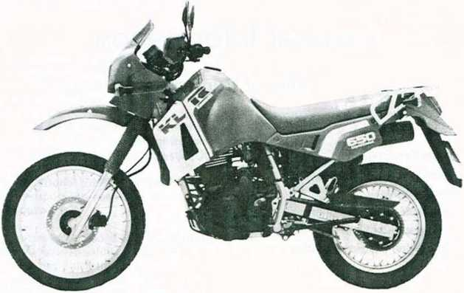
KL500-A1 :
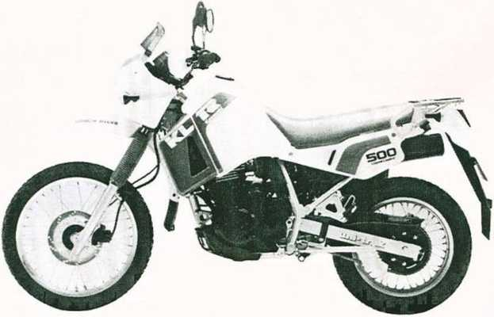

GENERAL
INFORMATION 1-3
Specifications
Items | KL 650-A1. A2,A3.A4,A5,A6,A7,A8,A9 | KL500-A1, A2
Dimensions:
Overall length | 2 290 mm, ©©© 2 205 mm,
 | ® (gy) (D © <§£>©(§5) 2 250 mm | *
Overall width | 940 mm | *
Overall height | 1 345 mm | *
Wheelbase | 1 495 mm | *
Road clearance | 240 mm | ■*
Seat height | 890 mm | *
Dry weight | 153 kg, © 153.5 kg | *
Curb weight: Front | 81 kg, (§) 81.5 kg | *
Rear | 97 kg | *
Fuel tank capacity | 23 L | *
Performance:
Climbing ability | O  CM  CO | #
Braking distance | 12.5 m from 50 km/h | #
Minimum turning radius | 2.4 m | *
Engine:
Type | 4-stroke, DOHC, 4-valve, 1-cylinder | *
Cooling system | Liquid cooled | ■*
Bore and stroke | 100.0 x 83.0 mm | 89.0 x 80.0 mm
Displacement | 651 mL | 497 mL
Compression ratio | 9.5 : 1 | *
Maximum horsepower | 35.3 kW (48 PS) @6500 r/min (rpm) | 29.4 kW (40 PS)
 | © 34.2 kW (46.5 PS) @6500 r/min (rpmhUTAC's norms © 19.9 kW (27 PS) @5800 r/min (rpm):DIN © -A3 19.9 kW (27 PS) @5500 r/min (rpm): DIN ® -A3 32.4 kW (44 PS) @6500 r/min (rpm) | @7 500 r/min (rpm)
Maximum torque | 54.9 N-m (5.6 kg-m, 40.5 ft-lb) @5500 r/min (rpm) | 38.2 N-m (3.9 kg-m.
Maximum torque | © 45.1 N-m (4.6 kg-m, 33.3 ft-lb) @2500 r/min (rpm): DIN | 28.2 ft-lb) @6 000
 | © -A3 48 N-m (4.9 kg-m, 35 ft-lb) @2300 r/min Irpm): DIN  @ -A3 49 N-m (5.0 kg-m, 36 ft-lb) @5000 r/min (rpm) | r/min (rpm)
Carburetion system | Carburetor, Keihin CVK40 | *
Starting system | Electric | *
Ignition system | CDI | »
Timing advance | Electronically advanced | *
Ignition timing | From 10° BTDC @1 300 r/min (rpm) to
 | 30° BTDC @3 300 r/min (rpm)
Spark Plug | NGK DPR8EA-9 or ND X24EPR-U9 | #
 | ®(D©© NGK DP8EA-9, orND X24EP-U9 | *

1-4 GENERAL INFORMATION
Items | KL 650-A1 ,A2,A3,A4,A5,A6,A7,A8,A9 | KL500-A1, A2
Valve timing:
Inlet Open | 19° (BTDC) | *
Close | 69° (ABDC) | *
Duration | 268° | *
Exhaust Open | 57° (BBDC) | *
Close | 31° (ATDC) | *
Duration | 268° | *
Lubrication system | Forced lubrication (wet sump) | ■*
Engine oil:
Grade | SE or SF class | *
Viscosity | SAE10W40, 10W50, 20W40, or20W50 | *
Capacity | 2.5 L | *
Drive Train:
Primary reduction system:
Type | Gear | *
Reduction ratio | 2.272 (75/33) | #
Clutch type | Wet multi disc | *
T ransmission:
Type | 5-speed, constant mesh, return shift | *
Gear ratios: 1st | 2.266 (34/15) | *
2nd | 1.529 (26/17) | *
3rd | 1.181 (26/22) | *
4th | 0.954 (21/22) | *
5th | 0.791 (19/24) | *
Final drive system:
Type | Chain drive | *
Reduction ratio | 2.866 (43/15) | 3.133 (47/15)
Overall drive ratio | 5.157 @Top gear | 5.637 @Top gear
Frame:
Type | Tubular, semi-double cradle | *
Caster (rake angle) | O  00  CN | *
Trail | 112 mm | *
Front Tire:
Type | Tube type | *
Size | 90/90-21 54S | *
Rear Tire:
Type | Tube type
Size | 130/80-17 65S | *
Front suspension:
Type | Telescopic fork (pneumatic) | *
Wheel travel | 230 mm | #

GENERAL INFORMATION 1-5
Items | KL 650-A1 ,A2,A3,A4,A5.A6,A7,A8,A9 | KL500-A1, A2
Rear suspension:
Type | Swing arm (uni-trak) | *
Wheel travel | 230 mm | *
Brake type:
Front | Single disc | *
Rear | Single disc | *
Electrical Equipment:
Battery | 12V 14 Ah | *
Headlight:
Type | Semi-Sealed beam | *
Bulb | 12 V 60/55 W (quartz-halogen) | *
Tail/brake light | 12 V 5/21 W, ©©© 12 V 8/27 W | *
Alternator:
Type | Three-phase AC | *
Rated output | 14 A @8 000 r/min (rpm), 14 V | *
Voltage regulator:
Type | Short-circuit | *
Specifications subject to change without notice, and may not apply to every country.
- : Same as KL650-A1
Abbreviation
® : Australian Model |  | Italian Model
@) : Austrian Model | © | South African Model
© : U.K. Model |  | Spanish Model
© : Canadian Model | © | U.S. Model
@> : Californian Model |  | Greek Model
© : French Model © : West German Model

1-6 GENERAL INFORMATION
Periodic Maintenance Chart
The scheduled maintenance must be done in accordance with this chart to keep the motorcycle in good running cpndition. The initial maintenance is vitally important and must not be neglected.
FREQUENCY
OPERATION
Whichever
comes firstly
À
tODOMETER READING
Every
See
Page
Spark plug — clean
(14-9)
Spark plug — check ¹
(14-7)
Valve clearance — check*
(3-11)
Air cleaner element — clean
(2-7)
Air cleaner element — replace
5 cleanings
2-5
Throttle grip play — check *
12-5
Idle speed — check
(2-4)
Fuel system — check
(2-8)
Coolant — change
Spark arrestor — clean
(for © , © model)
2 years
(5-4)
Evaporative emission control system
— check (for © model)*
3-7
(2-10)
Engine oil — change
Year
4-7
Oil filter — replace
(4-13)
Radiator hoses, connections — check*
year
(5-8)
Fuel hoses, connections — check*
Fuel hose — replaci"
4 years
Balancer chain tension — adjust
(4-16)
Clutch — adjust
(4-8)
(9-4)
Drive chain wear — check
Drive chain — lubricate
300 km
(9-5)
Drive chain slack — check
800 km
9-3
Brake lining wear — check
(10-4)
T(TS77~
Brake fluid level — check*
month
Brake fluid — change
2 years
(10-4)
Brake hoses, connections — check*
Brake hose — replace
4 years
Master cylinder cup and dust seal
— replace
2 years
Caliper piston seal and dust seal
— replace
2 years
Brake light switch — check '
(10-11)
Steering — check
(11-6)
Steering stem bearing — lubricate
2 years
(11-7)
Front fork oil — change
11-6
Tire wear — check
(8-5)
Spoke tightness and rim runout — check *
(8-6)
Swing arm pivot, uni-trak linkage — lubricate
(11-14)
Battery electrolyte level — check
month
(14-4)
General lubrication — perform
15-2
Nut, bolt, and fastener tightness
— check *
!_U
15-2
t : For higher odometer readings, repeat at the frequency interval established here. * : Replace, add, adjust, clean, or torque if necessary.
®: Californian Model © : U.S. Model © : Canadian Model (Page)
See Base Manual

GENERAL INFORMATION 1-7
Torque and Locking Agent
The following tables list the tightening torque for the major fasteners, and the parts requiring use of a non-permanent locking agent or liquid gasket.
Letters used in the "Remarks" column mean:
L : Apply a non-permanent locking agent to the threads.
LG : Apply liquid gasket to the threads.
LS : Apply liquid gasket (silicone sealant) to the threads.
M : Apply a molybdenum disulfide lubricant (grease or oil) to the threads and seated surface, or
washer.
S : Tighten the fasteners following the specified sequence.
Fastener | Torque |  |  | Remarks
Fastener | N-m | kg-m | ft-lb | Remarks
Engine Top End:
Cylinder head cover bolts | 7.8 | 0.80 | 69 in-lb
Camshaft cap bolts | 12 | 1.2 | 104 in-lb
Camshaft sprocket bolts | 49 | 5.0 | 36 | L
Oil pipe banjo bolts | 20 | 2.0 | 14.5
Cylinder head bolts: 10 mm | 65 | 6.6 | 48 | M, S
8 mm | 18 | 1.8 | 13.0 | S
6 mm | 9.8 | 1.0 | 87 in-lb | s
Cylinder head nuts | 25 | 2.5 | 18.0 | s
Cylinder bolt | 9.8 | 1.0 | 87 in-lb | s
Cylinder nuts | 25 | 2.5 | 18.0 | s
Engine Right Side/Left Side:
Cover damper mounting bolts | 9.8 | 1.0 | 87 in-lb | L
Clutch spring bolts | 9.8 | 1.0 | 87 in-lb
Clutch hub nut | 130 | 13.5 | 98
Primary gear nut | 120 | 12.0 | 87
Oil pressure relief valve | 15 | 1.5 | 11.0 | L
Balancer shaft (front) right end nut | 44 | 4.5 | 33
Balancer chain guide (inner) bolts
8 mm | 25 | 2.5 | 18.0 | L
6 mm | 12 | 1.2 | 104 in-lb | L
Shift return spring pin | - | - | - | L
Engine drain plug | 23 | 2.3 | 16.5
Oil pipe banjo bolts | 20 | 2.0 | 14.5
Cooling System:
Radiator fan switch | 7.4 | 0.75 | 65 in-lb
Water temperature sender | 15 | 1.5 | 11.0 | LS
Impeller nut | 9.8 | 1.0 | 87 in-lb | .

1-8 GENERAL INFORMATION
Fastener |  | Torque |  | Remarks
Fastener | N-m | kg-m | ft-lb | Remarks
Engine Removal/Installation:  Engine mounting bolts and nuts  10 mm | 44 | 4.5 | 33 | S
8 mm | 25 | 2.5 | 18.0 | S
Engine mounting bracket bolts and nuts (8 mm) | 25 | 2.5 | 18.0
Swing arm pivot bolt and nut  (14 mm) | 98 | 10.0 | 72 | S
Engine Bottom End/Transmission:  Crankshaft bearing retainer screws |  |  |  | L
Shift drum pin plate bolt | 12 | 1.2 | 104 in-lb | L
Wheels/Tires:  Front axle nut | 78 | 8.0 | 58
Rear axle nut | 93 | 9.5 | 69
Spoke nipples | 2.0-3.9 | 0.2 - 0.4 | 17-35 in-lb
Final Drive:  Engine sprocket bolts | 9.8 | 1.0 | 87 in-lb
Rear sprocket studs | - | - | - | L
Rear sprocket nuts | 32 | 3.3 | 24
Brakes:  Front master cylinder clamp bolts | 8.8 | 0.90 | 78 in-lb
Rear master cylinder mounting bolts | 23 | 2.3 | 16.5
Caliper mounting bolts | 25 | 2.5 | 18.0
Disc mounting bolts | 23 | 2.3 | 16.5
Brake hose banjo bolts | 25 | 2.5 | 18.0
Air bleed valves | 7.8 | 0.80 | 69 in-lb
Brake lever pivot nut | 5.9 | 0.60 | 52 in-lb
Suspension/Steering:  Front fork clamp bolts and nuts | 25 | 2.5 | 18.0
Air valves | 12 | 1.2 | 104 in-lb | L
Fork top bolts | 29 | 3.0 | 22
Fork bottom Allen bolts | 39 | 4.0 | 29 | L
Fork drain screws | - | - | - | LG
Rear shock absorber mounting bolts and nuts: Upper (12 mm) | 59 | 6.0 | 43
Lower (14 mm) | 98 | 10.0 | 72
Swing arm pivot bolt and nut (14 mm) | 98 | 10.0 | 72
Rocker arm pivot bolt and nut (14 mm) | 98 | 10.0 | 72
Tie-rod bolts and nuts (14 mm) | 98 | 10.0 | 72
Steering stem head nut | 39 | 4.0 | 29

GENERAL INFORMATION 1-9
Fastener |  | Torque |  | Remarks
Fastener | N-m | kg-m | ft-lb | Remarks
Controls/I nstruments:
Handlebar clamp bolts | 24 | 2.4 | 17.5
Frame:
Rear frame mounting bolts | 25 | 2.5 | 18.0
Electrical System:
Spark plug | 14 | 1.4 | 10.0
Magneto flywheel bolt | 175 | 18.0 | 130
Starter motor mounting bolts | 9.8 | 1.0 | 87 in-lb
Starter clutch bolts | 34 | 3.5 | 25 | L
The table below, relating tightening torque to thread diameter, lists the basic torque for the bolts and nuts. Use this table for only the bolts and nuts which do not require a specific torque value. All of the values are for use with dry solvent-cleaned threads.
General Fasteners:
Threads dia. (mm) | Torque
Threads dia. (mm) | N-m | kg-m | ft-lb
5 | 3.4 -4.9 | 0.35 - 0.50 | 30 - 43 in-lb
6 | 5.9 - 7.8 | 0.60 - 0.80 | 52 - 69 in-lb
8 | 14 - 19 | 1.4 - 1.9 | 10.0-13.5
10 | 25-34 | 2.6 - 3.5 | 19.0-25
12 | 44-61 | 4.5-6.2 | 33-45
14 | 73-98 | 7.4 - 10.0 | 54-72
16 | 115-155 | 11.5-16.0 | 83-115
18 | 165 - 225 | 17.0-23 | 125- 165
20 | 225 - 325 | 23-33 | 165-240

MO GENERAL INFORMATION
Cable, Wire, and Hose Routing
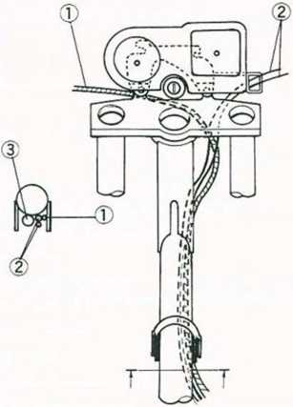
Control Cables
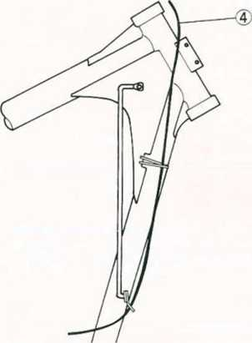
- Choke Cable
- Throttle Cable
- Main Harness
- Clutch Cable
- To Meter Bracket
- To Headlight
- To Turn Signal Light
- To City Light
Electrical Wires
- Ground Lead
- To Diode Assembly
- To Turn Signal Relay
- To Horn
- ToCDI Unit
- To Water Tempera
ture Sender
- To Ignition Coil
- To Magneto
- To Neutral Switch
and Pickup Coil
- To Radiator Fan
Relay
- To Radiator Fan
- To Radiator Fan
Switch
- Harness Position
Mark
- To Starter Relay
- To Starter Circuit
Relay
- To Side Stand Switch
- To Rear Brake Light
Switch
- To Fuses
- To Battery
To Regulator/
Rectifier 29. To Rear Harness
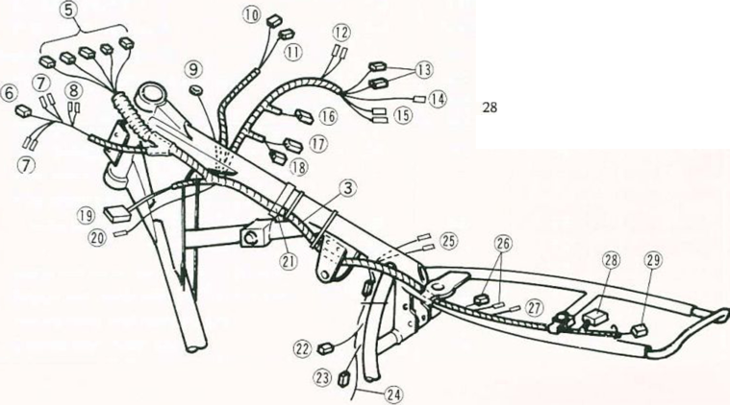
GENERAL INFORMATION 1-11
Electrical Wires
1.
2.
3.
4.
5.
6.
7.
8.
9.
10.
11.
12.
LH Switch Leads RH Switch Leads Starter Lockout Switch Leads RH Switch 6P Connector (Red) Meter 9P Connector Ignition Switch 6P Connector (Black) LH Switch 9P Connector (Red) Starter Lockout Switch 3P Connector Meter Bracket Main Harness To Turn Signal Light To City Light
13. | To Headlight
14. | Headlight Bracket
15. | Ground Lead
16. | Frame Top Tube
17. | To Neutral Switch
 | and Pickup Coil
18. | Main Harness
19. | To Water Tempera
 | ture Sender
20. | Ignition Coil
21. | Spark Plug Cap
22. | Horn
23. | Radiator Fan
 | Connector
24. | Turn Signal Relay
25. | Radiator Fan Relay
26. | CDI Unit 2P
 | Connector
27. Neutral Switch and Pickup Coil 3P
 | Connector
28. | Magneto 6P
 | Connector
29. | CDI Unit 6P
 | Connector
30. | CDI Unit
31. | Diode Assembly
Viewed from C
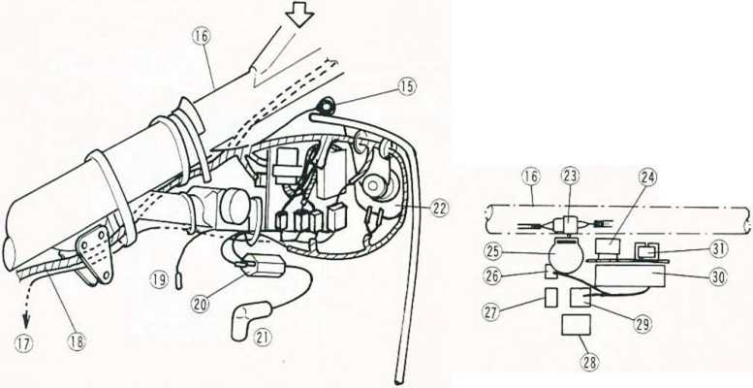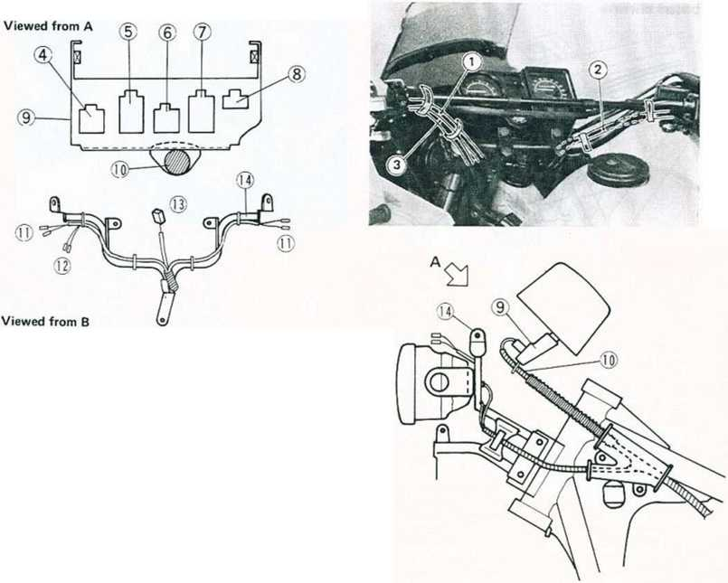
1-12 GENERAL INFORMATION Electrical Wires
- Main Harness
- Rear Brake Light
Switch Leads
- Rear Brake Light
Switch
- Magneto Leads
- Neutral Switch and
Pickup Coil Leads
- To Fuses
- To Battery
- Battery (+) Lead
- To Regulator/
Rectifier
- To Rear Harness
- Starter Relay
- Ground Lead
- Starter Motor Lead
- Starter Circuit Relay
- Side Stand Switch
- Battery (—) Lead
- Turn Signal Light
Leads
- Tail/Brake Light
Leads
- Rear Harness
- License Plate Light
Leads
- Ground Lead
- Radiator Fan Leads
- Radiator Fan Switch
Lead
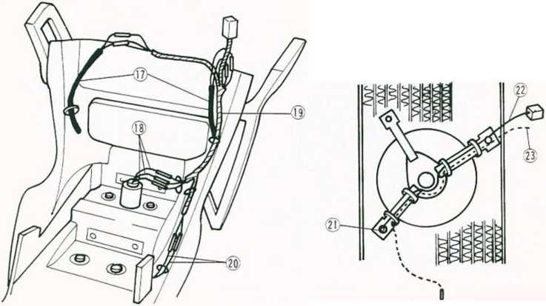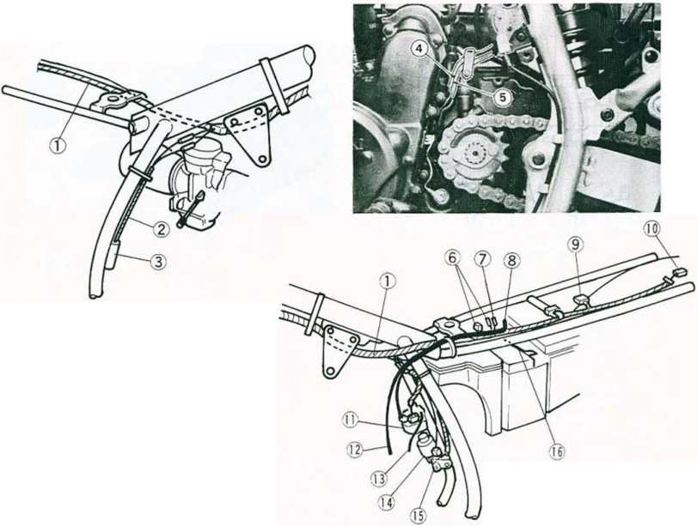
GENERAL INFORMATION 1-13
Fuel Hoses and Battery Vent Hose
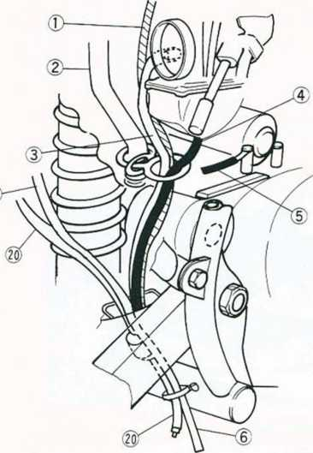
Vacuum Hoses and Breather Hoses (Californian Model)
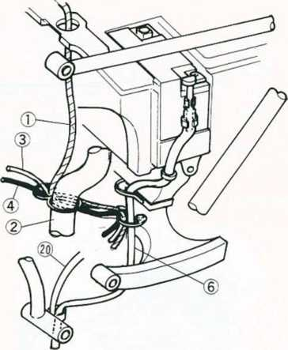
1. | Fuel Tank Breather | 11. Purge Hose (Green)
 | Hose | 12. To Carburetor
2. | Crankcase Breather | 13. To Fuel Tap
 | Hose | 14. Vacuum Hose (White)
3. | Carburetor Air Vent | 15. Liquld/Vapor
 | Hose | Separator
4. | Carburetor Overflow | 16. Breather Hose (Blue)
 | Hose | 17. Hose
5. | Ground Lead | 18. Canister
6. | Battery Vent Hose | 19. To Canister
7. | Breather Hose (Blue) | 20. Air Cleaner
8. | To Fuel Tank | Drain Hose (A3 ~)
9. | Fuel Return Hose (Red) | Drain Hose (A3 ~)
10. | Air Cleaner
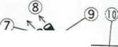
FUEL SYSTEM 2-1

Fuel System

Table of Contents
Exploded View 2-2
Service Data 2-4
Special Tool
Fuel Tank 2-5
Removal Point 2-5
Carburetor 2-5
Adjustment 2-5
Idle Inspection
Idle Adjustment
High Altitude Performance Adjustment (U.S model) 2-5
Maintenance
Service Fuel Level Inspection
Service Fuel Level Adjustment
Carburetor Disassembly 2-5
Disassembly Points
Assembly Points
Carburetor Installation 2-5
Adjustment After Installation 2-5
Air Cleaner 2-5
Element Removal
Inspection and Cleaning
Element Installation Points 2-5
Body Removal
Body Installation Point 2-6
Fuel System Cleanliness 2-6
Inspection *
Cleaning
Fuel Tank and Cap Inspection 2-6
Evaporative Emission Control System (Californian Model)
Periodic Inspection
Canister Inspection
Liquid/Vapor Separator Inspection
Separator Test
Fuel Tank Inspection
‘Refer to Base Manual

2-2 FUEL SYSTEM
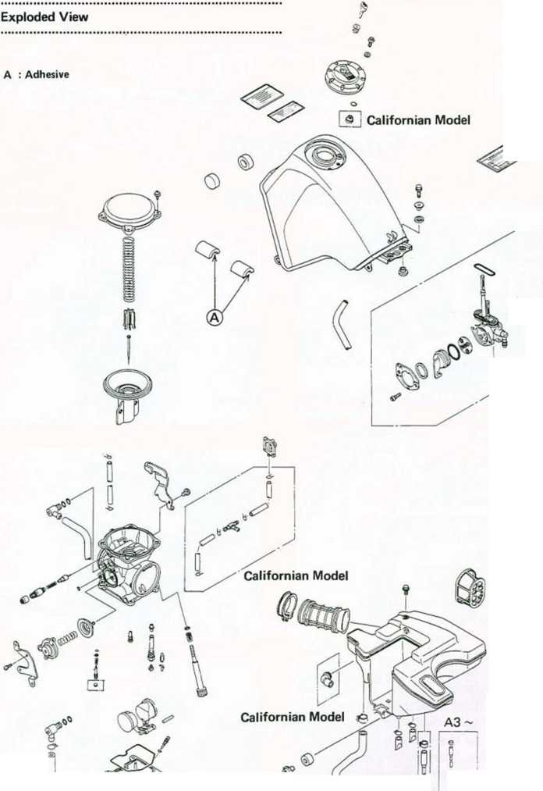
FUEL SYSTEM 2-3
Californian Model
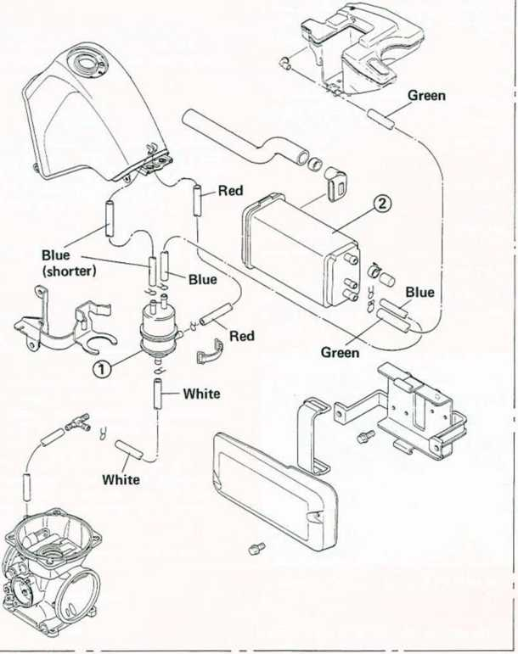
- Liquid/Vapor Separator
- Canister

2-4 FUEL SYSTEM
Specifications
Item | KL500-A1, A2 | KL650-A1, A2 | KL650-A3 ~
Carburetor:
Idle speed | 1300 ±100 r/min (rpm) | <— | <—
Standard specifications:
Make, type | Keihin, CVK40 | <— | <—
Main jet | #148 | #150, © #148, | #145,
Main air jet | #50 | ® *155 | @® #148
Needle jet | #6 | <—, ® #7 | #6
Jet needle | N31W | N31T, © N31R, | N74C, © N31R,
Pilot jet | #40 | ® N60B | ® N60N
Pilot air jet | #80 | #70 | <—
Pilot screw | 1³A turns out | 1³/s turns out, | 17. turns out.
Starter jet | #52 | © - ©® 1V₂ | © -, ® 17<
Service fuel level | —0.5 ±1 mm | <— | <—
Float height | 17.5 mm | <— | <—
Height altitude adjustment (US model):
Main jet |  | #145 | <—
Pilot jet |  | #38 | «—
Air Cleaner:
Element oil: Grade | SE class | <— | <—
Viscosity | SAE30 | <— | <—
© : West German Model © : U.S. Model ®: Swiss Model

FUEL SYSTEM 2-5
Fuel Tank
Removal Point
•Before removing the fuel tank or disconnecting the fuel hose from the fuel tap, turn the fuel tap lever to the OFF position to prevent fuel leaking out while the tank is removed or the hose is disconnected.
- WARNING |
OGasoline is extremely flammable and can be explosive under certain conditions. Turn the ignition switch OFF. Do not smoke. Make sure the area is well ventilated and free from any source of flame or sparks; this includes any appliance with a pilot light.
Carburetor
Adjustment:
High Altitude Performance Adjustment (US model)
To improve the Emission Control Performance of vehicle operated above 4 000 feet (1 219 meters), Kawasaki recommends the following Environmental protection Agency (EPA) approved modification.
NOTE
oWhen properly performed, these specified adjustments are not considered to be emission control system "tampering" and vehicle performance is generally unchanged as a result.
•High altitude adjustments require replacement of certain carburetor jets.
High Altitude Carburetor Specifications Main Jet: #145
Pilot Jet: #38
•After high altitude adjustments are performed, provide the customer with the Vehicle Emission Control Information Update Label and label installation instructions (P/N 99969-0614).
•Advise the customer that by law, the Vehicle Emission Control Information Update Label must be affixed to any vehicle modified with the high altitude adjustments.
NOTE
oIf a vehicle with the high altitude adjustments is used below 4 000 feet (1 219 meters), the update label must be removed and the original carburetor parts must be reinstalled.
Carburetor Disassembly:
Carburetor Installation
Refer to the Base Manual, noting the following. •Refer to Cable, Wire, and Hose Routing in the chapter 1 for the carburetor overflow tube and air vent tube routing.
Adjustment after Installation •Adjust the following.
Throttle Grip Choke Lever Idle Speed
Air Cleaner
Element Removal •Remove the right side cover.
•Remove the screws and take off the air cleaner element cap.
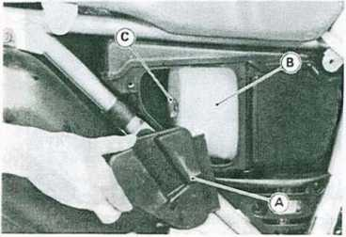
- Element Cap C. Wing Head Bolt
- Element
•Remove the wing head bolt and take off the air cleaner element.
•Push a clean, lint-free towel into the air cleaner housing to keep dirt or other foreign material from entering.
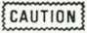
Olf dirt gets through into the engine, excessive engine wear and possibly engine damage will occur.
Element Installation Points
•Coat the element lip with a layer of all purpose grease to assure a complete seal against the cleaner case.
•Be sure the foam gasket Is in place In the groove in the element cap.

2-6 FUEL SYSTEM
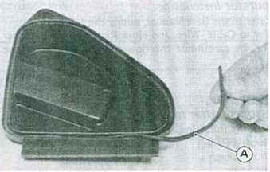
A. Foam Gasket
Body Installation Point
•If the air cleaner body drain tubes were removed,
install them in place on the bottom of the housing.
The longer drain tube including the air filter must be A. Air Vent Holes installed the rear side fitting (dirty side fitting).
CAUTION
ODo not apply compressed air to the air vent holes on
the tank cap. This could cause damage and clogging of
the labyrinth in the cap.
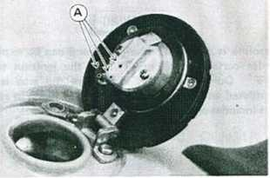
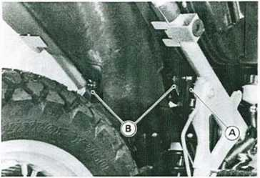
A. Long Drain Tube B. Short Drain Tubes
Fuel System Cleanliness
Fuel Tank and Cap Inspection
•Visually inspect the gasket on the tank cap for any damage.
♦Replace the gasket if it is damaged.
•Remove the hose(s) from the fuel tank, and open the tank cap.
•Check to see if the breather and water drain pipes (also the fuel return pipe for the US California vehicle) in the tank are not clogged. Check the tank cap breather too.
*lf the tank pipes are clogged, remove the tank and drain it and then blow the pipes free with compressed air.
*lf the tank cap breather is clogged, replace it.

ENGINE TOP END 3-1

Engine Top End

Table of Contents
Exploded View 3-2
Service Data 3-4
Special Tools
Camshaft Chain Tensioner 3-6
Removal
Installation 3-6
Cylinder Head Cover
Adjustment before Head
Cover Installation
Installation Points
Camshaft Chain Guides,
Camshaft Chain, Camshafts
Camshaft Removal Point
Chain Guide Installation Point
Camshaft Installation Points
Assembly Points of Camshafts and
Sprockets
Disassembly Point of
Camshaft Sprocket Bolt
Camshaft Oil Clearance Inspection
Camshaft Chain, Balancer Chain Wear . . .
KAWASAKI Automatic
Compression Release
Oil Pipes 3-
Oil Pipe Installation Points 3-
Valves
Valve Clearance Adjustment
Inspection
Adjustment
Measuring Valve Installed Height
Valve Maintenance
Valve Seat Inspection
Valve Seat Repair
Measuring Valve-to-Guide
Clearance (Wobble Method)
Cylinder Head 3*6
Compression Measurement
Removal Point of Cylinder Head
Installation Points of Cylinder Head .... 3-6
Adjustment and Operation after
Installation
Disassembly Points of Cylinder Head. ...
Cylinder Head Warp
Cylinder, Piston 3-7
Removal Point of Piston
Installation Points of Piston Rings 3-7
Installation Points of Cylinder Block. ...
Piston Ring End Gap
Cylinder Inside Diameter
Piston Diameter
Boring, Honing *
Muffler 3-7
Installation Points
Spark Arrester Cleaning (U.S. model) . . . 3-7
'Refer to Base Manual

3-2 ENGINE TOP END
Exploded View
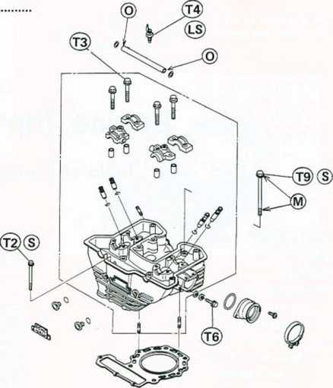
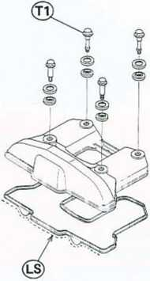
L : IMon-permanent Locking Agent LS: Liquid Gasket (Silicone Sealant)
M : Molybdenum Disulfide Grease O : Engine Oil
S : Follow the specific tightening sequence.
T1 : 7.8 N-m
T2: 9.8 N-m
T3: 12 N-m
T4: 15 N-m
T5: 18 N-m
T6: 20 N-m
T7: 25 N-m
T8: 49 N-m
T9: 65 N-m
(0.80 kg-m, 69 in-lb)
(1.0 kg-m, 87 in-lb)
<1.2 kg-m, 104 in-lb)
(1.5 kg-m, 11.0 ft-lb)
(1.8 kg-m, 13.0 ft-lb)
(2.0 kg-m, 14.5 ft-lb)
(2.5 kg-m, 18.0 ft-lb)
(5.0 kg-m, 36 ft-lb)
(6.6 kg-m, 48 ft-lb)
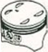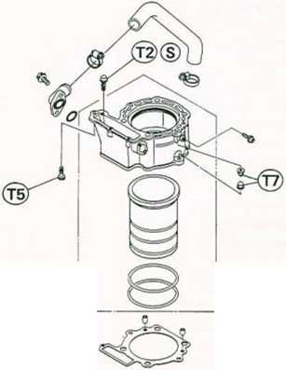
ENGINE TOP END 3-3
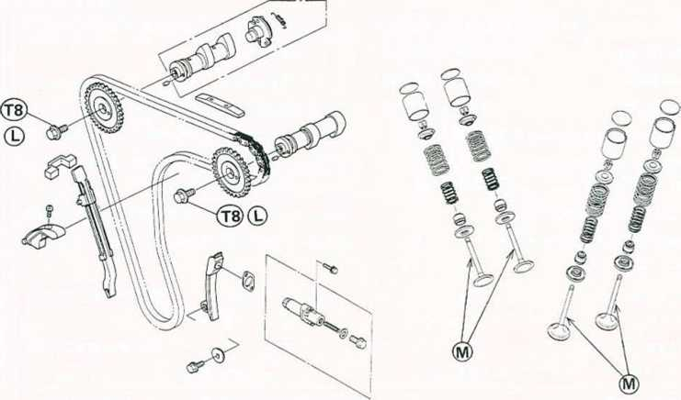
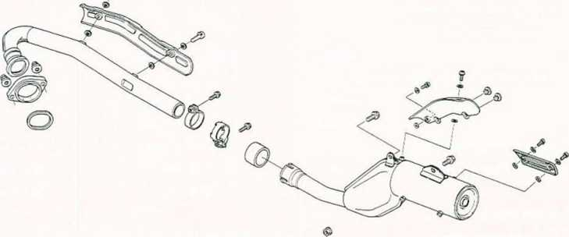

3-4 ENGINE TOP END
Service Data
Item |  | Standard | Service Limit
Camshafts, Chain:
Cam height: | Inlet | 36.75 — 36.85 mm | 36.65 mm
 | Exhaust | 36.25 — 36.35 mm | 36.15 mm
Camshaft bearing oil clearance |  | 0.030 — 0.064 mm | 0.15 mm
Camshaft journal diameter |  | 22.949 - 22.970 mm | 22.92 mm
Camshaft bearing inside diameter |  | 23.000-23.013 mm | 23.07 mm
Camshaft chain 20-link length |  | 127.0 - 127.4 mm | 128.9 mm
Balancer chain 20-link length |  | 190.5 — 190.9 mm | 193.4 mm
Valves:
Valve clearance: | Inlet | 0.10 — 0.20 mm
 | Exhaust | 0.15 — 0.25 mm
Valve head thickness: | Inlet | 1.0 mm | 0.5 mm
 | Exhaust | 1.0 mm | 0.7 mm
Valve stem bend |  | Less than 0.01 mm TI R | 0.05 mm TI R
Valve stem diameter: | Inlet | 6.965 — 6.980 mm | 6.95 mm
 | Exhaust | 6.955 — 6.970 mm | 6.94 mm
Valve guide inside diameter |  | 7.000 - 7.015 mm | 7.08 mm
Valve guide/valve clearance
(wobble method): | Inlet | 0.04 — 0.11 mm | 0.24 mm
 | Exhaust | 0.05 — 0.12 mm | 0.24 mm
Valve seating area outside diameter
 | Inlet | 36.9 — 37.1 mm
 | Exhaust | 31.9 — 32.1 mm
Valve seating area width |  | 0.8 — 1.2 mm
Valve spring free length: | Inner | 37.6 mm | 36.2 mm
 | Outer | 40.5 mm | 39.0 mm
Cylinder Head:
Cylinder compression |  | 530 - 855 kPa (5.4 - 8.7 kg/cm*, 77 - 124 psi)
Cylinder head warp |  |  | 0.05 mm

ENGINE TOP END 3-5
Item |  | Standard | Service Limit
Cylinder, Piston:
Cylinder inside diameter: | KL650 | 100.000- 100.012 mm | 100.10 mm
 | KL500 | 89.000-89.012 mm | 89.10 mm
Piston diameter: | KL650 | 99.942 - 99.957 mm | 99.80 mm
 | KL500 | 88.942 - 88.957 mm | 88.80 mm
Piston/cylinder clearance |  | 0.043 — 0.070 mm
Piston ring/groove clearance:
Top & 2nd |  | 0.02 — 0.05 mm | 0.16 mm
Piston ring groove width:
Top & 2nd |  | 1.21 - 1.22 mm | 1.31 mm
Oil |  | 2.81 — 2.83 mm | 2.91 mm
Piston ring thickness:
Top & 2nd |  | 1.17 - 1.19 mm | 1.10 mm
Piston ring end gap:
Top & 2nd |  | 0.2 — 0.4 mm | 0.7 mm

3-6 ENGINE TOP END
Camshaft Chain Tensioner
Head Oil Pipe
Installation
•Remove the cap bolt and take off the spring.
•Unlock the ratchet stopper and push the rod into the
tensioner body.
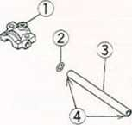
- Camshaft Cap
- O-ring
- Oil Pipe
- Apply engine oil.
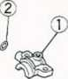
Cylinder Head
Installation Points of Cylinder Head
Refer to the Base Manual, noting the following.
- Ratchet Stopper B. Push Rod Cylinder Head Bolts and
Nuts Tightening Torque and Sequence
•Install the chain tensioner with the gasket so that the
arrow on it points downwards.
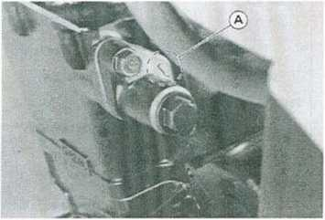
A. Arrow
•Install the spring and tighten the cap bolt with the gasket.
Oil Pipes
OH Pipe Installation Points
Refer to the Base Manual, noting the following. •Apply engine oil to both ends of the head oil pipe to prevent damage to the O-rings in the camshaft caps.
© — © : Cylinder Head Bolts (10 mm)
Torque them first to 20 N-m (2.0 kg-m,
- ft-lb) and then to 65 N-m (6.6 kg-m, 48 ft-lb) following the tightening sequence.
© - © : Cylinder Head Nuts
25 N-m (2.5 kg-m, 18.0 ft-lb)
© — © : Cylinder Nuts (Retighten)
25 N-m (2.5 kg-m, 18.0 ft-lb)
© : Cylinder Head Bolt (8 mm)
18 N-m (1.8 kg-m, 13.0 ft-lb)
@ - (jj) : Cylinder Head Bolts (6 mm)
9.8 N-m (1.0 kg-m, 87 in-lb)
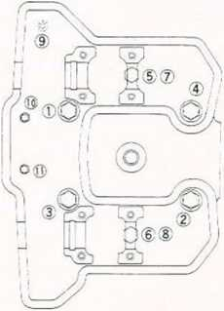
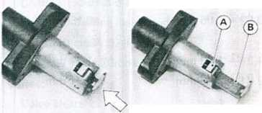
Cylinder, Piston
Installation Points of Piston Rings
Refer to the Base Manual, noting the following.
Cross Section of Piston Rings (Top and Second)
N Mark
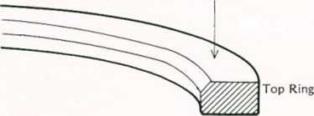
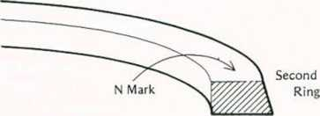
ODo not mix up the top and second rings. The top and second rings are not symmetrical and must be installed with the marked side facing up.
Muffler
Spark Arrester Cleaning (U.S. model)
This motorcycle is equipped with a spark arrester approved for off-road use by the U.S. Forest Service. It must be properly maintained to ensure its efficiency. In accordance with the Periodic Maintenance Chart, clean the spark arrester.
| WARNiNG~|
OTo avoid burns, wear gloves while cleaning the spark arrester. Since the engine must be run during this procedure, the muffler will become hot.
ENGINE TOP END 3-7
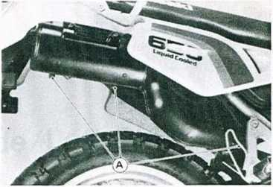
A. Drain Plugs
•In an open area away from combustible materials, start the engine with the transmission in neutral.
•Raise and lower engine speed while tapping on the muffler with a rubber mallet until carbon particles are purged form the muffler.
| WARNING |
oDo not run the engine in a closed area. Exhaiftt gases contain carbon monoxide, a colorless, odorless, poisonous gas. Breathing exhaust gas leads to carbon monoxide poisoning, asphyxiation, and death.
•Stop the engine.
•Install the drain plugs.
•Remove the drain plugs on the muffler.

ENGINE RIGHT SIDE/LEFT SIDE 4-1
Engine Right Side/Left Side

Table of Contents
Exploded View 4-2
Flow Chart — Right Side Parts Removal 4-4
Flow Chart — Left Side Parts Removal 4-5
Engine Lubrication System *
Service Data 4-6
Special Tools *
Clutch 4-7
Play Inspection 4-7
Play Adjustment
Clutch Release Removal 4-7
Clutch Release Installation 4-7
Clutch Removal
Clutch Installation
Friction Plate Wear,
Damage Inspection
Friction or Steel Plate
Warp Inspection
Clutch Spring Free Length
Measurement
Clutch Housing Finger Inspection Clutch Hub Spline Inspection . .
Primary Gear
Removal or Installation
Kick Starter (Optional)
Installation
Assembly Points
Engine Lubrication System 4-
Engine Oil and Filter 4-
Oil Change 4-
Oil Level Inspection
Installation Points of Oil Filter,
Oil Pressure
Relief Valve Opening Pressure
Oil Pressure Measurement
Oil Pump
Removal Point
Installation Points
Engine Sprocket 4-7
Removal 4-7
Installation Points
Magneto
Removal
Installation
Balancer Mechanism 4-8
Chain Tension Adjustment *
Removal Point 4-8
Assembly Points 4-8
Balancer Chain Guide Installation. Camshaft Chain Guide Installation Idler Shaft Circlip Installation . . . Balancer Chain Timing Procedure .
- Refer to Base Manual

4-2 ENGINE RIGHT SIDE/LEFT SIDE
Exploded View
G : Grease
L : Non-permanent Locking Agent M : Molybdenum Disulfide Grease
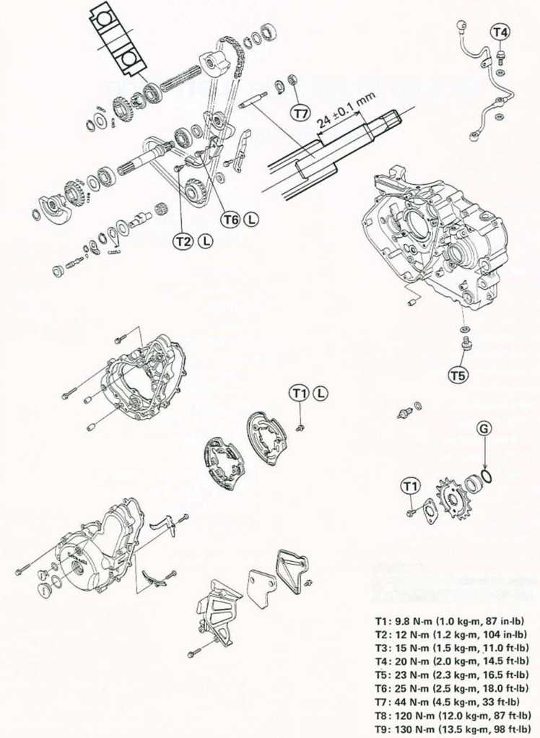
ENGINE RIGHT SIDE/LEFT SIDE 4-3
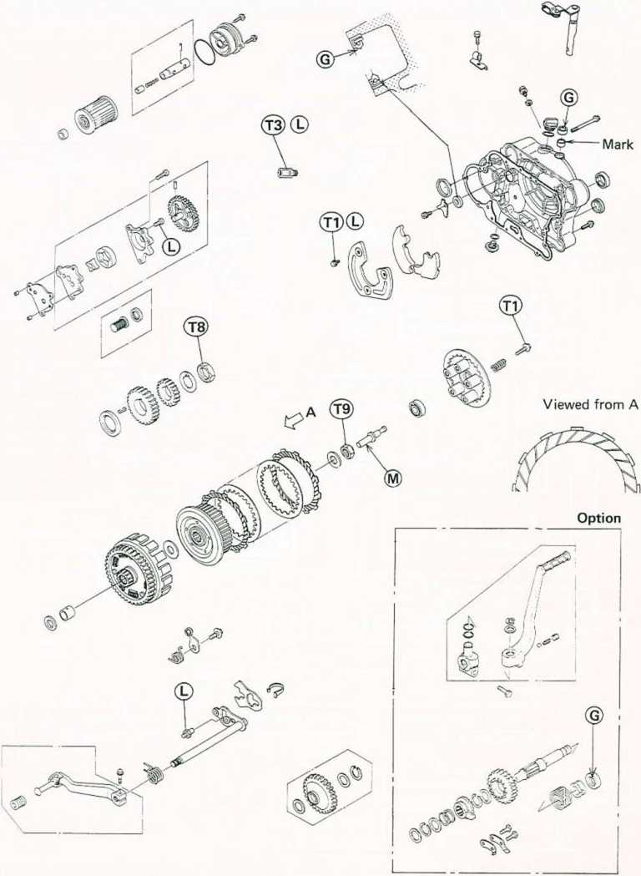

4-4 ENGINE RIGHT SIDE/LEFT SIDE
Flow Chart — Right Side Parts Removals
oThe following chart is intended to be an aid to proper removal. Select the component you wish to remove and follow the arrows to that point on the chart.
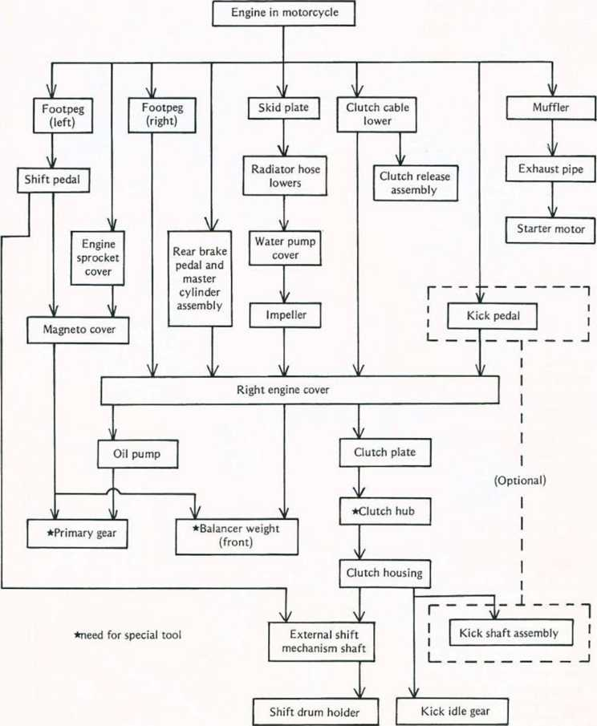

ENGINE RIGHT SIDE/LEFT SIDE 4-5
Flow Chart — Left Side Parts Removals
oThe following chart is intended to be an aid to proper removal. Select the component you wish to remove and follow the arrows to that point on the chart.
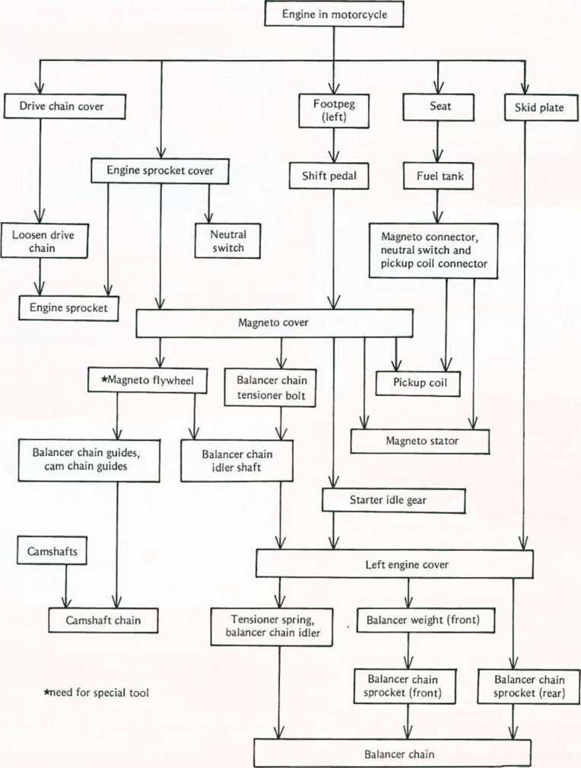

4-6 ENGINE RIGHT SIDE/LEFT SIDE
Service Data
Item | Standard | Service Limit
Clutch:
Clutch lever play | 2 — 3 mm  10 — 15 mm (at lever end)
Friction plate thickness | 2.9 — 3.1 mm | 2.75 mm
Friction, steel plate warp | Less than 0.2 mm | 0.3 mm
Clutch spring free length | 34.2 mm | 33.1 mm
Engine Lubrication System:
Engine oil: Grade | SE or SF class
Viscosity | SAE 10W40, 10W50, 20W40, or 20W50
Amount | 2.2 L (filter is not removed)
 | 2.5 L (filter is removed)
Level | Between upper and lower level lines
Relief valve opening pressure | 430 - 590 kPa  (4.4 - 6.0 kg/cm²,63 -85 psi)
Oil pressure | 78 - 147 kPa
@4 000 rpm (r/min), 90°C <194°F) | (0.8- 1.5 kg/cm*, 11-21 psi)

ENGINE RIGHT SIDE/LEFT SIDE 4-7
Clutch
Play Inspection
Refer to the Base Manual, noting the following. •When checking the clutch lever play without the hand cover removal, check the lever play at the lever end.
Clutch Release Installation
Refer to the Base Manual, noting the following. •Before installing the lever and shaft assembly, check the oil seai and replace it if necessary.
Engine Lubrication System
Engine Oil and Filter
OH Change
Refer to the Base Manual, noting the following.
•The engine drain plug is installed at the bottom of the crankcase.
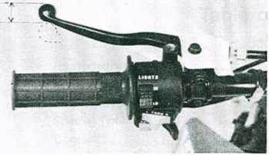
A. Clutch Lever Play (at lever end): 10 — 15 mm
Clutch Release Removal
Refer to the Base Manual, noting the following. •Before pulling out the clutch release lever and shaft assembly, take out the shaft positioning bolt.
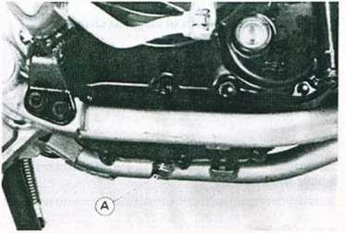
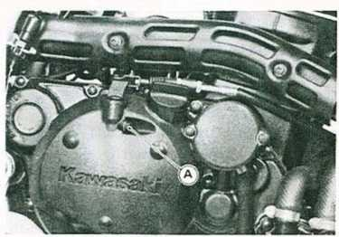
A. Drain Plug
Engine Oil
Grade: SE or SF class
Viscosity: SAE 10W40, 10W50 20W40, or 20W50 Amount: 2.2 L (oil filter is not removed)
- L (oil filter is removed)
A. Positioning Bolt
CAUTION
oDo not remove the clutch release lever and shaft assembly unless it is absolutely necessary. If removed, the oil seal replacement may be required.
Engine Sprocket
Removal
Refer to the Base Manual, noting the following. •Loosen the drive chain to remove it from the rear sprocket.
oRemove the cotter pin and loosen the rear axle nut.

4-8 ENGINE RIGHT SIDE/LEFT SIDE
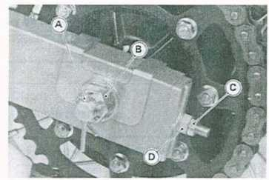
Assembly Points
Refer to the Base Manual, noting the following. •Tighten the front right balancer weight nut to the specified torque and bend the toothed lockwasher over the nut.
Tightening Torque
Balancer Weight Nut: 44 N-m (4.5 kg-m, 33 ft-lb)
- Cotter Pin C. Locknut
- Rear Axle Nut D. Chain Adjusting Nut
oLoosen the locknuts and back out both left and right chain adjusting nuts evenly, opush the rear wheel forward to loose the chain.
Balancer Mechanism
Removal Point
Refer to the Base Manual, noting the following. •Using the magneto holder (special tool: P/N 57001- 1184) to keep the crankshaft and balancer shafts from turning, loosen or tighten the nut of the front right balancer weight.
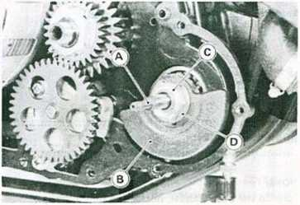
- Water Pump Shaft C. Nut
- Right Weight D. Toothed Lockwasher

COOLING SYSTEM 5-1

Cooling System

Table of Contents
Exploded View Service Data . . Cooling System Special Tool . . Coolant
5-2
5-3
5-3
5-4
Coolant Deterioration. . Coolant Level Inspection
*
54
Coolant Changing
Coolant Filling
Air Bleeding
Visual Leak Inspection
Cooling System Pressure Testing
Flushing
Precaution of Disassembly, Assembly
Radiator, Radiator Fan 5-4
Removal Points 5-4
Radiator Cleaning Points
Radiator Inspection
Radiator Cap Inspection
Radiator Hose, Reserve Tank Hose Inspection
Thermostatic Fan Switch, Water Temperature Sender
Removal Point
Installation Point
Inspection
Thermostat
Installation Point
Thermostat Inspection
Water Pump, Mechanical Seal 5-4
Disassembly
Inspection
Assembly Points 5-4
‘Refer to Base Manual

5-2 COOLING SYSTEM
Exploded View
LS: Liquid Gasket (Silicone Sealant)
T1 : 7.4 N-m <0.75 kg-m, 65 in-lb) T2: 9.8 N-m (1.0 kg-m, 87 in-)b)
T3: 15 N-m (1.5 kg-m, 11.0 ft-lb)
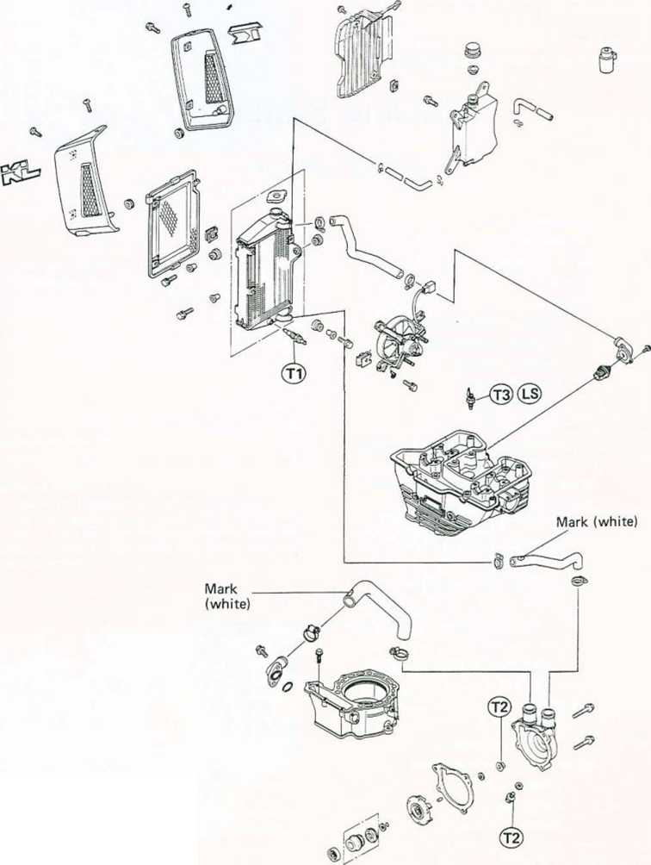
COOLING SYSTEM 5-3
Service Data
Item | Standard
Coolant:  Type (recommended)  Mixed ratio (provided coolant when shipping) Freezing point (provided coolant when shipping) Total amount Radiator Cap: Relief pressure  Thermostat: Valve opening temperature Valve full opening lift | Permanent type of antifreeze (soft water and ethylene glycol plus corrosion and rust inhibitor chemicals for aluminum engines and radiators)  Soft water 50%, coolant 50%  —35°C ( —31⁰ F )  1.3 L  93 - 123 kPa  (0.95 - 1.25 kg/cm², 14-18 psi)  69.5 - 72.5°C (157 - 162°F)  Not less than 3 mm @85°C (185° F)
Coolant Flow Chart
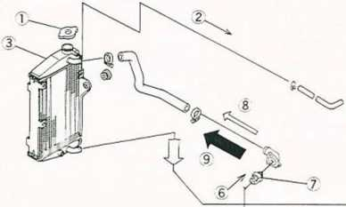
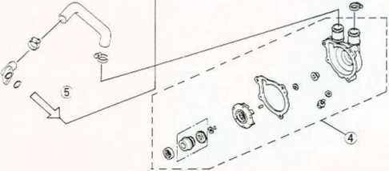
1.
2.
3.
4.
5.
6.
7.
- 9.
Radiator Cap
To Reservoir Tank
Radiator
Water Pump
To Cylinder Jacket
From Cylinder Head
Thermostat
Through Thermostat Air Bleeder Hole Through Thermostat Valve

5-4 COOLING SYSTEM
Coolant

Coolant Level Inspection
Refer to the Base Manual, noting the following.
•The reserve tank is mounted to the right lower side of the frame head pipe.
Water Pump, Mechanical Seal

Assembly Points
Refer to the Base Manual, noting the following.
- Impeller shim selection is not necessary. Install only the shim which is 0.8 mm thickness.
- FULL Mark C. Tank Cap
- LOW Mark
Water Pump Installation
°Set the motorcycle on its side stand during the coolant level Inspection.
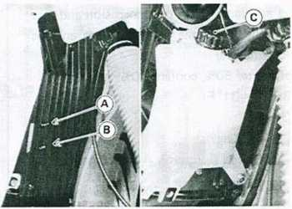
Radiator, Radiator Fan

Removal Points
Refer to the Base Manual, noting the following.
•The radiator is one-piece type and is mounted to the left lower side of the frame head pipe.
- Balancer Shaft
- Right Weight
- Nut
- Impeller
- Washer
- Shim (0.8 mm thickness)
- Impeller Shaft
- Lockwasher
Tightening Torque
Impeller Nut: 9.8 N-m (1.0 kg-m, 87 in-lb)
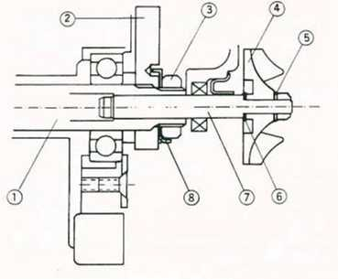
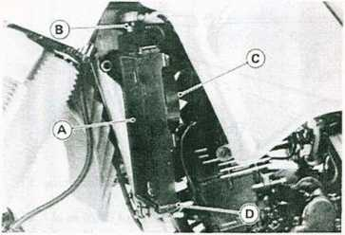
- Radiator
- Radiator Cap
- Radiator Fan
- Radiator Fan Switch

ENGINE REMOVAL/INSTALLATION 6-1

Engine Removal/Installation

Table of Contents
Exploded View 6-2
Engine Unit 6-3
Removal 6-3
Installation 6-4
Engine Disassembly
Precaution
Flow Chart
‘Refer to Base Manual

6-2 ENGINE REMOVAL/INSTALLATION

Exploded View
M : Molybdenum Disulfide Grease S : Follow the specific tightening sequence.
T1 : 25 N-m (2.5 kg-m, 18.0 ft-lb) T2: 44 N-m (4.5 kg-m, 33 ft-lb) T3: 98 N-m (10.0 kg-m, 72 ft-lb)
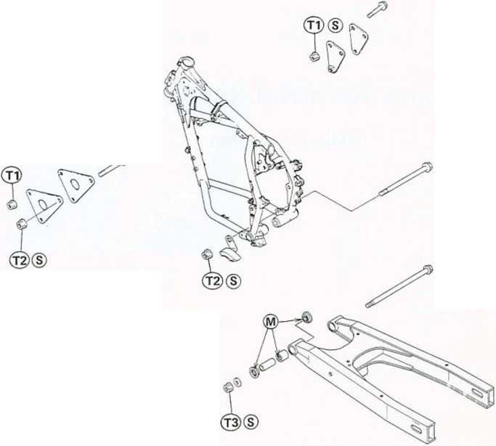
ENGINE REMOVAL/INSTALLATION 6-3

Engine Unit

Removal
•For later installation convenience, note and record how and where cables, wires, and hoses are routed. They should not be bent sharply, kinked, or twisted.
•Drain the engin'e oil (chapter 4) and coolant (chapter 5).
•Remove the parts and free the cables and wiring shown in the chart.
•Place a stand or block under the engine and remove the engine mounting bolts, nuts, and brackets. oThis chart is designed to aid in determining proper removal sequence. Select the component you wish to remove and follow the arrows to that point on the chart.
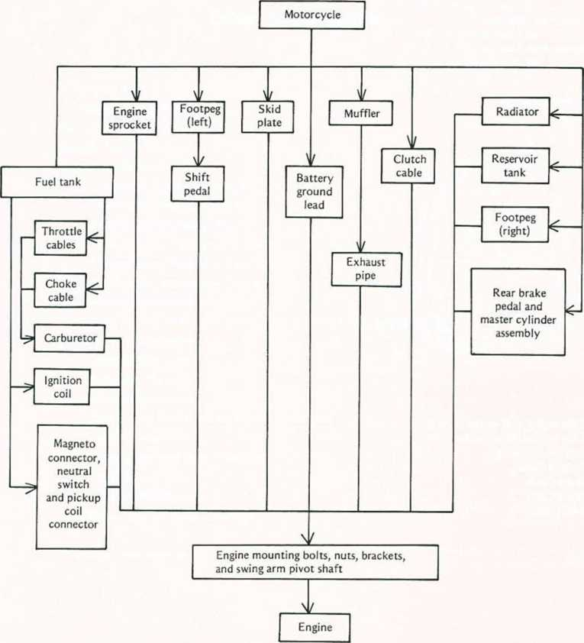

6-4 ENGINE REMOVAL/INSTALLATION

Installation
•Engine unit installation is the reverse of removal. Note the following.
•Tighten the engine mounting bolts, bracket bolts, and swing arm pivot bolt to the specified torque.
Tightening Torque
Engine Mounting Bolts (10 mm):
44 N*m (4.5 kg-m, 33 ft-lb)
Engine Mounting Bolts (8 mm):
23 N-m (2.3 kg-m, 16.5 ft-lb)
Engine Mounting Bracket Bolts (8 mm):
23 N-m (2.3 kg-m, 16.5 ft-lb)
Swing Arm Pivot Bolt:
98 N-m (10.0 kg-m. 72 ft-lb)
Rocker Arm Pivot Bolt:
98 N-m (10.0 kg-m, 72 ft-lb)
Tightening Sequence
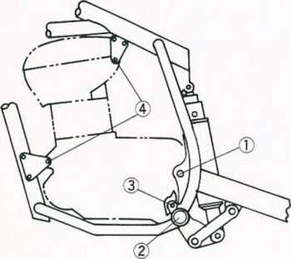
•Fill the engine with engine oil.
•Fill the cooling system with coolant. •Adjust the following.
Throttle Cables Choke Cable Clutch Cable Drive Chain

ENGINE BOTTOM END/TRANSMISSION 7-1

Engine Bottom End/Transmission

Table of Contents
Exploded View
Disassembly Flow Chart
Service Data
Special Tools
Crankcase Splitting
Crankcase Disassembly Point
Crankcase Assembly Points
Rear Balancer Installation
Transmission Disassembly Point
Transmission Assembly Points
Crankshaft Installation Points
Transmission Maintenance
Shift Drum, Shift Fork, Shift Rod, Gear Groove Inspection
Crankshaft Disassembly
Disassembly Point
Assembly Points
Crankshaft Maintenance
Connecting Rod Big End Radial Clearance
Big End Seizure
Connecting Rod Side Clearance
Crankshaft Runout
Crankshaft Alignment
Roller Bearing Wear, Damage
7-2
*
7-4
'Referto Base Manual

7-2 ENGINE BOTTOM END/TRANSMISSION
Shielded
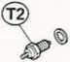
G : Grease
L : Non-permanent Locking Agent LG : Liquid Gasket
T1 : 12 N-m (1.2 kg-m, 104 in-lb) T2: 15 N-m (1.5 kg-m, 11.0 ft-lb)
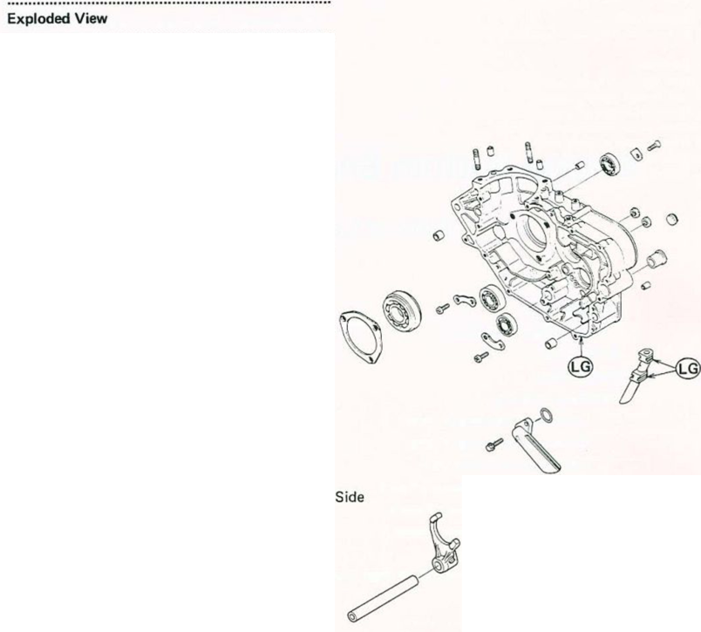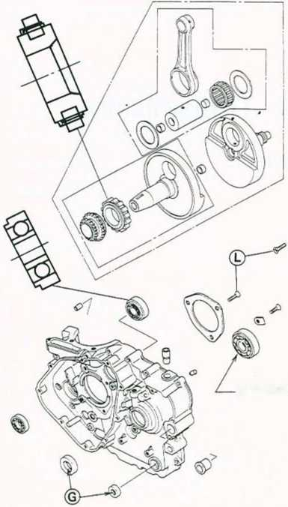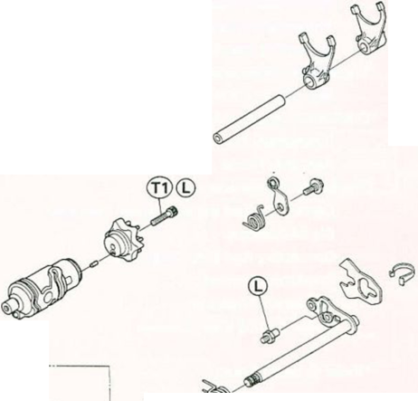
ENGINE BOTTOM END/TRANSMISSION 7-3
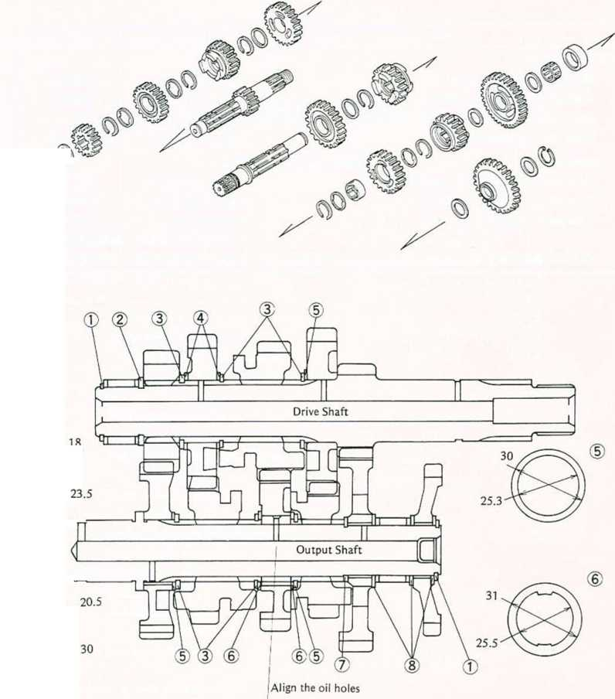
7-4 ENGINE BOTTOM END/TRANSMISSION
Service Data
Item | Standard | Service Limit
Transmission:
Shift fork finger thickness | 4.4 — 4.5 mm | 4.3 mm
Gear shift fork groove width | 4.55 — 4.65 mm | 4.8 mm
Shift fork guide pin diameter | 5.9 — 6.0 mm | 5.8 mm
Shift drum groove width | 6.05 — 6.20 mm | 6.3 mm
Crankshaft:
Connecting rod big end radial clearance | 0.008 — 0.020 mm | 0.07 mm
Connecting rod side clearance | 0.25 — 0.35 mm | 0.60 mm
Crankshaft runout: Left half | 0.03 mm TIR | 0.10 mm TIR
Right half | 0.04 mm TI R | 0.10 mm TIR
Cold-fitting tolerance between crankpin and flywheel | 0.093 -0.122 mm

WHEELS/TIRES 8-1

Wheels/Tires

Table of Contents
Exploded View 8-2
Service Data 8-3
Special Tools
Tires 8-4
Tire Removal
Installation Point of Tires
Adjustment after Tire Installation 8-4
Tire Wear Inspection
Wheels 8-4
Rear Wheel Removal 8-4
Rear Sprocket Installation
Rear Wheel Installation Points 8-4
Disc Installation 8-4
Front Wheel Balance 8-4
Spokes and Rims
Spoke Tightness Inspection
Rim Runout Inspection
Wheel Bearings
Bearing Removal
Installation Points
Wheel Bearing Inspection
Bearing Lubrication
’Referto Base Manual

8-2 WHEELS/TIRES
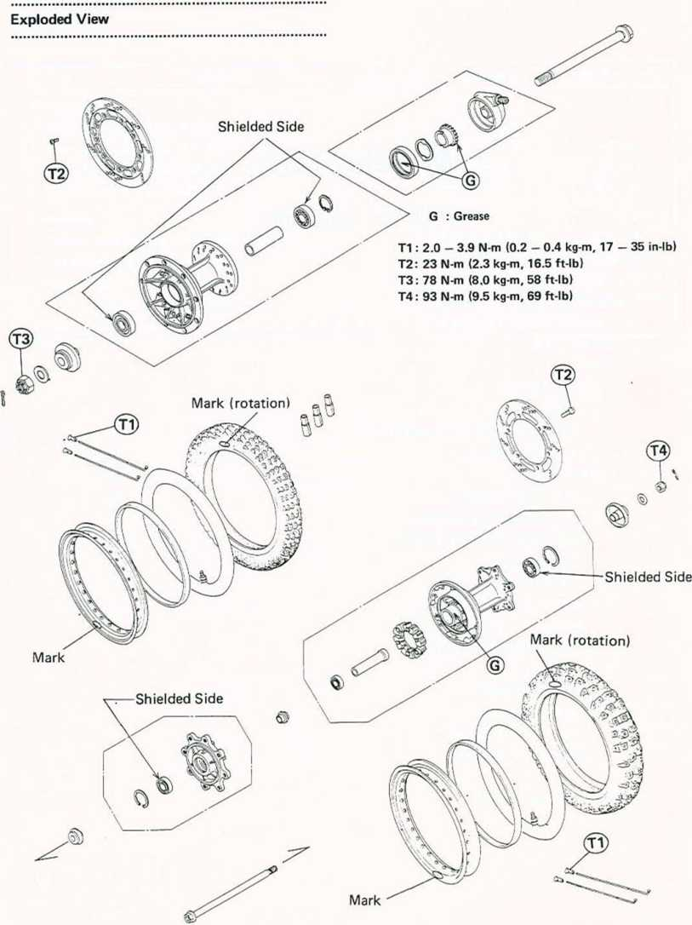

WHEELS/TIRES 8-3
Service Data
Item
Standard
Service Limit
Tires:
Standard tire:
Tire tread depth:
Front
Rear
Front
Rear
90/90-21 54S DUNLOP K750
® -A3 ~: DUNLOP TRAIL MAX 130/80-17 65S DUNLOP K750
® -A3 ~: DUNLOP TRAIL MAX 6.4 mm 8.8 mm
2 mm 2 mm
Tire air pressure:
Front | 150 kPa (1.5 kg/cm², 21 psi)
Rear | Up to 97.5 kg (215 lb) load | 150 kPa (1.5 kg/cm², 21 psi)
Rear | 97.5 - 182 kg (215 - 401 lb) load | 200 kPa (2.0 kg/cm², 28 psi)
Wheels:
Wheel balance Balance weights Spokes and Rims:
Rim runout: Radial & Axial
Less than 10 g 10 g, 20 g, 30 g
2 mm

8-4 WHEELS/TIRES

Tires

Adjustment after Tire Installation •Check and adjust the following.
Tire Air Pressure
Wheel Balance (front wheel only)
Rear Wheel Installation Points •Adjust the drive chain slack after installing the rear wheel.
•Tighten the rear caliper mounting bolts to the specified torque.
Tightening Torque
Rear Caliper Mounting Bolts:
25 N-m (2.5 kg-m, 18.0 ft-lb)

Wheels
•Check the rear brake effectiveness.

Rear Wheel Removal
•Remove the rear caliper from the caliper holder with the brake hose connected.

Disc Installation Points
•Clean the disc and wheel hub mating surfaces of any dirt and foreign particles.
•Mount the brake disc on the wheel so that the marked side faces out.
•Tighten the disc mounting bolts to the specified torque.
Tightening Torque
Disc Mounting Bolts: 23 N-m (2.3 kg-m, 16.5 ft-lb)
•After installing the disc, check the disc runout (see chapter 10).
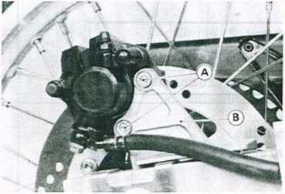
A. Caliper Mounting Bolts B. Caliper Holder
•Remove the cotter pin and take off the rear axle nut.
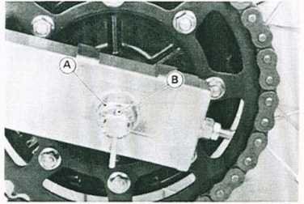
A. Mark
A. Rear Axle Nut B. Cotter Pin
•Place a stand or block under the motorcycle so that the rear wheel Is raised off the ground.
•Pull the rear axle off the wheel and free the drive chain from the rear sprocket.

Front Wheel Balance
To improve stability and decrease vibration at high speed, the front wheel must be kept balanced.
Check and balance the front wheel when required, or when a tire and/or rim Is replaced with a new one.
•Raise the front wheel so that It can be spun freely. •Check that all the spokes are tightened evenly and the rim runout is within the service limit.
•Spin the wheel lightly, and mark the wheel at the top when the wheel stops.
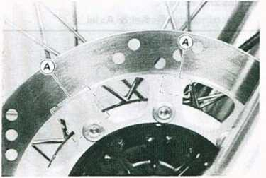

WHEELS/TIRES 8-5
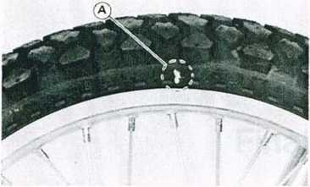
*lf the wheel rotates and the weight goes up, replace the weight with the next heavier size.
♦If the wheel rotates and the weight goes down, replace the weight with the next lighter size.
•Repeat these step until the wheel remains at rest after being rotated % turn.
•Rotate the wheel another 'A turn and then another 14 turn to see if the wheel is correctly balanced.
•Repeat the entire procedure as many times as necessary to achieve correct wheel balance.
•Install the balance weight firmly on the wheel. oClamp on the balance weight firmly using pliers.
A. Mark at the top.
- Repeat this procedure several times.
*lf the wheel stops of its own accord in various positions, it is well balanced.
*lf the wheel always stops in one position, balance the wheel.
•Temporarily attach a balance weight on the wheel. oAttach a balance weight loosely to the spoke under the marking.
NOTE
Balance weights are available from Kawasaki Dealers in 10, 20, and 30 gram sizes. An imbalance of less than
- grams will not usually after running stability. oDo not use four or more balance weight (more than 90 g). If the wheel requires an excess balance weight, remove and disassemble the wheel to find the cause.
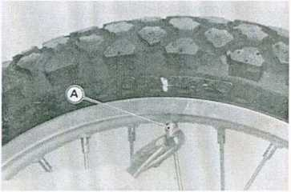
- Balance Weight
•Rotate the wheel % turn, and see whether or not the wheel stays in this position.
*lf it does, the correct balance weight is being used.
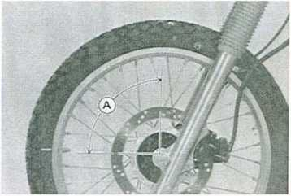
A. Zt turn.

FINAL DRIVE 9-1

Final Drive

Table of Contents
Exploded View 9-2
Service Data ; 9-2
Drive Chain ' 9-3
Chain Slack Inspection 9-3
Chain Slack Adjustment 9-3
Wear Inspection
Chain Guide Wear
Lubrication
Drive Chain Removal 9-3
Engine Sprocket
- Refer to Base Manual

9-2 FINAL DRIVE
Exploded View
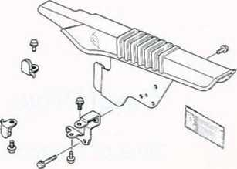
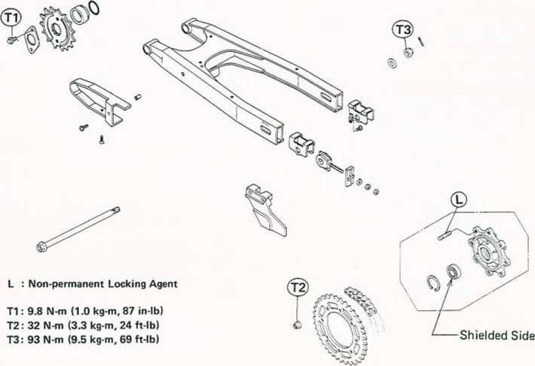
Service Data
Item | Standard | Service Limit
Drive Chain:  Standard chain: KL650-A1 ,A2,A3 KL650-A4— KL500  Chain slack Chain 20-link length | EK520LD-0 106 L  DID. JAPAN. 520V2 106 L  EK520LD-0 108 L  50 — 55 mm  31 7.5 — 31 8.4 mm | 50 — 60 mm 323 mm

Drive Chain

Chain Slack Inspection
•Stand the motorcycle on its side stand.
•If the drive chain appears dry, lubricate it.
- Route the rear wheel to find the place where the chain is tightest because the chain wears unevenly.
•Measure the vertical movement midway between the sprockets.
*lf the drive chain is too tight or too loose, adjust it so that the chain slack is within the standard value.
Drive Chain Slack
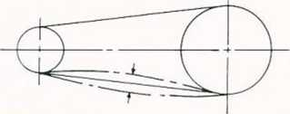
Drive Chain Slack
Standard: 50 — 55 mm
Too tight: less than 50 mm
Too loose: more than 60 mm

Chain Slack Adjustment
•Remove the cotter pin and loosen the rear axle nut.
•Loosen the left and right chain adjusting nut locknuts. *lf the chain is too tight, back out the left and right chain adjusting nuts evenly, and kick the wheel forward until the chain is too loose.
•Turn both chain adjusting nuts evenly until the chain has the correct amount of slack. To keep the chain and
FINAL DRIVE 9-3
wheel properly aligned, the notch on the left chain adjuster should align with the same swing arm mark that the right chain adjuster notch aligns with.
NOTE
oWheel alignment can also be checked using the straightedge or string method.

ja/arningJ
oMisalignment of the wheel will result in abnormal wear, and may result in an unsafe riding condition.
•Tighten the axle nut loosely, and tighten both chain adjusting nuts, but not enough to change the adjustment, and then tighten both locknuts securely.
•Tighten the axle nut to the specified torque.
Tightening Torque
Rear Axle Nut: 93 N-m (9.5 kg-m, 69 ft-lb)
•Rotate the wheel, measure the chain slack again at the tightest position, and readjust if necessary.
•Insert the new cotter pin through the axle nut and axle, and spread its ends.

| WARNING |
Olf the axle nut is not securely tightened and the cotter pin is not installed, an unshaft riding condition may result.
•Check the rear brake effectiveness.

Drive Chain Removal
•Place a stand or block under the motorcycle to raise the rear wheel off the ground.
•After removing the engine sprocket and drive chain from the rear sprocket, remove the swing arm pivot shaft and tie-rod bolt (upper or lower)
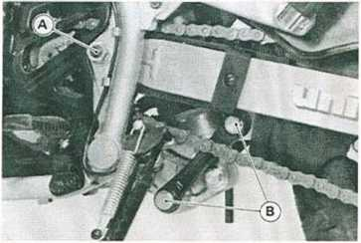
A. Swing Arm Pivot Shaft B Tie-rod Bolts
•Pulling back the swing arm, remove the drive chain from the motorcycle.
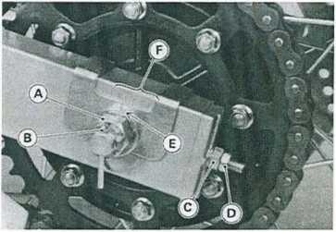
- Axle Nut D. Locknut
- Cotter Pin E. Notch
- Chain Adjusting Nut F. Marks

BRAKES 10-

Brakes

Table of Contents
Exploded View 10-2
Service Data 10-4
Special Tool 10-4
Front Brake Adjustment/Inspection 10-5
Brake Lining Wear Inspection
Brake Fluid Level Inspection 10-5
Brake Fluid Change
Brake Line Air Bleeding
Brake Fluid Recommendation
Front Brake Disassembly/Assembly 10-5
Inspection and Adjustment after
Installation
Pad Removal Points 10-5
Caliper Removal Points
Caliper Installation Points
Caliper Disassembly Points
Caliper Assembly Points 10-5
Disc Installation Points
Master Cylinder Installation 10-5
Master Cylinder Disassembly Points . . . 10-6
Master Cylinder Assembly Points
Rear Brake Adjustment/Inspection 10-6
Pedal Position Adjustment 10-6
Brake Lining Wear Inspection 10-7
Brake Fluid Level Inspection 10-7
Brake Fluid Change 10-7
Brake Line Air Bleeding 10-7
Brake Fluid Recommendation 10-7
Rear Brake Disassembly/Assembly 10-7
Inspection and Adjustment after
Installation 10-7
Pad Removal 10-7
Caliper Removal 10-8
Caliper Installation 10-8
Caliper Disassembly 10-8
Caliper Assembly 10-8
Disc Installation 10-8
Master Cylinder Installation Points .... 10-8
Master Cylinder Disassembly Points . . . 10-8
Master Cylinder Assembly 10-8
Brake Maintenance 10-8
Brake Disc Runout Inspection 10-8
Brake Light Switch
Inspection
Adjustment
Removal
- Refer to Base Manual

10-2 BRAKES

Exploded View
©
G : Grease
T1 : 5.9 N-m (0.60 kg-m, 52 in-lb) T2 : 7.8 N-m (0.80 kg-m, 69 in-lb) T3 : 8.8 N-m (0.90 kg-m, 78 in-lb) T4: 23 N-m (2.3 kg-m, 16.5 ft-lb) T5 : 25 N-m (2.5 kg-m, 18.0 ft-lb)
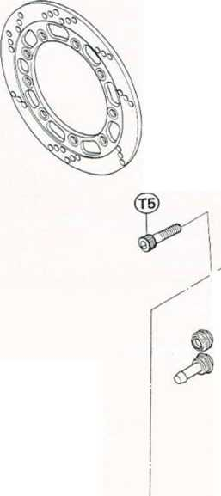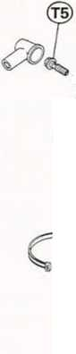
BRAKES 10-3
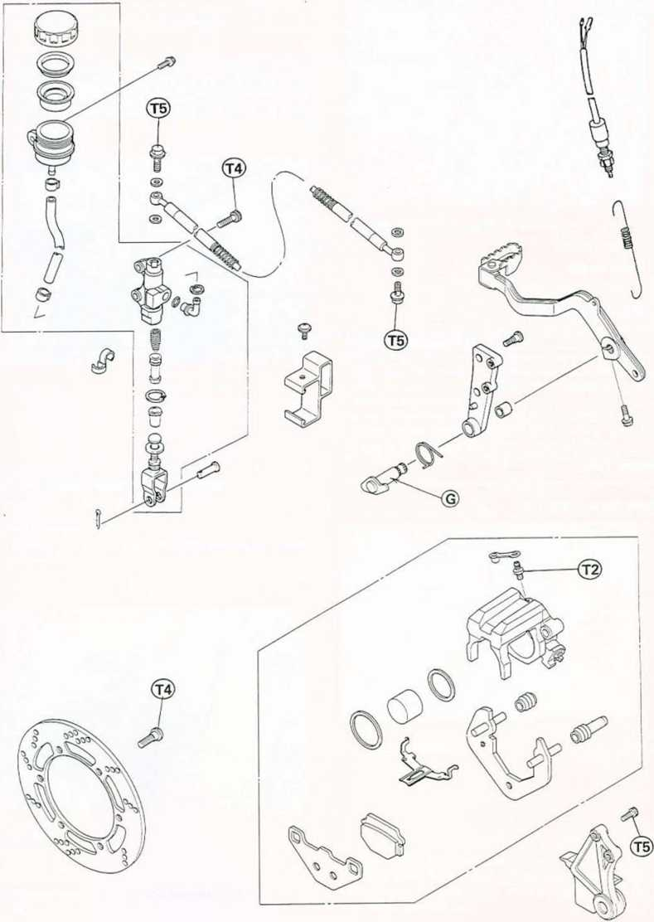

10-4 BRAKES
Service Data
Item | Standard | Service Limit
Brake Fluid:
Grade | D.O.T.3 or 4
Brake Pads:
Pad lining thickness | 4.5 mm | 1 mm
Brake Discs:
Disc thickness: Front | 3.8 — 4.1 mm | 3.5 mm
Rear | 4.8 — 5.1 mm | 4.5 mm
Disc runout | Less than 0.2 mm | 0.3 mm
Brake Pedal:
Pedal position | Level with footpeg top
Brake Light Switch:
Rear brake light switch operation | ON after about 1 5 mm pedal travel
Special Tool
Circlip Pliers: 57001-143

Front Brake Adjustment/Inspection

Brake Fluid Level Inspection
Refer to the Base Manual, noting the following. •Holding the reservoir horizontally, check that the brake fluid level in the reservoir is higher than the lower level.
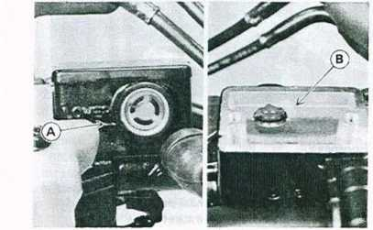
A. Lower Level 8. Upper Level
Front Brake Disassembly/Assembly

Caliper Assembly Points
•Apply brake fluid to the outside of the piston and the fluid seal, and push the piston into the cylinder by hand. Take care that neither the cylinder nor the piston skirt scratched.
•Apply a thin coat of PBC (Poly Butyl Cuprysil) grease to the caliper holder shafts and holder holes. (PBC is a special high temperature, water-resistant grease).
•Install the anti-rattle spring in the caliper as shown.

Pad Removal Points
- Remove the caliper mounting bolts and lift the caliper off the disc.
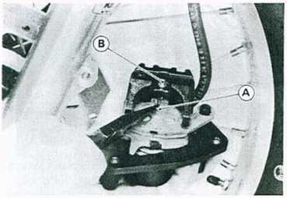
BRAKES 10-5
A. Safety Clip B. Retaining Pin
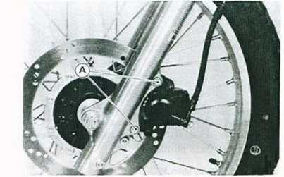
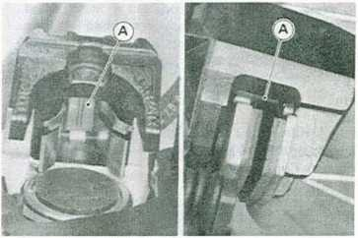
A. Anti-rattle Spring
A. Caliper Mounting Bolts
•Remove the safety clip and pull out the pad retaining pin.

Master Cylinder Installation
Refer to the Base Manual, noting the following.
•The master cylinder clamp must be installed with the UP mark pointing up.

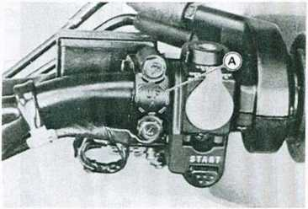
10-6 BRAKES
A. UP Mark
Master Cylinder Disassembly Points
•Using the circlip pliers (special tool: P/N 57001-143),
remove the circlip and pull the piston and spring out of
the cylinder.
•If it is not, adjust the brake pedal position as follows. •Remove the master cylinder bracket bolts.
Brake Pedal Position
Standard: Level with footpeg top
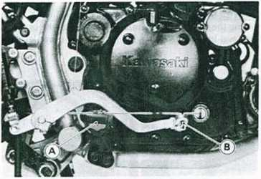
A. Footpeg B. Brake Pedal
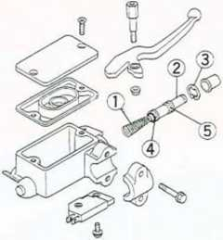
Front Master Cylinder
1.
2.
3.
4.
5.
Spring
Piston
Circlip
Primary Cup
Secondary Cup
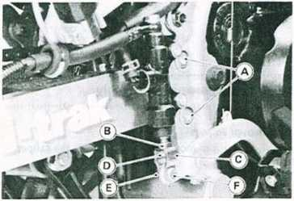
CAUTION
- Master Cylinder Bracket Bolts
- Locknut
- Clevis
- Adjusting Nut
- Cotter Pin
- Clevis Pin
ODo not remove the primary and secondary cups from *p_{u}|| _{out t}h_{e} cotter pin and the clevis pin. the piston since removal will damaged them. »Loosen the locknut of the rod with the clevis held.
•Up or down the adjusting nut by turning the clevis to adjust the brake pedal position.
Rear Brake Adjustment/Inspection

Pedal Position Adjustment
•When the brake pedal is in its rest position, it should be at the position specified.
NOTE
oIf the pedal position cannot be adjusted by turning the clevis, the brake pedal may be deformed or incorrectly installed.
01 f the brake rod protrusion is 3.0 — 3.5 mm below the nut, the pedal will be at the position specified.

BRAKES 10-7
Brake Rod Protrusion »Press down the brake pedal instand of squeezing the
brake lever to apply the rear brake.
- Master Cylinder
- Adjusting Nut
- Rod Protrusion
•Check the brake pedal position, and readjust It if necessary.
•Install the removed parts and tighten the locknut. •Check the brake light switch and adjust If necessary.

Brake Line Air Bleeding
Refer to the Front Brake Adjustment/Inspection section in the Base Manual, noting the following.
•Press down the brake pedal instead of squeezing the brake lever to apply the brake.

Brake Fluid Recommendation
Refer to the Front Brake Adjustment/Inspection section in the Base Manual.

Rear Brake Disassembly/Assembly
•Observe the WARNING and CAUTION in the Brake Fluid Recommendation.

Brake Lining Wear Inspection
Refer to the Front Brake Adjustment/Inspection section in the Base Manual.

Brake Fluid Level Inspection
Refer to the Front Brake Adjustment/Inspection section in the Base Manual, noting the following. •Holding the reservoir horizontally, check that the brake fluid level in the reservoir is between the upper and lower lines.
Inspection and Adjustment after Installation Refer to the Front Brake Disassembly/Assembly section in the Base Manual, noting the following.
•Check the rear brake for good braking power, no brake drag, and no fluid leakage.

1 warning!
ODo not attempt to drive the motorcycle until a full brake pedal is obtained by pumping the brake pedal until the pads are against the disc. The brake will not function on the first application of the pedal if this is not done.

Pad Removal
Refer to the Front Brake Disassembly/Assembly section in the Base Manual, noting the following.
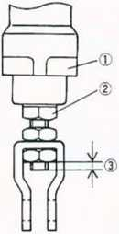
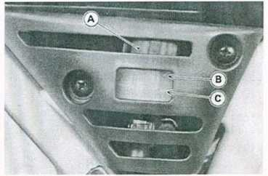
- Reservoir C. Lower Level
- Upper Level

Brake Fluid Change
Refer to the Front Brake Adjustment/Inspection section in the Base Manual, noting the following.
A. Rear Caliper Mounting Bolts
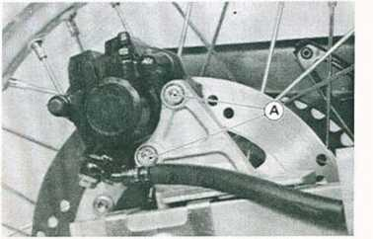

10-8 BRAKES

Caliper Removal
Refer to the Front Brake Disassembly/Assembly section in the Base Manual, noting the following.
•Use the brake pedal instead of using the brake lever to remove the caliper piston.

Caliper Installation
Refer to the Front Brake Disassembly/Assembly section in the Base Manual.

Caliper Disassembly
Refer to the Front Brake Disassembly/Assembly section in the Base Manual.

Caliper Assembly.
Refer to the Front Brake Disassembly/Assembly section in the Base Manual.

Disc Installation
Refer to the Front Brake Disassembly/Assembly section in the Base Manual.
Master Cylinder Installation Points •Discard the used flat washers, and install a new washer on each side of the brake hose fittings.
•Check and adjust the brake pedal position.
Master Cylinder Disassembly Points •Using the circlip pliers (special tool: P/N 57001-143), remove the circlip and pull the piston and spring out of the cylinder.
Rear Master Cylinder

[caution"
ODo not remove the primary and secondary cups from the piston since removal will damage them.

Master Cylinder Assembly
Refer to the Front Brake Disassembly/Assembly section in the Base Manual.

Brake Maintenance

Brake Disc Runout Inspection
A warped disc will cause the brake pads to drag on the disc and will wear down both the pads and disc quickly. Dragging will also cause overheating and poor braking efficiency.
•Raise the wheel off the ground.
oTurn the handlebar fully to one side if it is the front wheel.
•Set up a dial gauge against the brake disc and rotate the wheel to measure the runout. The difference between the highest and lowest dial reading is the amount of runout.
*lf runout is beyond the service limit, replace the brake disc.
- Spring
- Piston
- Circlip
- Primary Cup
- Secondary Cup
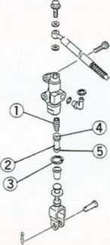

SUSPENSION/STEERING 11-1

Suspension /Steering

Table of Contents
Exploded View Service Data .. Special Tools. . Steering
11-2
11-4
11-5
Steering Inspection
Steering Adjustment
Stem Bearing Lubrication
Grease Seal Deterioration, Damage
Stem Bearing Removal
Stem Bearing, Grease Seal Installation
Steering Stem Installation
Adjustment after Installation
Front Fork 11-6
Air Pressure Adjustment
Fork Oil Level 11-6
Fork Oil Changing 11-6
Fork Disassembly 11-6
Fork Assembly 11-6
I nner Tu be I nspection
Guide Bush Inspection
Guide Bush Replacement 11-6
Uni-trak 11-6
Spring Preload Adjustment 11-6
Damper Adjustment 11-7
Rear Shock Removal 11-7
Rear Shock Scrapping
Rear Shock Installation Point 11-7
Uni-trak Sleeve Inspection
Uni-trak Needle Bearing Inspection
Uni-trak Lubrication
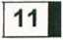
- Refer to Base Manual

11-2 SUSPENSION/STEERING Exploded View
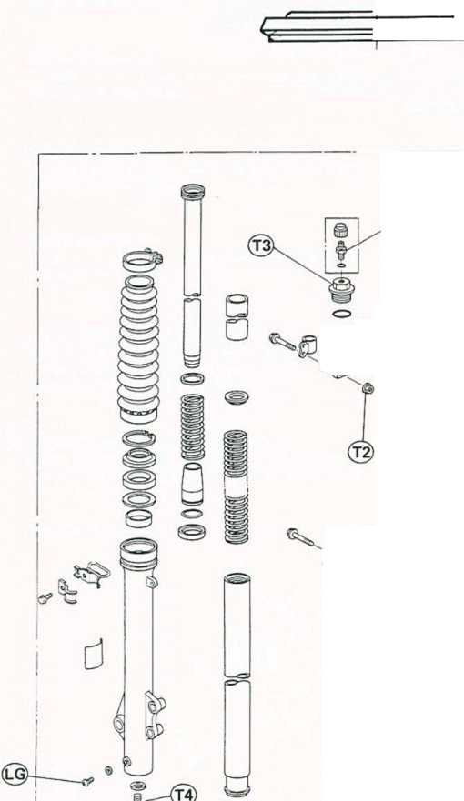
SUSPENSION/STEERING 11-3
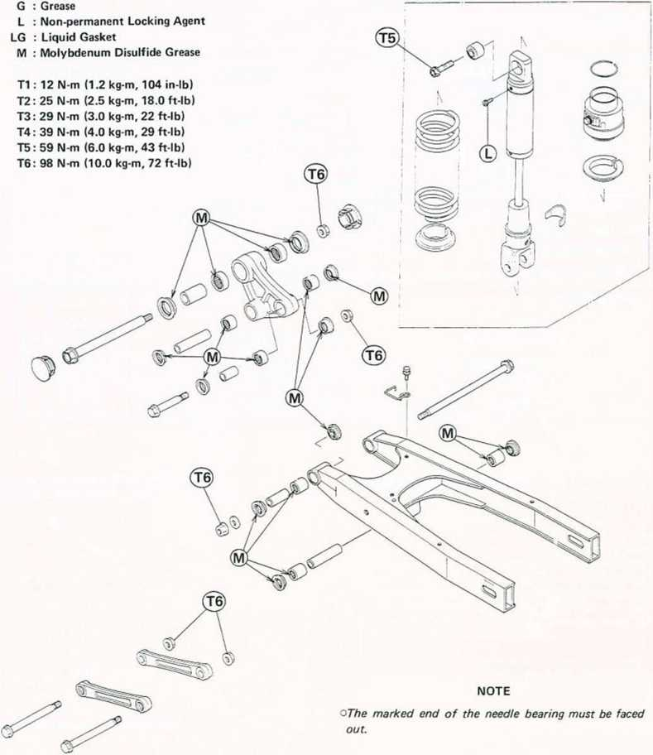

11^ SUSPENSION/STEERING
Service Data
Item | Standard | Service Limit
Front Fork:  Air pressure Oil viscosity Oil amount (par side)  Oil level (fully compressed) | 0 (atmospheric pressure) SAE 10W20 420 ±4 mL 190 ±2 mm  (from top of inner tube)
Rear Shock Absorber:  Spring preload adjuster Damper adjuster | No. 1 of 5 positions No. 1 of 4 positions
Uni-trak Sleeves:  Sleeve outside diameter:  Swing arm pivot Rocker arm pivot Tie-rod ends Rear Shock lower end | - - 20.000 mm  - - 28.000 mm  - - 20.000 mm  - - 20.000 mm | - mm  - mm  - mm  - mm

Special Tools

SUSPENSION/STEERING 11-5
Oil Seal Driver: 57001-1104
Stem Bearing Driver: 57001-137 Adapter: 57001-1074
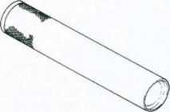
Driver Press Shaft: 57001-1075 Drivers: 57001-1076,1106
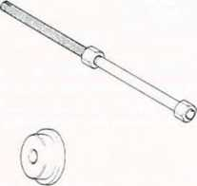
o:
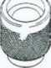
NOTE
oFollowing tools can be used for front fork servicing instead of using the oil seat driver (P/N 57001- 1104).
Fork Outer Tube Weight: 57001-1218
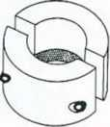
Fork Oil Seal Driver: 57001-1219
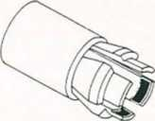
Stem Nut Wrench: 57001-1100
Stem Bearing Remover: 57001-1107
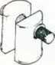
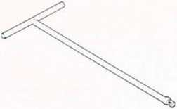
Handle: 57001-183 Adapter: 57001-1057
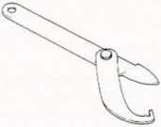

11-6 SUSPENSION/STEERING

Front Fork

Fork Oil Level
Refer to the Base Manual, noting the following.
Front Fork Oil Level
190 ±2 mm below the top end of the inner tube

Fork OH Changing
Refer to the Base Manual, noting the following.
Front Fork Oil
Rating: Kayaba G-10
Viscosity: SAE 10W20 Amount per side:
When changing oil: 355 mL After disassembly and completely dry:
420 ±4 mL

Fork Disassembly
Refer to the Base Manual, noting the following.
•When separating the inner tube from the outer tube, the fork outer tube weight (special tool: P/N 57001- 1218) can be used to separate them instead of using the driver (special tool: P/N 57001-1104). Perform the following.
oMount the weight (special tool) on the top of the outer tube, by fitting the step of the weight to the top corner of the outer tube.
oHoldlng the inner tube by hand in a vertical position, stroke the outer tube several times and pull it down.

Fork Assembly
Refer to the Base Manual, noting the following.
•When installing the guide bush and oil seal at the outer tube top, the fork oil seal driver (special tool: P/N 57001-1219) can be used to Install them Instead of using the driver (special tool: P/N 57001-1104). See Guide Bush Replacement.

Guide Bush Replacement
Refer to the Base Manual, noting the following.
•When installing the guide bush and oil seal at the outer tube top, the fork oil seal driver (special tool: P/N 57001-1219) can be used to install them instead of using the driver (special tool: 57001-1104). Perform the following.
olnstall the guide bush (with a used guide bush or washer on it) by tapping the used guide bush or washer with the driver until it stops. The slit of the bush must be faced toward the left or right.
Guide Bush Installation
- Driver: 57001-1219
- Used Guide Bush.
- Slit (toward the left or right)
- New Guide Bush
- Tap

Uni-trak

Spring Preload Adjustment
The spring preload adjuster on the rear shock ab-
sorber has 5 positions so that the spring force can be
- Fork Outer Tube Weight: 57001-1218 adjusted for different riding conditions.
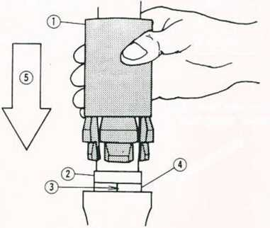
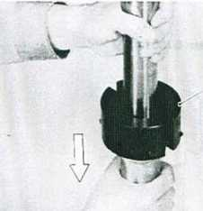

SUSPENSION/STEERING 11-7
•Using a socket wrench, turn the spring preload adjuster as required.
oFor Californian vehicles, remove the liquid/vapor separator from its bracket.
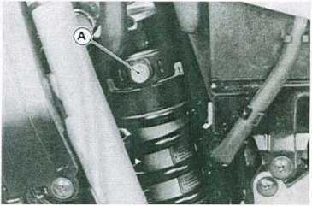
A. Spring Preload Adjuster
Setting Table for Spring Preload and Damper Adjusters
Riding  ^xÇondition  Adjuster | An average- build rider or a rider with load | A rider and a passenger | A rider and a passenger with load
Spring preload | ©or 2 | @ or 3 | © , 4, or 5
Damper | (D orn | (g)orm | © or nn
O: Standard setting (number) is identified with a circle marking.

Damper Adjustment
Refer to the Base Manual, noting the following.
•See Setting Table in the Spring Preload Adjustment paragraph to adjust the damper adjuster.
Rear Shock Removal •Remove the following.
Side Covers Seat
Fuel Tank
Battery
Muffler
•Remove the mounting bolt of the rear brake master cylinder reservoir.
•Remove the rear right footpeg bracket bolts.
•Loosen the clamp of the carburetor air duct. •Disconnect the main harness connectors, and remove the clamps to free rear frame from the harness.
•Loosen the rear frame lower bolts and remove the upper bolts.
•Tilt the rear frame backwards.
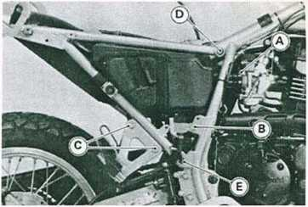
- Carburetor Air Duct Clamp
- Reservoir Mounting Bolt
- Footpeg Bracket Bolts
- Rear Frame Upper Bolt (remove)
- Rear Frame Lower Bolt (loosen)
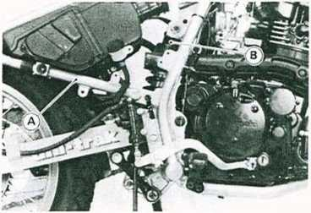
A. Rear Frame B. Rear Shock Absorber
•Loosen the upper and lower shock absorber mounting nuts. Do not remove them yet.
•Place a stand or block under the motorcycle so that the rear wheel off the ground.
•Remove the rear shock absorber mounting bolts and nuts, take out the rear shock absorber.

Rear Shock Installation Point
•Tighten the following bolts to the specified torque.
Tightening Torque
Rear Shock Mounting:
Upper: 59 N-m (6.0 kg-m, 43 ft-lb)
Lower: 98 N-m (10.0 kg-m, 72 ft-lb)
Rear Frame Mounting Bolts:
25 N-m (2.5 kg-m, 18.0 ft-lb)

CONTROLS/INSTRUMENTS 12-1

Controls / Instruments
«

Table of Contents
Exploded View 12-2
Service Data 12-4
Special Tool 12-4
Choke Lever *
Adjustment *
Throttle Grip 12-5
Inspection 12-5
Adjustment 12-5
Clutch See chapter 4
Meter Unit 12-6
Removal 12-6
Disassembly *
Speedometer *
Speedometer Disassembly *
Lubrication *
Handlebar *
Installation *
IjD
’Refer to Base Manual

12-2 CONTROLS/INSTRUMENTS
A : Adhesive
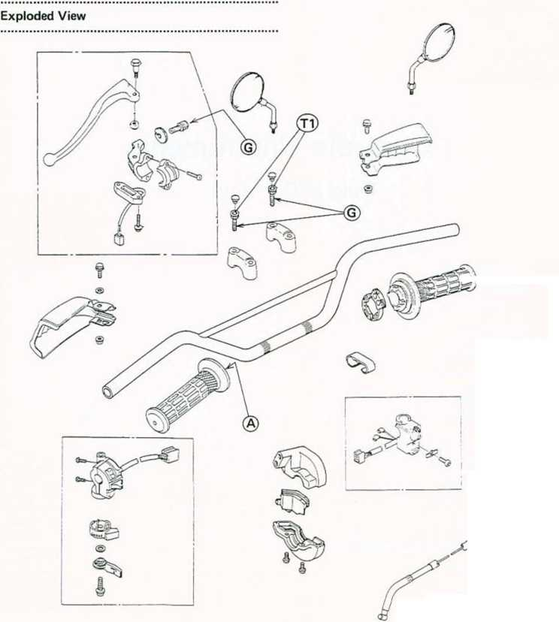
CONTROLS/INSTRUMENTS 12-3

12-4 CONTROLS/INSTRUMENTS
Service Data
Item | Standard
Choke Lever:  Choke cable free play  Throttle Grip:  Throttle grip free play  Clutch:  Clutch lever free play | 2 — 3 mm 2 — 3 mm 2 — 3 mm  10 — 15 mm (at lever end)

CONTROLS/INSTRUMENTS 12-5

Throttle Grip
There are two throttle cables: an accelerator cable for opening the throttle valve, and a decelerator cable for closing it.
If the throttle grip has excessive free play due to cable stretch or misadjustment, there will be a delay in throttle response. Also, the throttle valve may not open fully at full throttle.
On the other hand, if the grip has no play, the throttle will be hard to control, and the idle speed will be erratic. Check the throttle grip play periodically in accordance with the Periodic Maintenance Chart, and adjust the play if necessary.
Inspection
•Check that there is 2 — 3 mm throttle grip free play when lightly turning the throttle grip back and forth.
Adjustment
•Loosen the locknuts, and screw both throttle cable adjusting nuts in fully at the upper ends of the throttle cables to give the throttle grip plenty of play.
•With the throttle grip completely closed, turn out the decelerator cable adjusting nut until the inner cable just becomes tight.
•Tighten the locknut.
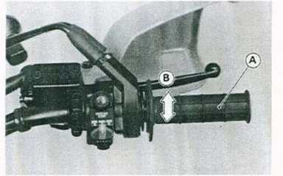
A. Throttle Grip B. 2 — 3 mm
•With the throttle grip closed, check that the decelerator inner cable is tight by touching it at the lower end.
- Accelerator Cable Adjusting Nut C. Locknuts
- Decelerator Cable Adjusting Nut
•Turn the accelerator cable adjusting nut until the correct throttle grip free play is obtained.
•Tighten the locknut.
NOTE
oIf the throttle cables cannot be adjusted by using the cable adjuster nuts at the upper ends of of the throttle cables, use the cable adjusters at the lower ends of the throttle cables. Do not forget to securely tighten the adjuster locknuts after adjustment.
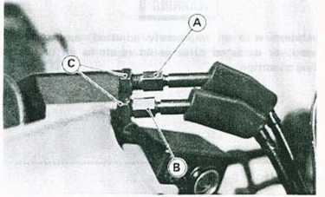
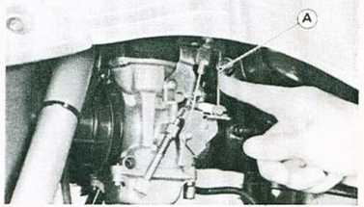
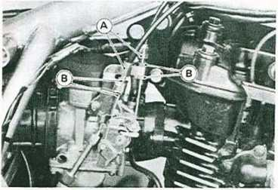
A. Cable Adjusters B. Locknuts
- Decelerator Inner Cable
*lf the throttle grip free play is incorrect or the decelerator inner cable is loose with the throttle closed, adjust the throttle grip.

| WARNING |
cBe sure the upper ends of the outer cables are fully seated in their adjusting nuts, or they could slip into place later, creating enough grip play to prevent

12-6 CONTROLS/INSTRUMENTS
throttle operation, resulting in a hazardous riding conditions.
•Start the engine.
•Turn the handlebar from side to side while Idling the engine.
*lf Idle speed varies, the throttle cables may be poorly routed or they may be damaged.
•Correct any problem before operating the motorcycle.

WARNING^
oOperation with an improperly adjusted, incorrectly routed, or damaged cable could result in an unsafe riding condition.
Meter Unit

Removal
•Remove the headlight cover and connector cover.
•Disconnect the 9-pin meter connector.
•Remove the meter mounting nuts and the speedometer cable nut, and take off the meter unit.
- Meter Mounting Nuts C. Meter 9-pin Connector
- Speedometer Cable Nut (White)
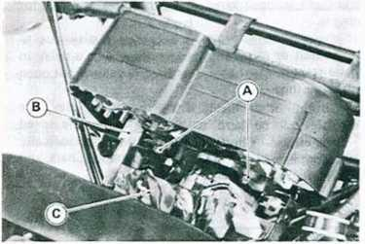
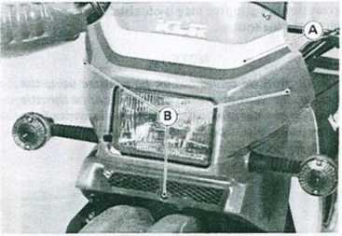
A. Headlight Cover B. Screws
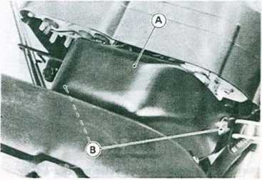
A. Connector Cover B. Screws

FRAME 13-1

Frame

Table of Contents
Exploded View 13-2
Disassembly Flow Chart — Chassis 13-4

[¡0

13-2 FRAME
Exploded View
Californian Model
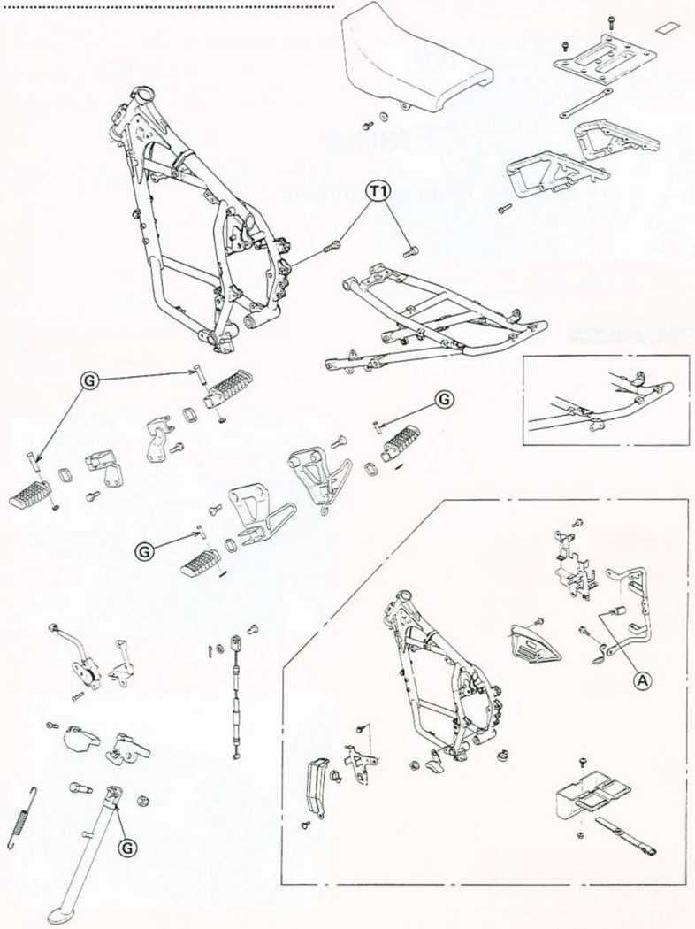
FRAME 13-3
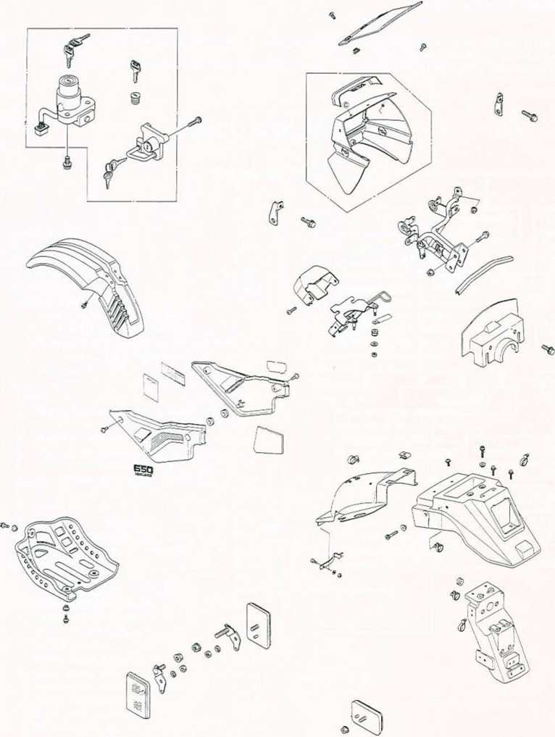
A : Adhesive G : Grease
T1 : 25 N-m (2.5 kg-m, 18.0 ft-lb)
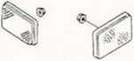

13-4 FRAME
Disassembly Flow Chart — Chassis
oThis chart is designed to aid in determining proper removal sequence. Select the component you wish to remove and follow the arrows to that point on the chart.
•Set the motorcycle up on a stand or jacks so that It Is stable during the removal and installation operations.
Motorcycle
Front
brake
caliper
Headlight
cover
Switch
connectors
Front
wheel
Meter
unit
— Clutch cable
Brake hose <ir
— Throttle cables
— Choke cable
Handlebar
Front fender
Front fork
Steering stem, bearings
Seat
Muffler
Harness
connectors
k.
Rear frame
Loosen drive chain
Rear brake caliper
Rear
wheel
Rear shock absorber
Unl-trak
links
Headlight,
bracket
Swing arm
Drive chain
Engine
_3k
Main frame

ELECTRICAL SYSTEM 14-1

Electrical System

Table of Contents
Exploded View 14-2
Service Data 14-4
Special Tools
Precautions 14-5
Battery 14-5
Charging System 14-5
Measuring Regulator/Rectifier
Output Voltage (Loaded)
Measuring Stator Coil Resistance 14-5
Testing Stator Coil Insulation
Regulator/Rectifier Inspection 14-5
Ignition System 14-7
Adjustment 14-7
Spark Plug Cleaning and Gapping 14-7
Removal/Installation 14-7
Magneto Removal or Installation 14-7
Magneto Installation 14-7
Ignition Coil Installation 14-7
Ignition System Maintenance 14-8
Switch Inspection 14-8
Diode Inspection
Ignition Coil Inspection 14-9
CDI Unit Inspection 14-10
Exciter or Pickup Coil Inspection 14-10
Electric Starter System 14-11
Starter Motor Removal 14-11
Installation Points 14-11
Starter Motor Disassembly 14-11
Starter Motor Assembly Points 14-11
Starter Clutch Removal 14-12
Installation Point 14-12
Starter Motor Brush Length 14-12
Brush Spring Inspection 14-12
Commutator Cleaning and Inspection . . 14-12
Armature Inspection 14 13
Brush Plate Inspection 14-13
Positive Brush Assembly Inspection . . . 14-13
Starter Relay Inspection 14-13
Starter Circuit Relay Inspection 14-14
Starter Button Inspection 14-14
Starter Clutch Inspection 14-14
Lighting System 14-15
Headlight Horizontal Adjustment
Headlight Vertical Adjustment 14-15
Headlight Bulb Installation
Headlight, Dimmer, or Passing
Switch Inspection 14-16
Front Brake Light Switch Inspection. . .
Rear Brake Light Switch Adjustment . .
Rear Brake Light Switch Inspection ...
Turn Signal Inspection
Tachometer and Water Temperature Gauge .. 14-16
Disassembly 14-16
Maintenance 14-17
Meter Mounting Inspection
Meter Power Supply Test
Tachometer Inspection 14-17
Water Temperature Gauge
Circuit Check
Water Temperature Sender Check
Radiator Fan 14-17
Initial Check 14-17
Fan Motor Inspection 14-17
Fan Relay Inspection 14-17
Fan Switch Inspection
Wiring Diagram 14-19
‘Refer to Base Manual

14-2 ELECTRICAL SYSTEM
Exploded View
KL650-A4
Non*permanent Locking Agent Molybdenum Disulfide Grease : Silicone Grease
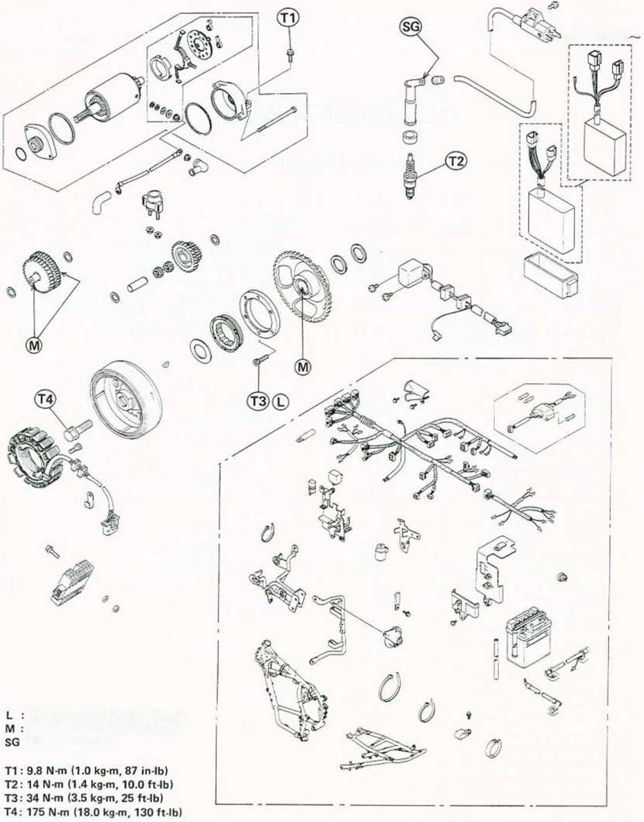
ELECTRICAL SYSTEM 14-3
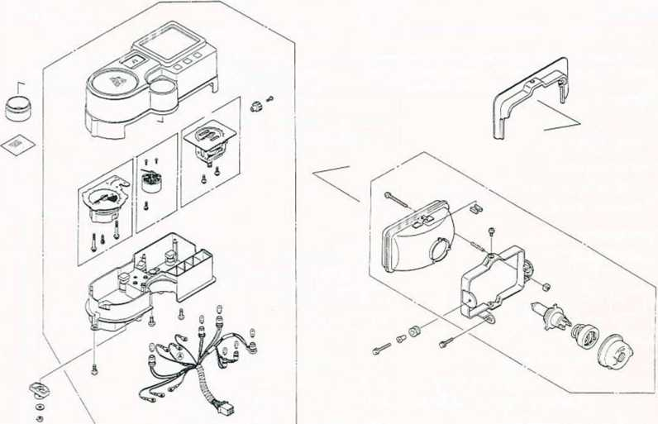

14-4 ELECTRICAL SYSTEM
Service Data
Item | Standard | Service Limit
Battery:
Electrolyte level | Between upper and lower levels
Specific gravity | 1.280 @20°C (68° F)
Charging System:
Regulator/rectifier output voltage | Battery - 15 V
Magneto stator coil resistance | 0.3 - 1.0 n
Ignition System:
Sparkplug: Type | NGK DPR8EA-9 or ND X24EPR-U9 ®(D©(Q> NGK DP8EA-9 or ND X24EP-U9
Gap | 0.8 — 0.9 mm
Ignition coil:
Arcing distance | 7 mm or more (3-needle method)
Primary winding resistance | 0.15-0.21 n
Secondary winding resistance | 3.8 — 5.8 kii
Exciter coil resistance | 100- 200 n
Pickup coil resistance | 100- 150 12
Electric Starter System:
Starter motor: Carbon brush length | 12.0- 12.5 mm | 6 mm
Commutator diamater | 28 mm | 27 mm
Meter Unit:
Water temperature sender resistance | 47 — 57 Si @80°C(176°F) 26 -30fl @100°C (212°F)
Radiator Fan:
Radiator fan switch: ON | Above 94- 100°C (201 -212°F)
OFF | Below 91°C (196°F)
@ : Australian Model ©: Italian Model
© : South African Model
<0> : US Model

ELECTRICAL SYSTEM 14-5
Precautions
Refer to the Base Manual, noting the following. oBecause of the large amount of current, never keep the starter button pushed when the starter motor will not turn over, or the current may burn out the starter motor windings.
Battery
Refer to the Base Manual, noting the following. •Refer to Cable, Wire, and Hose Routing in the chapter 1 for the battery vent hose routing.
Charging System
Charging System Wiring Diagram
W —
-W'
J-BR
J
®
-BR-
- Charging Coils (Magneto)
- Regulator/Rectifier
- Ignition Switch
Measuring Stator Coil Resistance
Refer to the Base Manual, noting the following.
©
77T
- Fuse 20A
- Battery
- Loads
Regulator/Rectifier Inspection Rectifier Circuit Test:
•Remove the regulator/rectifier.
Stator Coil Resistance
Meter Connections:
Lead location
Meter range
One meter load
Another meter lead
Meter Reading
Female magneto connector
(disconnected)
x 1 ft
One yellow lead
Other yellow lead
0.3- 1.0 ft
A. Regulator/Rectifier
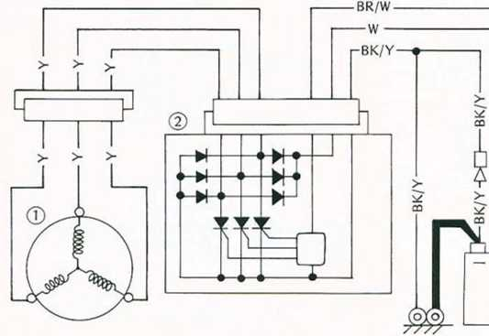
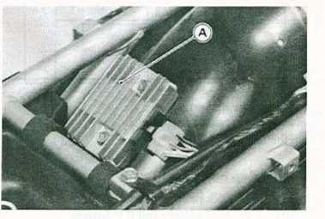
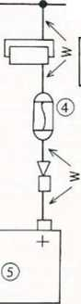
14-6 ELECTRICAL SYSTEM
•Zero the ohmmeter, and connect it to the regulator/ rectifier terminals.
•Check the resistance between the terminals following the table.
★The resistance should be low in one direction and more than ten times as much in the other direction. If any two leads are low or high in both directions, the rectifier is defective and must be replaced.
NOTE
oThe actual meter reading varies with the meter used and the individual rectifier, but, generally speaking the lower reading should be from zero to the first % of the scale.
Regulator/Rectifier Terminal
B (Battery) Terminal M (Monitor) Terminal
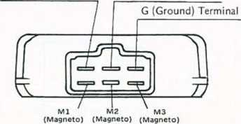
Rectifier Circuit Inspection
No. | Connections |  | Reading | Meter  Range
No. | Meter (+) to | Meter (-) to | Reading | Meter  Range
1 | Ml
2 | M2 | B | OO
3 | M3
4 | Ml
5 | M2 | G |  | x ion
6 | M3 |  | 0 - | or
7 |  | Ml | Vz scale | x 100 Î2
8 | B | M2
9 |  | M3
10 |  | Ml
11 | G | M2 | OO
12 |  | M3
Regulator Circuit Test:
•Remove the regulator/rectifier.
•Prepare the test tools shown.
Tools for Regulator Circuit Test
Test light -* Bulb rated 12 V and 3 — 6 W
Batteries -*■ 12 V battery and 6 V battery
Test wires -*• 5 auxiliary wires
•Connect the test light and the 12 V battery to the regulator/rectifier as shown.
•Check M1, M2, and M3 terminals respectively.
Regulator Circuit Test-1 st Step
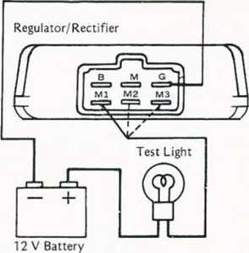
CAUTION
OThe test light limits the current flow through the regulator/ rectifier. Do not use an ammeter or multimeter in its place.
★If the test light turns on, the regulator/rectifier is defective. Replace it.
★If the test light does not turn on, continue the test. •Momentarily apply 12 V to the voltage monitoring terminal.
•Check Ml, M2, and M3 terminals respectively.
Regulator Circuit Test-2nd Step
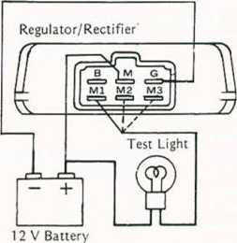

ELECTRICAL SYSTEM 14-7
*lf the test light turns on, the regulator/rectifier is defective. Replace it.
*lf the test light does not turn on, continue the test. •Momentarily apply 18 V to the voltage monitoring terminal by adding a 6 V battery.
•Check Ml, M2, and M3 terminals respectively.
CAUTION
Do not apply more than 18 V to the regulator/rectifier and do not leave the 18 V applied for more than a few seconds, or the unit will be damaged.
Regulator Circuit Test-3rd Step
6 V Battery
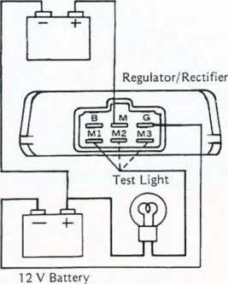
*lf the test light did not light when the 18 V was applied momentarily to the voltage monitoring terminal, the regulator/rectifier is defective. Replace it.
*lf the regulator/rectifier passes all of the tests described, it may still be defective. If the charging system still does not work properly after checking all of the components and the battery, test the regulator/rectifier by replacing it with a known good unit.
Ignition System
Adjustment:
Spark Plug Cleaning and Gapping
Refer to the Base Manual, noting the following.
Standard Spark Plug
Plug Type: NGK DPft8EA-9 or ND X24EPR-U9
@Q>©<0> NGK DP8EA-9 or ND X24EP-U9 Plug Gap: 0.8 — 0.9 mm
Tightening Torque: 14 N-m (1.4 kg-m, 10.0 ft-lb)
@ : Australian Model
0 : Italian Model
(§) : South African Model
© : US Model
Removal/Installation:
Magneto Removal or Installation
Refer to the Base Manual, noting the following.
- Replace the magneto flywheel bolt with a new one. This bolt is required to replace if it has been tightened once to the specified torque.
•Tightening procedure of the magneto flywheel bolt is the following.
oTighten the magneto flywheel bolt to 120 N-m (12.0 kg-m, 87 ft-lb) of torque. Do not overtighten it now.
OLoosen the bolt and then tighten it again to the same torque (above).
oFinally, tighten the bolt to the specified torque.
Tightening Torque
Magneto Flywheel Bolt:
175 N-m (18.0 kg-m. 130 ft-lb)
^cautTotT
oUse a 6-point socket instead of a 12-point one to tighten the flywheel bolt to the specified torque.
Ignition Coil Installation
•Connect the primary leads to the ignition coil terminals as shown in the figure.
Ignition Coil Terminals
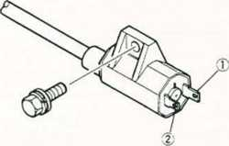
1. (+) Terminal <- BK 2. (-) Terminal «- BK/Y

14-8 ELECTRICAL SYSTEM
Ignition System Maintenance: Ignition System Wiring Diagram
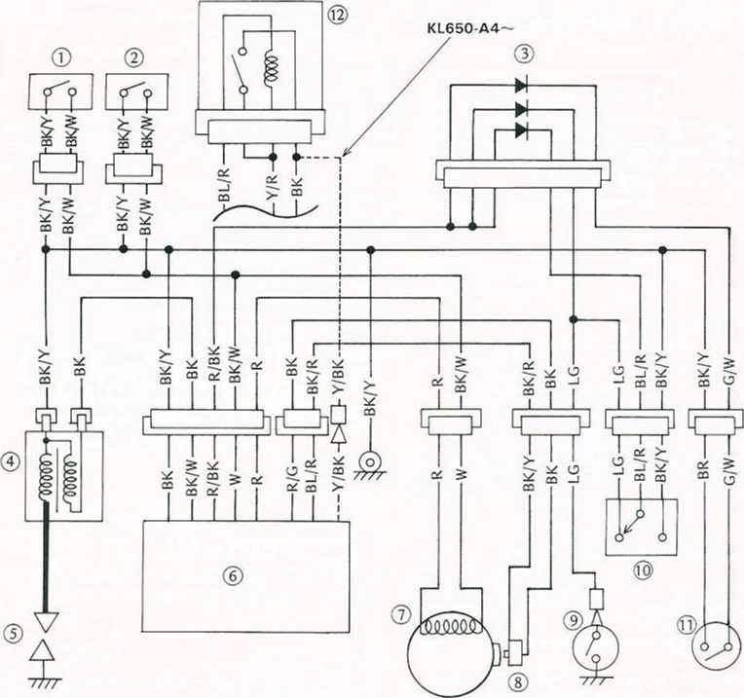
- Ignition Switch
- Engine Stop Switch
- Diodes
- Ignition Coil
- Spark Plug
- CDI Unit
- Exciter Coil (Magneto)
- Pickup Coil
- Neutral Switch
- Starter Lockout Switch
- Side Stand Switch
- Starter Circuit Relay
Engine Stop Switch and Starter Button Connections
Engine Stop Switch |  |  |  |  | Starter Button
OFF  RUN | BK/W | BK/Y | BR |  |  | Y/R | Pushed
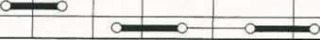
Switch Inspection
Refer to the Base Manual, noting the following.
Starter Lockout Switch Connections
Color | BK/Y | BL/R | LG
When the clutch lever is pulled on
When the clutch lever is released

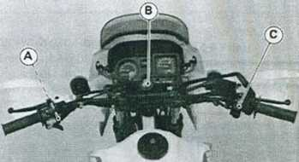
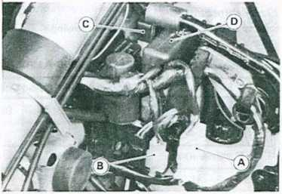
ELECTRICAL SYSTEM 14-9
- Starter Lockout Switch C. Engine Stop Switch
- Ignition Switch
- Magneto 6-pin Connector
- Neutral Switch and Pickup Coil 3-pin Connector
- Diodes
- CDI Unit
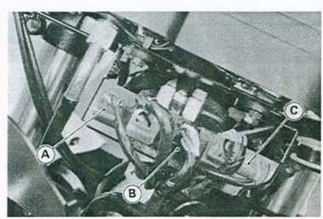
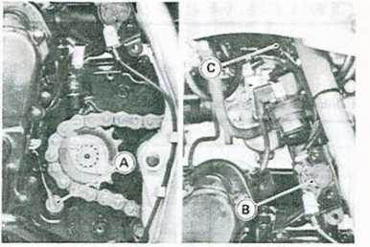
- Engine Stop Switch 6-pin Connector (Red)
- Ignition Switch 6-pin Connector (Black)
- Starter Lockout Switch 3-pin Connector
Ignition Coil Inspection
Refer to the Base Manual, noting the following.
Ignition Coil Test (Arcing Distance)
® Bif:
-Ç (?+ <j)4
- Neutral Switch
- Side Stand Switch
- Side Stand Switch 2-pin Connector
Ignition Coil Winding Resistance
©
o |  | o
-►d
- Measure primary winding resistance.
- Measure secondary winding resistance.
- Ignition Coil
- Electro Tester: 57001-980
- Ignition Coil
Ignition Coil Resistance
Primary: 0.15 — 0.21 fl
Secondary: 3.8 — 5.8 k£2

14-10 ELECTRICAL SYSTEM
CDI Unit Inspection
Refer to the Base Manual, noting the following.
CDI Unit Internal Resistance {KL500, KL650-A1 .A2.A3I Unit : kß
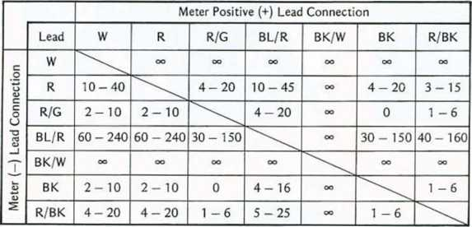
CDI Unit Internal Resistance (KL650-A4~) Unit : kQ
 |  | Meter Positive ( + ) Lead Connection
 | Lead | W | R | R/C | BL/R | BKAV | BK | Y/BK
c | W |  | OO | OO | OO | OO | CO | OO
u  o | R | 10-55 |  | 5-25 | 5-35 | OO | 5-25 | 20-90
c  o  t I | R/C | 2-10 | 2-10 |  | 1-6 | OO | 0 | 10-50
—  ■z  CJ | BIVR | 4-20 | 4-20 | 1-6 | \ | OO | 1 -6 | 10-55
T | BKAV | CO | OO | OO | OO | \ | CO | OO
£ | BK | 2-10 | 2-10 | 0 | 1-6 | OO | \ | 10-50
5 | Y/BK | 15-80 | 15-80 | 10-50 | 10-55 | OO | 10-50 | \
Exciter or Pickup Coil Inspection
Refer to the Base Manual, noting the following.
Resistance of Exciter and Pickup Coil Meter : x10S2
Connections female connectors (disconnected) W - R : 100 - 200 H (Exciter Coil )
BK/Y-BK : 100 - 150 fi (Pickup Coil)

ELECTRICAL SYSTEM 14-11
Electrical Starter System
•Take the armature out of the yoke housing.
•Remove the brush plate assembly from the housing.
Starter Motor Removal •Remove the muffler and exhaust pipe.
•Disconnect lead from starter motor terminal.
•Unscrew starter motor mounting bolts and pull the starter motor out of its guide.
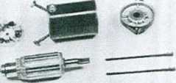
•Remove the nut and remove the terminal bolt, and then remove the positive brush assembly with the plastic holder.
- Mounting Bolts C. Ground Lead
- Starter Motor Terminal
Starter Motor Assembly Points •Push the brush plate into place with its tab fitting in the yoke housing notch.
CAUTION
Do not tap the starter motor shaft or body. Tapping on the shaft or body could damage the motor.
Installation Points
•When installing the starter motor, clean the starter motor legs and crankcase where the starter motor is grounded.
•Apply a small amount of engine oil to the O-ring.
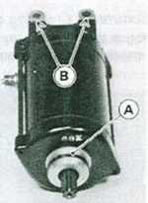
A. Tab B. Notch
•Install the brush end cover so that the long vertical tab on the brush plate aligns with the key slot in the cover.
A. O-ring
B. Clean here.
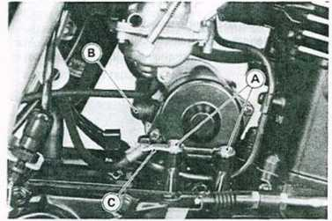
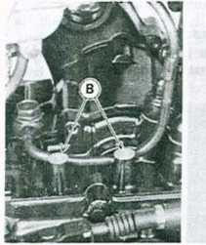
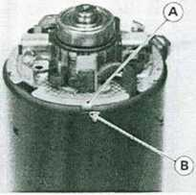
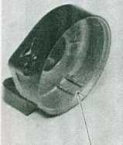
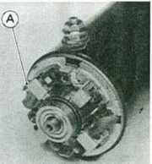
Starter Motor Disassembly '₈
•Unscrew the retaining screws and pull off both end covers. A. Long Tab B. Key Slot

14-12 ELECTRICAL SYSTEM
•As a further check, these marks should align on the outside of the starter.
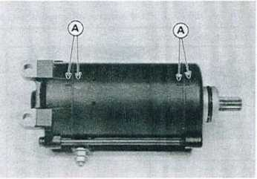
A. Align marks.
Starter dutch Removal
•Pull off the magneto flywheel from the crankshaft. •Holding the magneto flywheel in a vise, remove the Allen bolts.
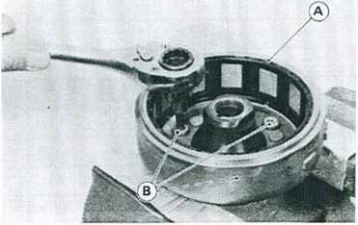
A. Magneto Flywheel B. Starter Clutch Allen Bolts •Separate the starter clutch assembly.
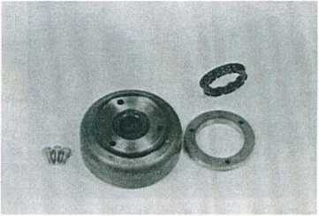
Installation Point
•Apply a non-permanent locking agent to the threads of the Allen bolts and tighten them to the specified torque.
Tightening Torque
Starter Clutch Bolts: 34 N-m (3.5 kg-m, 25 ft-lb)
Starter Motor Brush Length •Measure' the length of each brush.
*lf any is worn down to the service limit, replace all brushes.
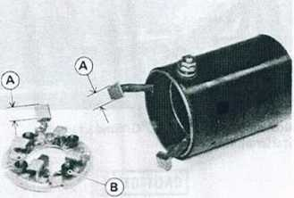
A. Measure brush length. B. Brush Spring
Brush Spring Inspection
•Check that the brush springs are in place and snap the brushes firmly Into place.
★If not, reinstall or replace the spring.
Commutator Cleaning and Inspection •Smooth the commutator surface If necessary with fine emery cloth, and clean out the grooves.
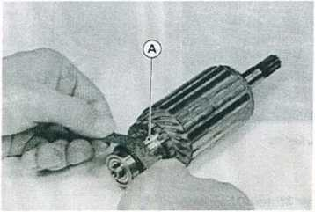
A. Commutator

ELECTRICAL SYSTEM 14-13
•Measure the diameter of the commutator.
♦Replace the starter motor with a new one if the commutator diameter is less than the service limit.
Armature Inspection
•Using the x 1 £2 ohmmeter range, measure the resistance between any two commutator segments. *lf there is a high resistance or no reading (“>) between any two segments, a winding is open and the starter motor must be replaced.
•Using the highest ohmmeter range, measure the resistance between the metal plate and the positive brush holders.
*lf there is any reading at all, the brush holder has a short and the brush plate must be replaced.
- Segment B. Shaft
•Using the highest ohmmeter range, measure the resistance between the commutator and the shaft.
*lf there Is any reading at all, the armature has a short and the starter motor must be replaced.
Even if the foregoing checks show the armature to be good, it may be defective in some manner not readily detectable with an ohmmeter. If all other starter motor and starter motor circuit components check good, but the starter motor still does not turn over or only turns over weakly, replace the starter motor with a new one.
Positive Brush Assembly Inspection •Using the x 1 il ohmmeter range, measure the resistance between the positive brush and the terminal bolt.
♦If there is a high resistance or no reading (“), a lead is open and the brush assembly must be replaced.
•Using the highest ohmmeter range, measure the resistance between the terminal bolt and the pole housing.
★If there is any reading at all, the insulation is faulty and the positive brush assembly must be replaced.
Brush Plate Inspection
•Using the x 1 ohmmeter range, measure the resistance between the negative brushes and the plate.
*lf there is not close to zero ohms, the brush plate must be replaced.
Starter Relay Inspection
•Disconnect the starter motor lead and battery positive (+) lead from the starter relay.
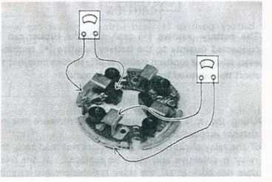
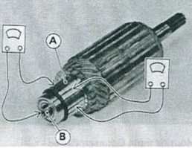
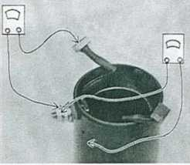

14-14 ELECTRICAL SYSTEM

CAUTION
OThe battery positive (+) lead with the rubber cap is connected directly to the battery positive (+) terminal even when the ignition switch is off, so take care not to short the removed lead to chassis ground.
Starter Button Inspection
•Using an ohmmeter, check to see that only the connections shown in the table have continuity (about zero ohms).
*If the switch has an open or short, repair it or replace it with a new one.
•Using the x 1 i2 ohmmeter range, measure the resistance across the relay terminals.
*lf the relay clicks but the meter does not read zero, the relay is defective and must be replaced. If the relay does not click at all, the relay is defective and must be replaced.
*lf the relay makes a single clicking sound and the meter reads zero the relay is good. The trouble Is in the starter motor or the motor power supply wires.
Switch Position:
Ignition switch ON Engine stop switch RUN Starter button ON
Neutral switch ON (Transmission is in Neutral)
Meter Connection:
Location Starter relay terminals
(leads disconnected)
Meter Range x 1 S2
Meter Reading: 0 £1 and relay clicks when starter
button is pushed.
Starter Button Connections*
 | BR | Y/R
Push
*When engine stop switch is RUN.
A. RH Switch Housing 6-pin Connector (Red)
Starter Clutch Inspection
- Remove the alternator cover and starter idle gear, and turn the starter clutch gear by hand. The starter clutch gear should turn clockwise freely, but should not turn counterclockwise.
*lf the clutch does not operate as it should or if It makes noise, disassemble the starter clutch, examine each part visually, and replace any worn or damaged parts.
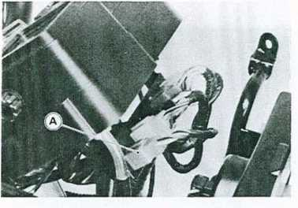
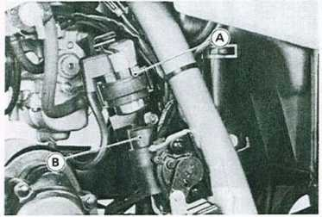
A. Starter Relay B. Starter Circuit Relay
Starter Circuit Relay Inspection
Starter circuit relay inspection Is the same as the radiator fan relay inspection. Refer to the Fan Relay Inspection is the Base Manual.
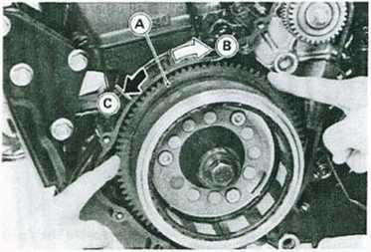
- Starter Clutch Gear C. Locked.
- Turns freely.

Electric Starter System Wiring Diagram
ELECTRICAL SYSTEM 14-15
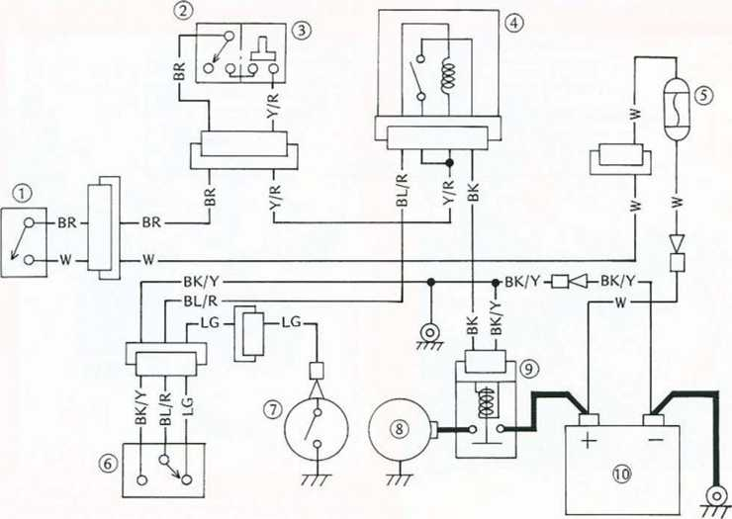
- Ignition Switch
- Engine Stop Switch
- Starter Button
- Starter Circuit Relay
- Fuse 20A
- Starter Lockout Switch
- Neutral Switch
- Starter Motor
9. Starter Relay 10. Battery
NOTE
oStarter dutch inspection can be done by removing the
starter motor.
Lighting System
Headlight Vertical Adjustment
Refer to the Base Manual, noting the following. •Loosen the headlight lower mounting bolt.
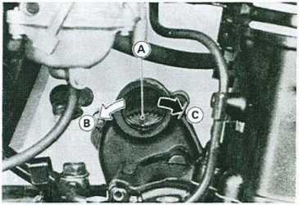
- Starter Idle Gear C. Locked.
- Turns Freely. A. Headlight Lower Mounting Bolt
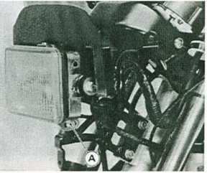

14-16 ELECTRICAL SYSTEM
Headlight, Dimmer, or Passing Switch Inspection Refer to the Base Manual, noting the following.
Headlight, Dimmer, or Passing Switch Connections (Other than US and Canada)
Headlight Switch |  |  |  | Dimmer Switch |  |  |  | Passing Button
Color | BR | R/W |  | Color | R/BK |  | R/Y | Color | BR I R/BK*
ON |  |  |  | HI | O— | —Í
OFF |  |  |  |  |  | -- |  | Push | CmmmmD
PO |  |  |  | LO |  | Ö—I | —C |  | I
*R/Y for Italian Model
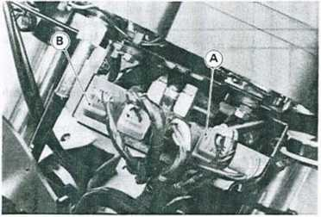
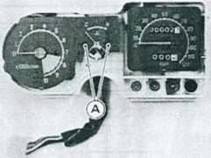
- LH Switch Housing 9-pin Connector (Red) A. Screws
- RH Switch Housing 6-pln Connector (Red)
•Remove the tachometer or water temperature gauge.
Tachometer and Water Temperature Gauge
Disassembly:
•Remove the meter cover.
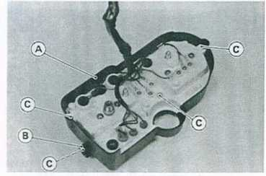
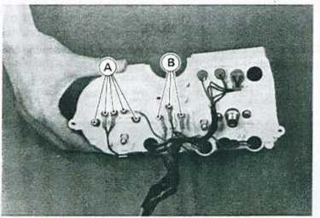
- Tachometer Mounting Screws
- Water Temperature Gauge Mounting Screws
- Meter Cover
- Knob
C. Screw

ELECTRICAL SYSTEM 14-17
Maintenance:
Refer to the Base Manual, noting the following.
Fan Motor Inspection
Refer to the Base Manual, noting the following.
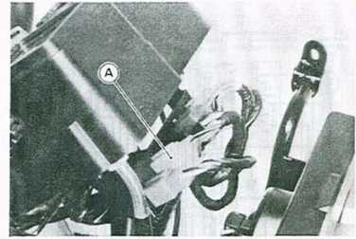
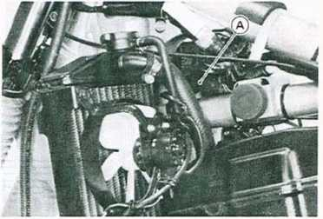
A. Meter 9-pin Connector (White) A. Radiator Fan Connector
Tachometer Inspection Fan Relay Inspection
Refer to the Base Manual, noting the following.
NOTE
oThe tachometer inspection is explained on the assump-
tion that the ignition system operates normally.
•Turn the ignition switch ON.
•With the BK/Y and the BR lead connected, open or
connect the BK lead to the BR lead repeatedly using an
auxiliary wire. Then the tachometer hand should flick.
★If the hand does not flick, replace the tachometer unit.
Radiator Fan
Initial Check
Refer to the Base Manual, noting the following.
•The radiator and radiator fan assembly is mounted to left lower side of the frame head pipe.
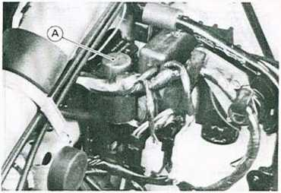
A. Fan Relay
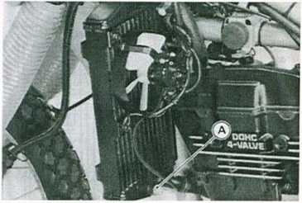
A. Radiator Fan Switch

Wiring Diagram
Front Brake Light Switch
Right Handlebar Switches ©Starter Button ©Engine Stop Switch
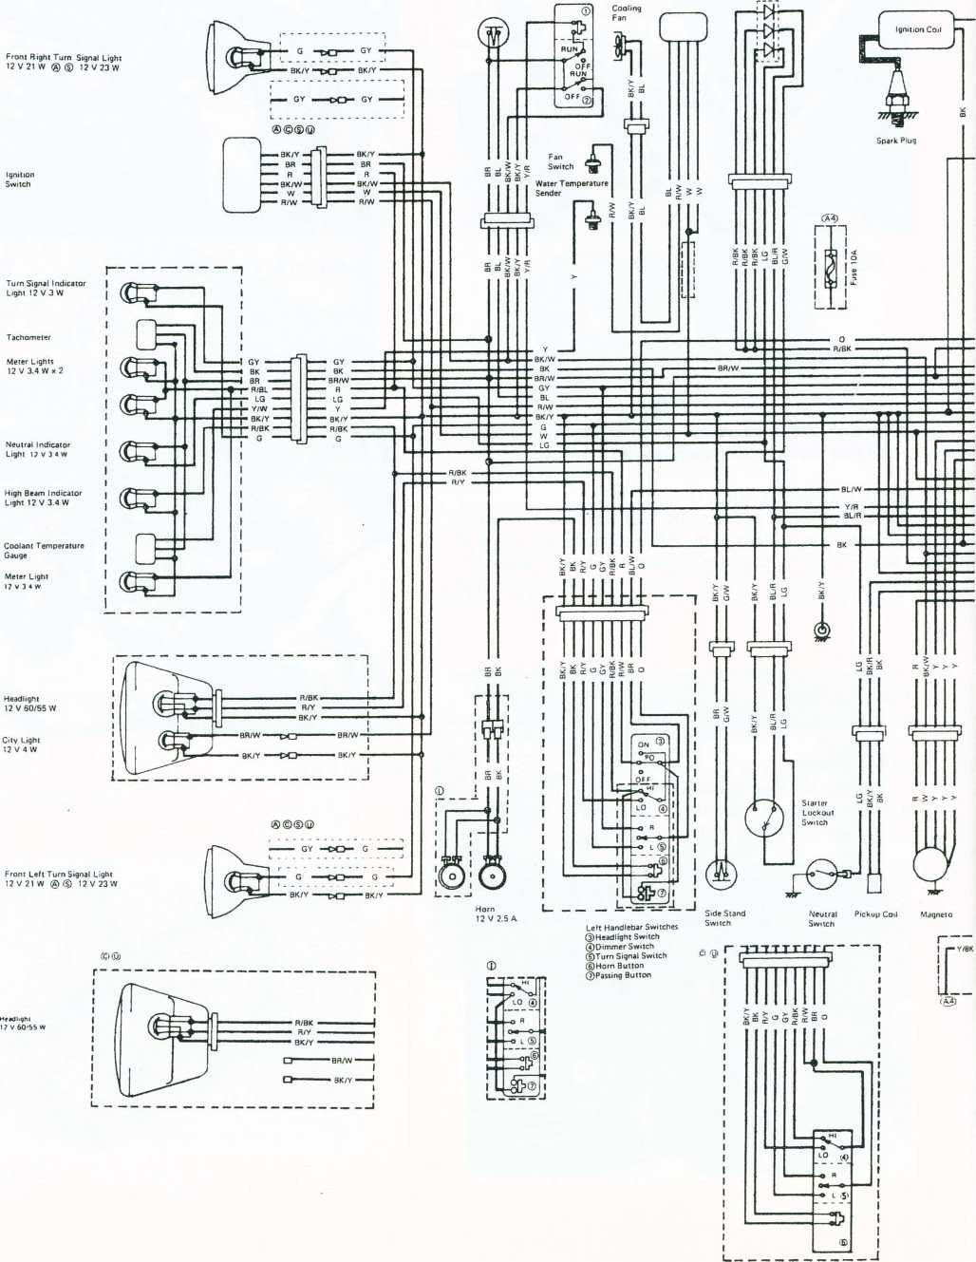

14-19
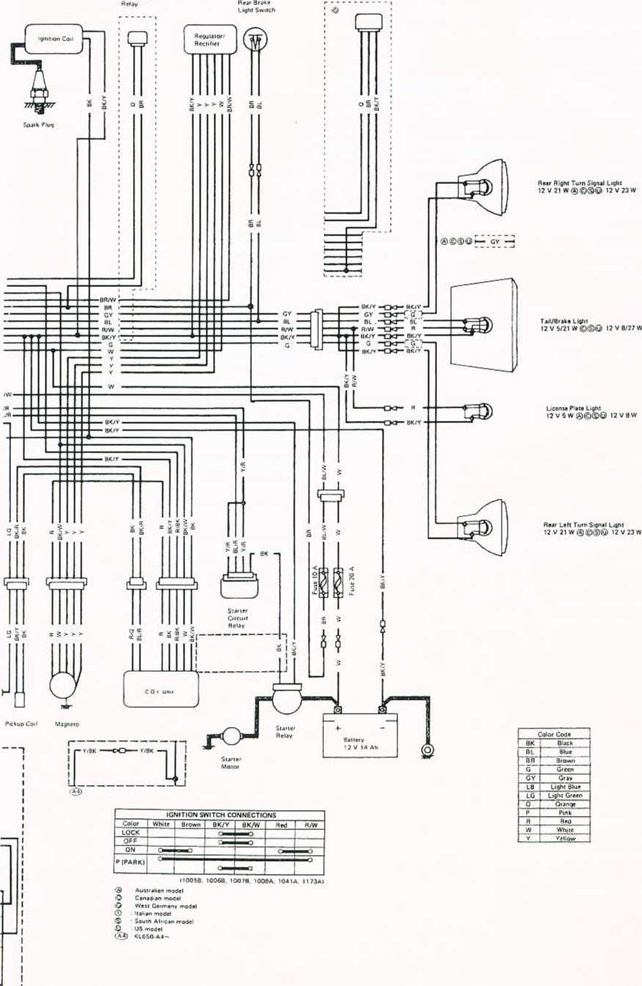

APPENDIX 15-1

Appendix

Table of Contents
Additional Considerations for Racing
Carburetor
Spark Plug
Spark Plug Inspection
Troubleshooting Guide 15-2
General Lubrication 15-2
Lubrication 15-2
Nut, Bolt, and Fastener Tightness 15-2
Tightness Inspection 15-2
Unit Conversion Table
'Refer to Base Manual

15-2 APPENDIX
Troubleshooting Guide
Refer to the Base Manual, adding the following.
Engine Doesn't Start, Starting Difficulty: Starter motor not rotating:
Starter motor damaged Battery voltage low Relay not contacting or operating Starter button not contacting Wiring open or shorted Ignition switch damaged Engine stop switch damaged Engine stop switch off Fuse blown
Starter lockout or neutral switch damaged Starter motor rotating but engine doesn't turn over:
Starter motor clutch damaged Alternator rotor bolt loosened
General Lubrication
Lubrication
•Before lubricating each part, clean off any rusty spots with rust remover and wipe off any grease, oil, dirt, or grime.
•Lubricate the points listed below with indicated lubricant.
NOTE
■ Whenever the vehicle has been operated under wet or rainy conditions, or especially after using a high- pressure spray water, perform the general lubrication.
Pivots: Lubricate with Motor Oil.
Side Stand Clutch Lever Brake Lever Brake Pedal Rear Brake Rod Joint
Points: Lubricate with Grease.
Throttle Inner Cable Lower Ends Clutch Inner Cable Upper End Side Stand Switch Inner Cable Lower End Speedometer Inner Cable*
*Grease the lower part of the inner cable sparingly.
Cables: Lubricate with Rust Inhibitor.
Choke Cable Throttle Cables Clutch Cable Side Stand Switch Cable
Cable Lubrication
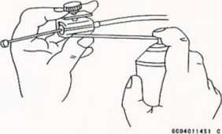
Nut, Bolt, and Fastener Tightness
Tightness Inspection
•Check the tightness of the bolts and nuts listed here. Also, check to see that each cotter pin Is In place and In good condition.
NOTE
oFor the engine fasteners, check the tightness of them when the engine is cold tat room temperature).
*lf there are loose fasteners, retorque them to the specified torque following the specified tightening sequence. Refer to the appropriate chapter for torque specifications. If torque specifications are not in the appropriate chapter, see the basic torque table (see Torque and Locking Agent In the General Information chapter).
For each fastener, first loosen It by '/i turn, then tighten it.
*lf cotter pins are damaged, replace them with new ones.
Nut, Bolt, and Fastener to be checked
Wheels:
Front Axle Nut Front Axle Nut Cotter Pin Rear Axle Nut Rear Axle Nut Cotter Pin Brakes:
Front Master Cylinder Clamp Bolts Front Caliper Mounting Bolts Rear Master Cylinder Mounting Bolts Rear Master Cylinder Bracket Bolts Rear Caliper Mounting Bolts Brake Lever Pivot Nut Brake Pedal Bolt Brake Rod Joint Cotter Pin

APPENDIX 15-3
Suspension:
Front Fork Clamp Bolts and Nuts Rear Shock Absorber Mounting Bolts and Nuts Swing Arm Pivot Shaft Nut Uni-trak Rocker Arm Pivot Nut Uni-trak Tie-rod Bolts and Nuts Steering:
Stem Head Nut Handlebar Clamp Bolts Engine:
Engine Mounting Bolts and Nuts Cylinder Head Bolts Cylinder Head Nuts Exhaust Pipe Holder Nuts Exhaust Pipe Mounting Bolt Muffler Mounting Bolts and Nuts Exhaust Pipe and Muffler Connecting Clamp Bolt Radiator Mounting Bolts Shift Pedal Bolt Others:
Side Stand Nut Rear Frame Mounting Bolts Clutch Lever Holder Clamp Screws Clutch Lever Pivot Nut Footpeg Bracket Mounting Bolts Footpeg Pivot Cotter Pins Rear Carrier Mounting Bolts

SUPPLEMENT - 2000 - 2001 MODELS 16-1
Supplement - 2000 - 2001 Models
Table of Contents
Foreword 16-2
General Information 16-3
Model Identification -...16-3
General Specifications 16-4
Torque and Locking Agenl 16-6
Fuel System 16-6
Specifications 16-6
Engine Top End 16-7
Exploded View 16-7
Engine Right Side / Left Side 16-8
Exploded View 16-8
Specifications 16-10
Engine Bottom End / Transmission 16-11
Exploded View 16-11
Final Drive 16-12
Exploded View 16-12
Specifications 16-12
Electrical System 16-13
Specifications 16-13
Wiring Diagram 16-14

16-2 SUPPLEMENT - 2000 - 2001 MODELS

Foreword

How to Use this Manual
This “Supplement - 2000 - 2001 Models" designed to be used in conjunction with the front part of this manual (up to 15-3) and /or Base Manual KLR600 Service Manual - Part No. 99924-1050-01. The specifications and maintenance procedures described in this chapter are only those that are unique to the KL650-A14/A15 model.
Complete and proper servicing of the KL650-A14/A15 model therefore requires mechanics to read both this chapter and the front of this manual.

SUPPLEMENT - 2000 - 2001 MODELS 16-3
General Information Model Identification
KL650-A14 Left Side View
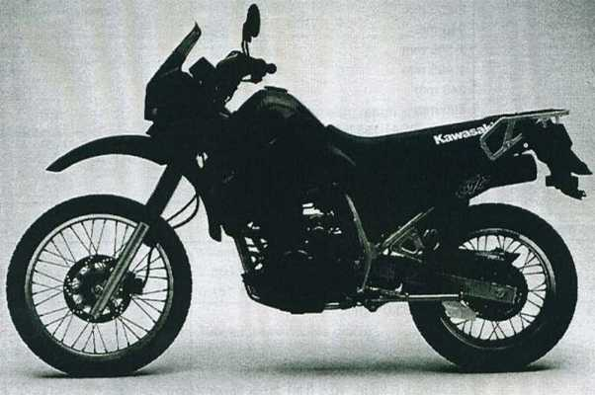
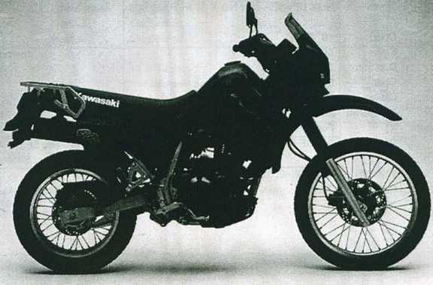

16-4 SUPPLEMENT - 2000 - 2001 MODELS

General Specifications
Items | KL650-A14 | KL650-A15
Dimensions:
Overall length | 2 205 mm
Overall width | 940 mm
Overall height | 1 345 mm
Wheelbase | 1 495 mm
Road clearance | 240 mm
Seat height | 890 mm
Dry weight | 153 kg, (CA) 153.5 kg
Curb weight: Front | 81 kg, (CA) 81.5 kg
Rear | 97 kg
Fuel tank capacity | 23 L
Performance:
Minimum turning radius | 2.4 m
Engine:
Type | 4-stroke, DOHC, 4-valve, 1-cylinder
Cooling system | Liquid-cooled
Bore and stroke | 100.0 x 83.0 mm
Displacement | 651 mL
Compression ratio | 9.5 : 1
Maximum horsepower | 35.3 kW (48PS) @6500 r/mln (rpm)
Maximum torque | 55 N-m (5.6 kg-m, 40.5 ft-lb) @5500r/min (rpm)
Carburetion system | Carburetor, Kelhin CVK40
Starting system | Electric
Ignition system | CDI
Timing advance | Electronically advanced
Ignition timing | From 10° BTDC @1 300 r/min (rpm) to
 | 30* BTDC @3 300r/min (rpm)
Spark plugs | NGK DPR8EA-9 or ND X 24 EPR-U9
Valve timing:
Inlet Open | 19° BTDC
Close | 69° ABDC
Duration | 268'
Exhaust Open | 57“ BBDC
Close | 31° ATDC
Duration | 268
Lubrication system | Forced lubrication (wet sump)
Engine oil: Grade | SE, SF or SG class | API SE, SF or SG
 |  | API SH or SJ with JASO MA
Viscosity | SAE10W40, 10W50, 20W40, or 20W50
Capacity | 2.5 L

SUPPLEMENT - 2000 - 2001 MODELS 16-5
Items | KL650-A14 | KL650-A15
Drive Train:
Primary reduction system:
Type | Gear
Reduction ratio | 2.272 (75/33)
Clutch type | Wet multi disc
Transmission:
Type | 5-speed, constant mesh, return shift
Gear ratios: 1 st | 2.266 (34/15)
2nd | 1.444 (26/18)
3rd | 1.136 (25/22)
4th | 0.954 (21/22)
5th | 0.791 (19/24)
Final drive system:
Type | Chain drive
Reduction ratio | 2.866 (43/15)
Overall drive ratio | 5.157 @Top gear
Frame:
Type | Tubular, semi-double cradle
Caster (rake angle) | 28°
Trail | 112 mm
Front tire: Type | Tube type
Size | 90/90-21 54S
Rear tire: Type | Tube type
Size | 130/80-17 65S
Front suspension: Type | Telescopic fork (pneumatic)
Wheel travel | 230 mm
Rear suspension: Type | Swingarm (uni-trak)
Wheel travel | 230 mm
Brake Type: Front | Single disc
Rear | Single disc
Electrical Equipment:
Battery | 12 V 14 Ah
Headlight: Type | Semi-Sealed beam
Bulb | 12 V 60/55 W (quartz-halogen)
Tail/brake light | 12 V 8/27 W | 12 V 5/21 W
Alternator: Type | Three-phase AC
Rated output | 17 A @7 000 r/min (rpm),14 V
Voltage regulator: Type | Short-Circuit
Specification subject to change without notice, and may not apply to every country. (CA): California Model

16-6 SUPPLEMENT - 2000 - 2001 MODELS
Torque and Locking Agent
Fastener |  | Torque |  | Remarks
Fastener | N-m | Kg-m | ft-lb | Remarks
Engine Right Side/Left Side  Clutch spring bolts | 8.8 | 0.9 | 78 in-lb
Final Drive  Engine sprocket Nut | 98 | 10 | 72
Fuel System specifications
Item | KL650-A14/A15
Carburetor:
Idle speed | 1300± 50r/min (rpm)
Standard specifications:
Make.type | Keihin,CVK40
Main jet | #148
Main air jet | #50
Needle jet | #6
Jet needle | N 31R
Pilot jet | #40
Pilot air jet | #70
Pilot screw | 1 3/8 turns out
Starter jet | #52
Service fuel level | 0.5mm above -1.5mm below the float bowl mating surface.
Float height | 17.5mm
High altitude adjustment
(US model):
Main jet | #145
Pilot jet | #38
Air Cleaner:
Element oil: Grade | SE class
Viscosity | SAE30

SUPPLEMENT - 2000 - 2001 MODELS 16-7

Engine Top End Exploded View
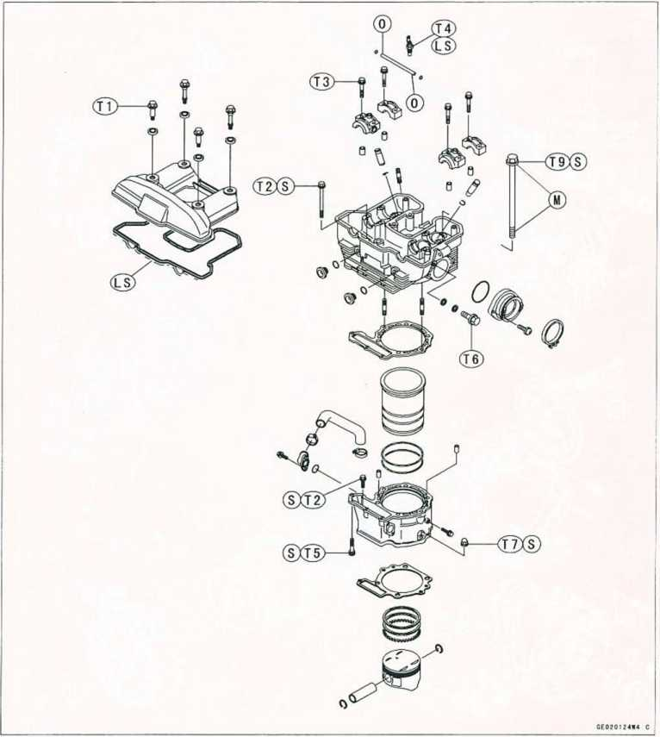
L:Non-permanent Locking Agent LS:Liquid Gasket(Silicone Sealant) M:Molybdenum Disulfide Grease 0:-Engine Oil
S:Follow the specific tightening sequence.
T1:7.8 N-m(0.80 kg-m.69 in-lb) T2:9.8N-m(1.0 kg-m,87 in-lb) T3:12N-m(1.2 kg-m,104 in-lb) T4:15N-m(1.5 kg-m, 11.0 ft-lb) T5:18N-m(1.8 kg-m. 13.0 ft-lb) T6:20N-m(2.0 kg-m.14.5 ft-lb) T7:25N-m(2.5 kg-m,18.0 ft-lb) T8:49N-m(5.0 kg-m,36 ft-lb) T9:65N-m(6.6 kg-m.48 ft-lb)

16-8 SUPPLEMENT - 2000 - 2001 MODELS

Enginr Right Side / Left Side Exploded View
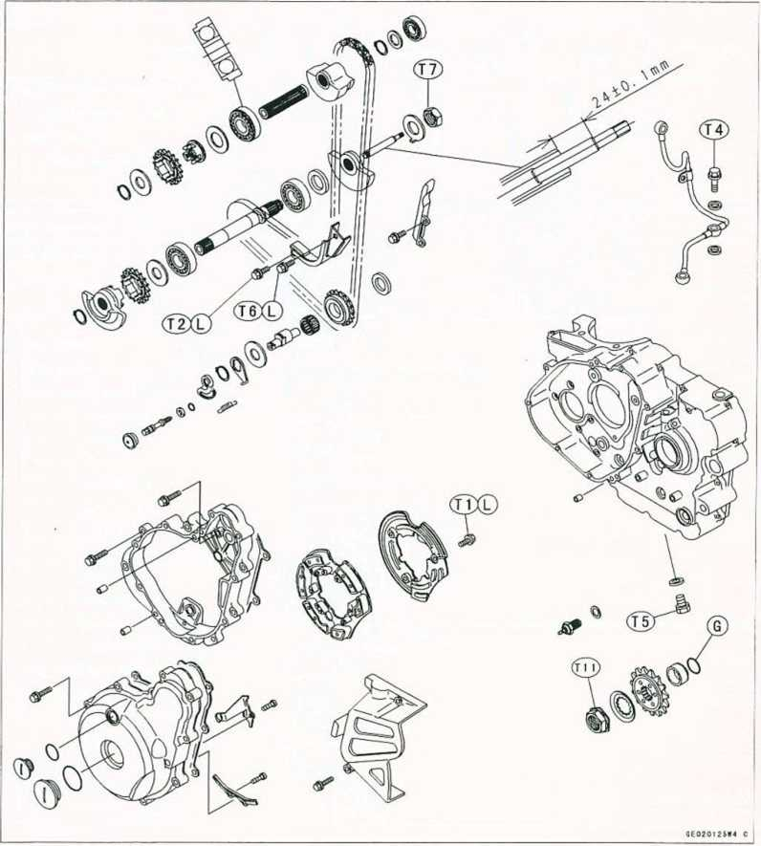
GrGrease
L:Non-permanent Locking Agent M:Molybdenum Disulfide Grease T1:9.8N-m(1.0kg-m,87in-lb) T2:12N-m(1.2kg-m,104in-lb)
T3:15N-m(1.5kg-m.11.0ft-lb)
T4:20N-m(2.0kg-m,14.5ft-lb)
T5:23N-m(2.3kg-m, 16.5ft-lb)
T6:25N-m(2.5kg-m, 18.0ft-lb)
T7:44N-m(4.5kg-m,33ft-lb)
T8:120N-m{12.0kg-m,87ft-lb)
T9:130N-m( 13.5kg-m, 98ft-lb)
T10:8.8N-m(0.9kg-m,78in-lb)
T11:98N-m(10kg-m.72ft-lb)

SUPPLEMENT - 2000 - 2001 MODELS 16-9
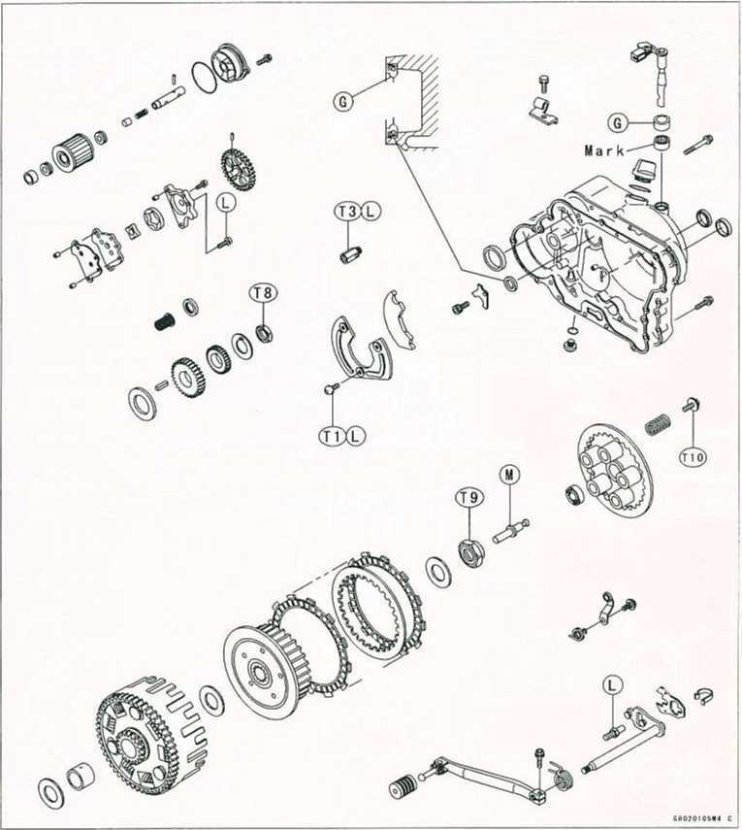

16-10 SUPPLEMENT - 2000 - 2001 MODELS

Specifications
Item | Standard | Service Limit
Clutch:
Clutch lever play | 2-3 mm  10-15 mm (at lever end)
Friction plate thickness | 2.8-3.1 mm | 2.6 mm
Friction, steel plate warp | Less than 0.2 mm | 0.3 mm
Clutch spring free length | 38.7 mm | 36.4 mm
Engine Lubrication System:
Engine oil: Grade | SE. SF, or SG class  (On and After KL650-A15)  API SE, SF or SG  API SH or SJ with JASO MA
Viscosity | SAE 10W40, 10W50.20W40, or 20W50
Amount | 2.2 L (filter is not removed)
 | 2.5 L (filter is removed)
Level | Between upper and lower level lines
Relief valve opening pressure | 430 - 590 kPa (4.4 - 6.0 kg/cm², 63 - 85 psi)
Oil pressure | 78- 147 kPa
@4000 rpm (r/mln), 90‘C (194“F) | (0.8 - 1.5 kg/cm², 11-21 psi)

SUPPLEMENT - 2000 - 2001 MODELS 16-11
Engine Bottom End/Transmission
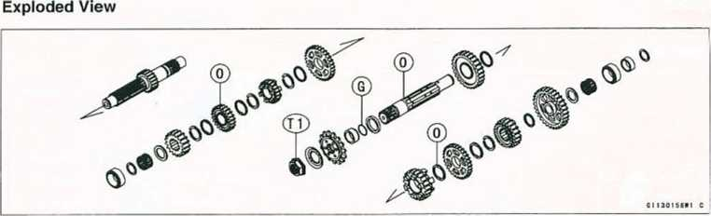
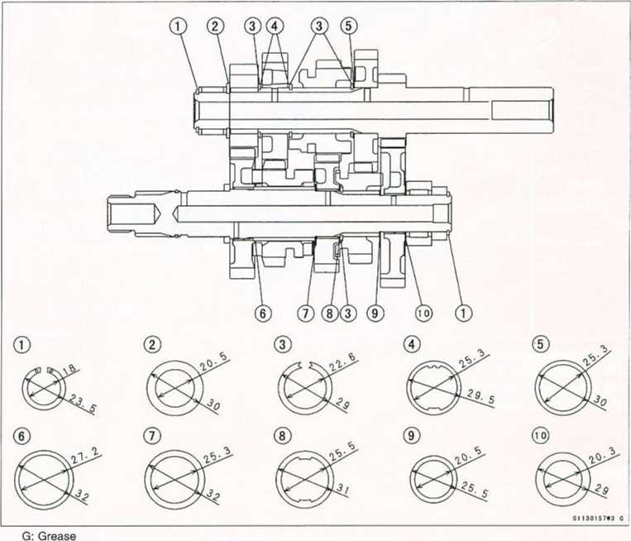
0: Engine Oil
T1: 9.8 N-m (10kg-m, 72 ft-lb)

16-12 SUPPLEMENT - 2000 - 2001 MODELS
Final Drive
Exploded View
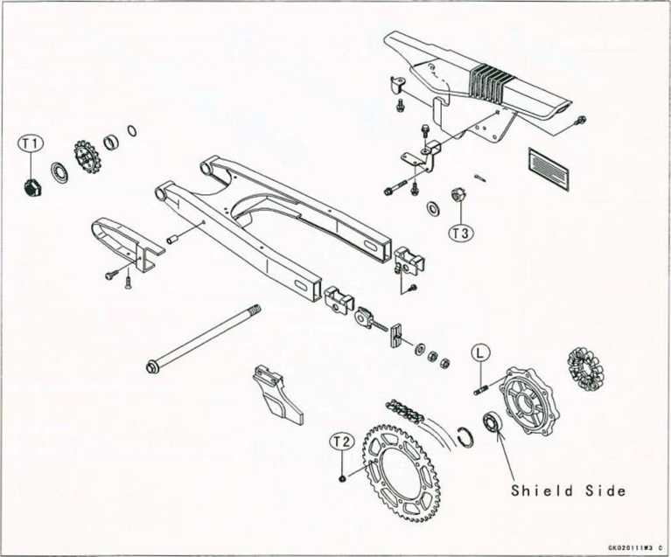
L : Non-permanent Locking Agent T1 : 98 N-m (10kg-m,72ft-lb)
T2 : 32 N-m (3.3kg-m.24 ft-lb)
T3 : 93 N-m (9.5kg-m.69ft-lb)

Specifications
Item | Standard | Service Limit
Drive Chain:  Standard chain : On and After KL650-A14 Chain slack Chain 20-link length | EK520SR-0, 106L 50 - 55 mm 317.5 - 318.1mm | 50 - 60 mm 323mm

SUPPLEMENT - 2000 - 2001 MODELS 16-13
Electrical System Specifications
Item | Standard | Service Limit
Battery:
Electrolyte level | Between upper and lower levels
Specific gravity | 1.280@20°C (68” F)
Charging System:
Regulator / rectifier output voltage | Battery - 15 V
Magneto stator coil resistance | 0.3 - i.on
Ignition System:
Spark plug: Type | NGK DPR8EA-9 or ND X24EPR-U9
Gap | 0.8 - 0.9 mm
Ignition coil:
Arcing distance | 7mm or more (3-needle method)
Primary winding resistance | 0.15 -0.21 a
Secondary winding resistance | 3.8-5.8k O
Exciter coil resistance | 100 - 200il
Pickup coil resistance | 100- 150Q
Electric Starter System:
Starter motor: Carbon brush length | 12.0 - 12.5 mm | 6 mm
Commutatoy diameter | 28 mm | 27 mm
Meter Unit:
Water temperature sender resistance | 47 - 57 Q @80t3 (176° F)
 | 26-30H @ lOOt (212° F)
Radiator fan switch: ON | Above 94 - 100°C 201-212° F)
OFF | Below 91 "C (196" F)

16-14 SUPPLEMENT - 2000 - 2001 MODELS
KL650-A14/A15 Wiring Diagram
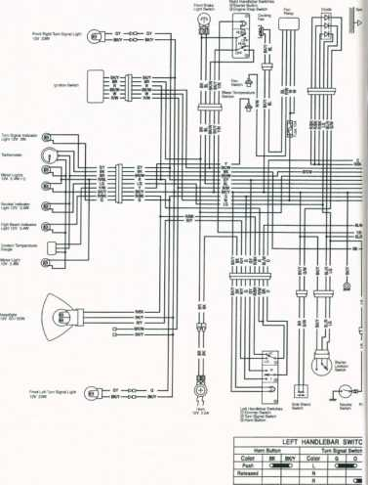

SUPPLEMENT - 2000 - 2001 MODELS 16-15
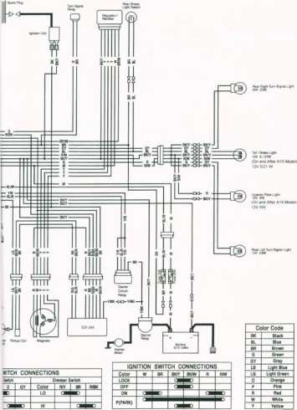

SUPPLEMENT - 2002 MODEL 17-1

Supplement - 2002 Model

Table of Contents
Foreword 17-2
How to Use this Manual 17-2
General Information 17-3
General Specifications 17-3
Torque and Locking Agent 17-5
Engine Right Side/Left Side 17-6
Specifications 17-6
Engine Oil and Oil Filter 17-6
Engine Oil Change 17-6

17-2 SUPPLEMENT - 2002 MODEL
Foreword
How to Use this Manual
This “Supplement - 2002 Model" designed to be used in conjunction with the front part of this manual (up to 16-15) and/or Base Manual KLR600 Service Manual - Part No. 99924-1050-01. The specifications and maintenance procedures described in this chapter are only those that are unique to the KL650-A16 model.
Complete and proper servicing of the KL650-A16 model therefore requires mechanics to read both this chapter and the front of this manual.

SUPPLEMENT - 2002 MODEL 17-3
General Information
General Specifications
Items |  | KL650-A16
Dimensions:
Overall length |  | 2205 mm
Overall width |  | 940 mm
Overall height |  | 1 345mm
Wheelbase |  | 1 495 mm
Road clearance |  | 240 mm
Seat height |  | 890 mm
Dry weight |  | 153 kg, (CA) 153.5 kg
Curb weight: | Front | 81 kg, (CA) 81.5 kg
 | Rear | 97 kg
Fuel tank capacity |  | 23 L
Performance
Minimum turning radius |  | 2.4 m
Engine
Type |  | 4-stroke, DOHC, 4-valve, 1-cylinder
Cooling system |  | Liquid-cooled
Bore and stroke |  | 100.0 x 83.0 mm
Displacement |  | 651 mL
Compression ratio |  | 9.5 : 1
Maximum horsepower |  | 35.3 kW (48 ps) @6500 r/mln (rpm)
Maximum torque |  | 55 N-m (5.6 kgf-m. 40.5 ft-lb) @5500 r/min (rpm)
Carburetion system |  | Carburetor, Keihin CVK40
Starting system |  | Electric
Ignition system |  | CDI
Timing advance |  | Electronically advanced
Ignition timing |  | from 10 BTDC @1300 r/mln (rpm) to 30 BTDC @3300 r/min (rpm)
Spark plugs |  | NGK DPR8EA-9 or ND X 24 EPR-U9
Valve timing:
Inlet | Open | 19 BTDC
 | Close | 69 ABDC
 | Duration | 268
Exhaust | Open | 57” BBDC
 | Close | 31 ATDC
 | Duration | 268
Lubrication system |  | Forced lubrication (wet sump)
Engine oil: | Type | API SE, SF or SG  API SH or SJ with JASO MA
 | Viscosity | SAE10W40
 | Capacity | 2.5 L

17-4 SUPPLEMENT - 2002 MODEL
General Information
Items |  | KL650-A16
Drive Train:
Primary reduction system:
Type |  | Gear
Reduction ratio |  | 2.272 (75/33)
Clutch type |  | Wet multi disc
Transmission:
Type |  | 5-speed, constant mesh, return shift
Gear ratios: | 1st | 2.266 (34/15)
 | 2nd | 1.444 (26/18)
 | 3rd | 1.136(25/22)
 | 4th | 0.954 (21/22)
 | 5th | 0.791 (19/24)
Final drive system:
Type |  | Chain drive
Reduction ratio |  | 2.866 (43/15)
Overall drive ratio |  | 5.157 ©Top gear
Frame:
Type |  | Tubular, semi-double cradle
Caster (rake angle) |  | 28
Trail |  | 112 mm
Front tire: | Type | Tube type
 | Size | 90/90-21 54S
Rear tire: | Type | Tube type
 | Size | 130/80-17 65S
Front suspension | Type | Telescopic lork (pneumatic)
 | Wheel travel | 230 mm
Rear suspension: | Type | Swingarm (uni-trak)
 | Wheel travel | 230 mm
Brake type: | Front | Single disc
 | Rear | Single disc
Electrical Equipment:
Battery |  | 12 V 14 Ah
Headlight: | Type | Semi-Sealed beam
 | Bulb | 12 V 60/55 W (quartz-halogen)
Tail/brake light |  | 12V 5/21 W
Alternator: | Type | Three-phase AC
 | Rated output | 17 A @7000 r/min (rpm), 14 V
Voltage regulator | Type | Short-Circuit
Specification subject to change without notice, and may not apply to every country. (CA): California Model

SUPPLEMENT - 2002 MODEL 17-5
General Information
Torque and Locking Agent
 |  | Torque
Fastener | N-m | kgf-m | ft lb | Remarks
Fuel System:
Fuel tap bolts | 2.5 | 0.25 | 22 in-lb
Engine Removal/Installation
Engine mounting bolts and nuts
10 mm | 44 | 4.5 | 33
8 mm | 27 | 2.8 | 20
Wheels/Tires:
Front axle nut | 88 | 9.0 | 65
Rear axle nut | 98 | 10 | 72
Spoke nipples | 5.1 | 0.52 | 45 in-lb
Brakes:
Brake pedal mounting bolt | 8.8 | 0.9 | 78 in-lb
Master cylinder mounting bolts | 25 | 2.5 | 18
Suspension/Steering:
Steering stem nut | 4.9 | 0.5 | 43 in-lb
Swing arm pivot nut | 88 | 9.0 | 65
Front fork clamp bolts - upper | 20 | 2.0 | 14
Controls/Instruments:
Handlebar clamp bolts | 25 | 2.5 | 18
Frame:
Rear frame mounting bolts | 27 | 2.8 | 20
Step holder mounting bolts | 32 | 3.3 | 24
Electrical System:
Fan switch | 7.8 | 0.8 | 69 in-lb

17-6 SUPPLEMENT - 2002 MODEL
Engine Right Side/Left Side
Specifications
Item | Standard | Service Limit
Engine Lubrication System:
Engine oil: Type | API SE, SF or SG
 | API SH or SJ with JASO MA
Viscosity | SAE10W40
Capacity | 2.2 L (filter Is not removed)
 | 2.5 L (filter Is removed)
Level | Between upper and lower level lines
Relief valve opening pressure | 430 - 590 kPa
 | (4.4 - 6.0 kgf/cm², 63 - 85 psi)
Oil pressure | 78- 147 kPa
@4000 rpm (r/min), 90 C (194F) | (0.8 - 1.5 kgf/cm², 11-21 psi)
Engine Oil and Oil Filter
Engine Oil Change
Type: API SE, SF or SG
API SH or SJ with JASO MA
Viscosity: SAE10W-40
Capacity: 2.2 L (Oil filler is not removed)
2.5 L (Oil filter is removed)
NOTE
Depending on the atmospheric temperature of your riding area, the
engine oil viscosity should be changed accordingly to the chart.
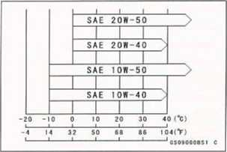

MODEL APPLICATION
Year | Model | Beginning Frame No.
1987 | KL650-A1 | JKAKLE A1 □ HA000001 or KL650A-000001
1987 | KL500-A1 | KL500A-000001
1988 | KL650-A2 | JKAKLEA1 □ JA008701 or KL650A-008701
1988 | KL500-A2 | KL500A-000501
1989 | KL650-A3 | JKAKLEA1 □ KA013601 or KL650A-013601
1990 | KL650-A4 | JKAKLEA1DLA016001
1991 | KL650-A5 | JKAKLEA1DMA018001
1992 | KL650-A6 | JKAKLEA1DNA021901
1993 | KL650-A7 | JKAKLEA1 □ PA026001
1994 | KL650-A8 | JKAKLEA1DRA030001
1995 | KL650-A9 | JKAKLEA1 □SA032001
2000 | KL650-A14 | JKAKLEA1DYA057001
2001 | KL650-A15 | JKAKLEA1 □ 1A070001
2002 | KL650-A16 | JKAKLEA1D2D075001
□: This digit in the frame number changes from one machine to another.
■ -C Kawasaki
KAWASAKI HEAVY INDUSTRIES, LTD.
Consumer Products & Machinery Company
Part No. 99924-1080-58

